Project | IEEE 802.16 Broadband Wireless Access Working Group <http://ieee802.org/16>
Title | Alternative Paths for a BS failure for 802.16n networks
Date Submitted | 2011-03-15
Source(s) | Wai Leong Yeow, Hoang Anh Tuan, Haiguang Wang, Shoukang Zheng, Jaya Shankar, Joseph Teo  Institute for Infocomm Research  1 Fusionopolis Way, #21-01, Connexis (South Tower)  Singapore 138632 | Voice: +65 6408-2254  E-mail: wlyeow@i2r.a-star.edu.sg
Re: | Call for contributions for 802.16n AWD
Abstract | In this document, we propose mechanisms to prepare alternative paths for a BS failure
Purpose | To discuss and adopt the proposed text in the 802.16n draft Text
Notice | This document does not represent the agreed views of the IEEE 802.16 Working Group or any of its subgroups. It represents only the views of the participants listed in the “Source(s)” field above. It is offered as a basis for discussion. It is not binding on the contributor(s), who reserve(s) the right to add, amend or withdraw material contained herein.
Copyright Policy | The contributor is familiar with the IEEE-SA Copyright Policy <http://standards.ieee.org/IPR/copyrightpolicy.html>.
Patent Policy | The contributor is familiar with the IEEE-SA Patent Policy and Procedures:  <http://standards.ieee.org/guides/bylaws/sect6-7.html#6> and <http://standards.ieee.org/guides/opman/sect6.html#6.3>.  Further information is located at <http://standards.ieee.org/board/pat/pat-material.html> and <http://standards.ieee.org/board/pat>.

Alternative Paths for a BS failure for 802.16n networks

Wai Leong Yeow, Hoang Anh Tuan, Haiguang Wang,
Jaya Shankar, Joseph Teo
Institute for Infocomm Research (I2R)
1 Fusionopolis Way, #21-01, Connexis South Tower
Singapore 138632

1. Introduction
A base station failure is very disruptive. All stations served by the BS will have to look for neighboring BS to perform network entry. This will cause a usage spike in physical resources, and may cause neighboring BSs to be swarmed. There may be further delay incurred since initial ranging is contention-based. Furthermore, all ongoing service flows will have to be reinitiated, resulting in longer delays for service re-connections at the upper layers.
The 802.16n SRD requires the HR-network to support establishment and maintenance of alternative paths to support fast recovery in the event of disruption. We propose to factor the possibility of multi-mode into alternative path establishment in event of a BS failure, in order to minimize disruption caused in terms of recovery time and physical resource utilization. Specifically, the HR-network shall prepare and maintain a failover topology of alternate paths with role-changed stations, and support fast network recovery with failover configuration.

2. Alternative paths and configuration after a BS failure for HR-Network
Upon a HR-BS failure, all stations in network would be in one of the following networks after attempts to recover:
- Join another BS/RS. Another BS/RS is in the vicinity.
- Standalone network without BS/RS. No infrastructure stations are reachable.
With HR-MSs capable of multi-mode, two additional cases are possible, and the size of the standalone network may be further reduced.
- Backup BS (B-BS). A HR-MS assumes the role of a HR-BS. Neighboring stations join the new HR-BS.
- Join another BS via a backup RS (B-RS). A HR-MS assumes the role of a HR-RS. The new HR-RS joins another BS in the vicinity, and neighboring stations join it via the new HR-RS.
Terminology:
- Failover Stations: We call HR-MSs, which switch modes in cases 3 and 4, Failover Stations.
- Failover Topology: we call the collection of alternative paths of all subordinate stations of BS-0 a failover topology.

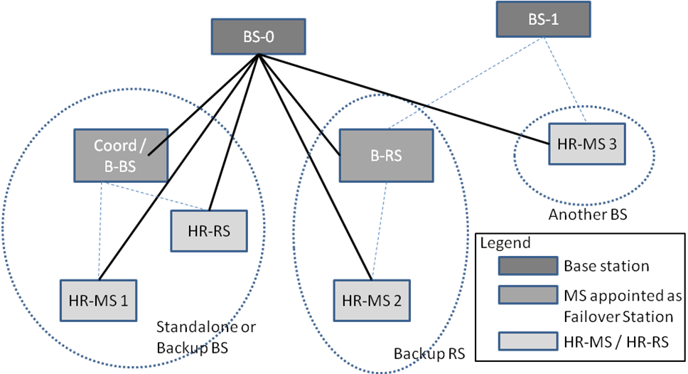
Figure 1. Failover configuration of BS-0. Solid lines represent the links with BS-0 before failure. Dotted lines represent the links after failure. Each dotted eclipse represents a new network after failure.

Fig. 1 shows the four possible cases with Failover Stations. The rightmost network is Case 1 where another HR-BS, BS-1, is in the vicinity and connections related to HR-MS3 joins BS-1 after BS-0 failed. The network in the center is Case 3 where a HR-MS role-changed to HR-RS and HR-MS2 joins BS-1 through it. The leftmost network represents Cases 2 and 4, respectively:
- A Standalone network with an optional coordinator for local connectivity and
- A HR-MS role-changed to HR-BS.
We propose that the base station (BS-0) is responsible for forming the failover topology and configuration, based on neighbor lists and capabilities of its subordinate stations. BS-0 shall maintain the failover topology and configuration. It shall assign Failover Stations, and update them periodically with their respective list of subordinate stations in the failover topology. BS-0 shall update the Failover Stations (FSs) with configuration information that will facilitate fast network entry of its subordinate stations. BS-0 also informs and updates its subordinate stations of their respective FS. The failover topology shall be periodically updated.

3. Fast Network Entry
Failover configuration is pre-negotiated information between a SS and its alternative path which facilitates a fast network entry in the event of SPOF. It is updated periodically by the serving BS.
For fast network entry involving mode-changes of the FS, we propose that the BS to pre-negotiate information between the FS and its alternative path, and determine failover configuration between the FS and its subordinate SSs in the failover topology. This information shall be stored in the respective FS, SSs, and the access station on the alternative path of FS.

4. Summary
We propose to factor the possibility of multi-mode into alternative path establishment in event of a BS failure, in order to minimize disruption caused. Specifically, we proposed mechanisms to prepare and maintain a failover topology of alternate paths with role-changed stations, and support fast network recovery with failover configuration.

5. Text Proposal for IEEE 802.16n AWD
Note:
The text in BLACK color: the existing text in AWD
The text in RED color: the removal of existing AWD text
The text in BLUE color: the new text added to the Multi-Carrier DG Text

[-------------------------------------------------Start of Text Proposal---------------------------------------------------]
17.2.1.1 HR-MS Multi-mode capability registration
A HR-MS that is capable of role change to HR-RS and/or HR-BS shall register this capability to the serving HR-BS during network entry, together with the basic capability negotiation phase. HR-MS should indicate to the serving HR-BS if it is unavailable to perform a role-change.

17.2.7.x Alternative Path Establishment and Maintenance

17.2.7.x.1 Alternative Path Establishment with Multi-mode
The serving HR-BS shall determine alternative paths for every subordinate stations in the event of a SPOF. The stations along an alternative path shall include HR-MS or HR-BS that switches mode to relay or base-station modes if the alternative path is a better path than others. The station which switches mode is designated by the serving BS and is called a Failover Station (FS).

17.2.7.x.2 Alternative Path Maintenance at FS
The serving HR-BS shall maintain alternative paths of its subordinate stations through FSs. It shall periodically update FSs with a TBD message containing a list of SS it is responsible for network re-entry after SPOF, and configuration information to facilitate fast network re-entry. The serving HR-BS shall periodically update its SSs with a TBD message containing their respective FS and configuration information to facilitate fast network re-entry to that FS.

17.2.7.x.3 Facilitate Fast Network Entry at FS after SPOF
Upon detection of a failure at the serving BS, FSs shall switch mode and perform network entry using the most recent configuration information. It shall facilitate fast network re-entry for SSs obtained from the most recent configuration information.

[-------------------------------------------------End of Text Proposal----------------------------------------------------]

References
- IEEE 802.16n-10/0048, “802.16n System Requirements Document including SARM annex”, January 2011.
- IEEE 802.16n-10/0049, “802.16n Table of Contents for Amendment Working Draft”, January 2011.

Use of IEEE-Copyrighted Conference and Journal Papers
The IEEE 802.16 Working Group has obtained permission to post IEEE-copyrighted material from IEEE conferences and publications when received in an official contribution to the Working Group. IEEE requires two conditions:
- A full copyright and credit notice must be posted at the top of the paper in the following format:
Copyright ©2002 Institute of Electrical and Electronics Engineers, Inc. Reprinted, with permission, from [all relevant journal info].
This material is posted here with permission of the IEEE. Internal or personal use of this material is permitted. However, permission to reprint/republish this material for advertising or promotional purposes or for creating new collective works for resale or redistribution must be obtained from the IEEE (contact pubs–permissions@ieee.org).
By choosing to view this document, you agree to all provisions of the copyright laws protecting it.
- If the author is not the submitter of the contribution, the author’s written approval for the reuse of the material must be attached.

