Project | IEEE 802.16 Broadband Wireless Access Working Group <http://ieee802.org/16>
Title | Proposal for Random Access Throttling
Date Submitted | 2011-03-05
Source(s) | Bin Chen, George Cummings, George Calcev, Erik Colban  Huawei Technologies | Voice: [Telephone Number (optional)]]  E-mail: binchen@huawei.com, gcummings@huawei.com, George.calcev@huawei.com, ecolban@huawei.com  *<http://standards.ieee.org/faqs/affiliationFAQ.html>
Re: | Call for comments on the M2M AWD, as announced by the Task Group chair, on January 18th, 2011.
Abstract | When a large number of M2M devices reside in a cell, there are occasional bursts of random access (ranging) attempts, which, if not throttled, may cause congestions. This contribution claims that there are methods that may be used by the BS to estimate the number of devices performing ranging at the same time (or within a short time interval). It proposes signaling that the BS may use to limit the number of devices that continue ranging.
Purpose | Discuss and adopt.
Notice | This document does not represent the agreed views of the IEEE 802.16 Working Group or any of its subgroups. It represents only the views of the participants listed in the “Source(s)” field above. It is offered as a basis for discussion. It is not binding on the contributor(s), who reserve(s) the right to add, amend or withdraw material contained herein.
Copyright Policy | The contributor is familiar with the IEEE-SA Copyright Policy <http://standards.ieee.org/IPR/copyrightpolicy.html>.
Patent Policy | The contributor is familiar with the IEEE-SA Patent Policy and Procedures:  <http://standards.ieee.org/guides/bylaws/sect6-7.html#6> and <http://standards.ieee.org/guides/opman/sect6.html#6.3>.  Further information is located at <http://standards.ieee.org/board/pat/pat-material.html> and <http://standards.ieee.org/board/pat>.

Proposal for Random Access Throttling
Bin Chen, George Cummings, George Calcev, Erik Colban
Huawei Technologies

Introduction
One of the most important features of M2M communication is that it needs to handle a large number of devices (there may be as many as 30,000 devices in a cell). Call models used for dimensioning of networks used for human communications may not apply to M2M communications. Unlike communications that are initiated by humans, M2M communications are typically triggered by events. Events caused by catastrophic events such as earthquakes, flooding, fire, power outages are examples of such events. Other examples are events that are not catastrophic by nature, but that, by the laws of their statistical distribution in time or by the way that the devices have been programmed to react to them, occasionally cause a number of devices larger than normal to access the network at the same time. Without measures in place to handle such bursts of network access, the network could become congested, which has detrimental consequences.

The procedure that the device must initiate to obtain an allocation depends on the state of the device. If the subscriber station is in idle state—and it is expected that M2M devices will spend most time in idle state—the procedure starts with initial ranging. If there are thousands of subscriber stations ranging within a short time interval, the probability of collisions is very high. With thousands of M2M devices sending ranging codes over a very short time interval, the BS may not be able to decode correctly more than a very few of the transmitted codes or, even worse, none at all.

The backoff mechanism specified in the standard has the effect of spreading the ranging from the different subscriber stations over a larger interval of time, thus reducing the probability of collisions. However, it does not reduce the number of ranging attempts; rather it increases it, as the subscriber stations will continue retrying until they have exhausted the number of permitted attempts.

In this contribution we show that there are methods that the BS may use to estimate the number of devices that are performing ranging simultaneously. Based on this estimate the BS may signal to reduce the number of devices that continue ranging by some fraction.

Estimating the Number of Devices that are Ranging
The BS’s estimation is based on the probability distribution of the number of ranging opportunities that are selected when N devices are competing for M ranging opportunities. (Note: For 16m it may be better to let M be the number of opportunities × codes.) When each of the N devices select a ranging opportunity at random from the M provided ranging opportunities, there is a high probability that some opportunities are not selected. Based on the number of ranging opportunities selected by at least one device or equivalently, based on the number of ranging opportunities not selected by any device, it is possible to estimate the number devices that are competing for the M ranging opportunities. Figure 1 shows the distribution of ranging opportunities selected by 50, 100, 200 devices when competing for 100 ranging opportunities.
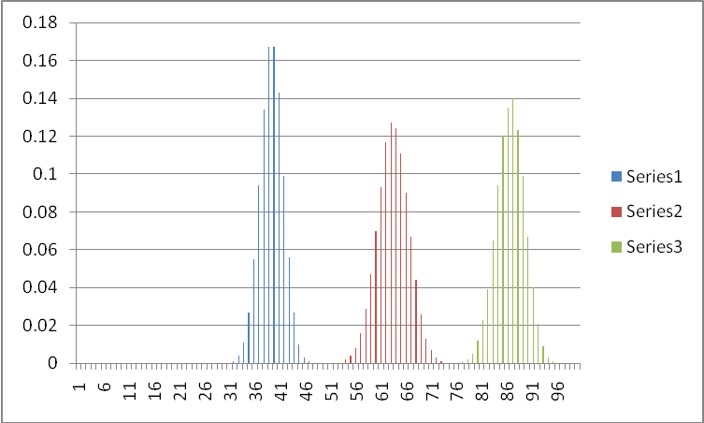

Figure 1: Distribution of number of selected ranging opportunities selected by 50 (Series 1), 100 (Series 2), and 200 (Series3) devices competing for 100 ranging opportunities.

Figure 1 illustrates how the number of ranging slots selected by at least one device is affected by the number of devices competing for those ranging opportunities. One can observe that even when the number of devices is twice the number of available ranging slots, there is close to zero probability that all ranging opportunities are selected.

Knowing the probability distribution of the number of slots Q that are selected when M slots are provided given that N devices are competing for them, one can derive the probability distribution of the number of devices N competing for the M slots, given that Q slots have been selected. To derive this second distribution an a priori distribution of the number of devices ranging is used. An a priori assumption could be that the number of devices ranging is Poisson distributed for some given value of the parameter lambda. An alternative a priori assumption is that any number of devices ranging has equal probability (i.e., there is no a priori bias toward the number of devices that are ranging).

Figure 2 shows an example of this distribution.

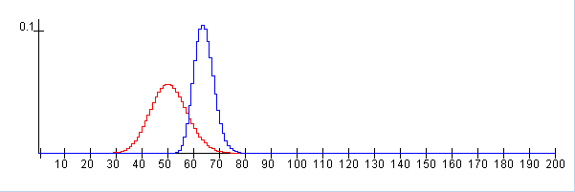

Figure 2: Example where the a priori distribution (red) is Poisson distributed with parameter lambda = 50 and the observed number of selected time slots is 49 out of 100. The a posteriori distribution (blue) has mean 63.5 and standard deviation 3.8.

Controlling Access

Once the BS has estimated the number of devices that are ranging the base station may adjust the number of ranging opportunities that it provides or it may signal to the devices to stop or postpone ranging.
When too many devices are ranging, the BS signals a parameter p between 0 and 1 in a broadcast message. The parameter p indicates the probability of a device ranging. For instance, if the BS estimates that the number of devices is 2 times higher than the optimal number, the BS broadcasts the value 0.5 for p. That reduces the estimated number of devices that range by half. A device, when receiving the parameter p, initiates or continues ranging with probability p. That is, when receiving the parameter p, the device performs a test that we refer to as the ‘p-test’. The p-test produces a random result, ‘pass’ or ‘fail’, with probability for pass equal to p. If the result is ‘pass’ it may continue ranging, otherwise it stops ranging. When selecting the value of p, the BS may take into account that some devices may have been successful in their first try and will not need to retry. When the device continues ranging it follows the standard procedure, i.e., it selects a new ranging opportunity in the next ranging window and a new code and transmits that code in that ranging opportunity.
The base station may signal a different value for p each time it transmits the parameter. For instance, if the base station estimates that the number of devices ranging is decreasing, it can increase the value of p.

We ask the M2M TG to discuss and comment on the procedure presented in this contribution. If the TG sees some merit in this proposal we will bring a new contribution providing the signaling details.

