Project | IEEE 802.16 Broadband Wireless Access Working Group <http://ieee802.org/16>
Title | Technical Comments to P802.16j/D1 : 7.1.7 Distributed Security Control in Multihop Relay System
Date Submitted | 2007-09-15
Source(s) | Jui-Tang Wang, Tzu-Ming Lin Wern-Ho Sheen, Fang-Ching Ren, Chie-Ming Chou, I-Kang Fu,  ITRI/NCTU  195,Sec. 4, Chung Hsing Rd.  Chutung, Hsinchu, Taiwan 310, R.O.C | tmlin@itri.org.tw
Re: | Comments with Letter Ballot #28 “P802.16j/D1”
Abstract | This contribution describes the clarifications for RS configuration message to avoid the confliction on usage of multicast CIDs.
Purpose | To make IEEE Project 802.16j more maturity
Notice | This document does not represent the agreed views of the IEEE 802.16 Working Group or any of its subgroups. It represents only the views of the participants listed in the “Source(s)” field above. It is offered as a basis for discussion. It is not binding on the contributor(s), who reserve(s) the right to add, amend or withdraw material contained herein.
Release | The contributor grants a free, irrevocable license to the IEEE to incorporate material contained in this contribution, and any modifications thereof, in the creation of an IEEE Standards publication; to copyright in the IEEE’s name any IEEE Standards publication even though it may include portions of this contribution; and at the IEEE’s sole discretion to permit others to reproduce in whole or in part the resulting IEEE Standards publication. The contributor also acknowledges and accepts that this contribution may be made public by IEEE 802.16.
Patent Policy | The contributor is familiar with the IEEE-SA Patent Policy and Procedures:  <http://standards.ieee.org/guides/bylaws/sect6-7.html#6> and <http://standards.ieee.org/guides/opman/sect6.html#6.3>.  Further information is located at <http://standards.ieee.org/board/pat/pat-material.html> and <http://standards.ieee.org/board/pat>.
Technical Comments to P802.16j/D1 :
7.1.7 Distributed Security Control in Multihop Relay System
Jui-Tang Wang, Tzu-Ming Lin Wern-Ho Sheen, Fang-Ching Ren, Chie-Ming Chou, I-Kang Fu,
ITRI/NCTU
- Problem Statement
With distributed security control in multihop relay system, the authorization key (AK) established between MS and MR-BS is distributed to the access RS. The AK stored in access RS can make authentication procedure (SA-TEK 3-way handshake procedure) and key distribution procedure (TEK 3-way handshake procedure) locally. Therefore, the MS/RS can accomplish authentication and key distribution procedure quickly with the access RS. However, the AK out of the core network is not safety for the owner (MS). First, the AK stands for the MS, so the AK is the root key of all MS-related key (KEK, TEK, HMAC_KEY_U, …, etc). So the AK cannot be out of the core network. And then transferring AK over the air is not allowed because transferring AK over air is not always secure. Once somebody obtains the AK by some ways, he also can get all another keys at the same time. Which means the access links are not secure within 7~30 days (the life time of AK). Moreover, access RS can control all key change directly without the MR-BS managing when AK is not expired. When the AK is allowed to cache in the RS, the access RS may issue AK synchronization and TEK synchronization problems.
In additional to consider network security, we have to consider system security in RS. In a relay network, the MR-BS is believed to secure. It is because the MR-BS always is located in a building or under some protection. However, the protection of RS is not as good as MR-BS because the RS can be built in traffic light, bus, or rooftop. The RS security might be broke by physical ways easily, e.g. hacker cracks RS directly. The hacker would crack the RS for obtaining MS’s AK. When MS’s AK is obtained by such a physical way, the access links would not be secure anymore until the time when AK is updated. Even if TEK is updated again, the access link is still not secure. Moreover, the MR-BS is not aware the security state of access links and do nothing even if the MR-BS is notified the crack event. Figure 1 illustrates such issues. Compared with distributing AK to Access RS, distributing TEK can raise the security of relay network and shorten the insecure period when key is cracked.
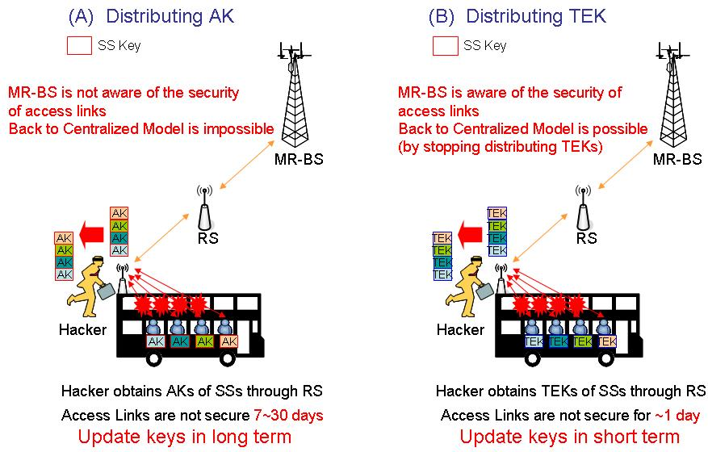
Figure 1. Security Problem of distributing AK

- Proposal
In order to solve above mentioned problems and keep the accomplished authentication and key distribution quickly, we propose a key-based authentication in 802.16j multi-hop relay network. The access RS only possess TEK and H/CMAC_KEY_U/D to process data encryption/decryption and integrity check.
To only transferring TEK and H/CMAC_KEY_U/D into the access RS, the AK should avoid to delivery over air and store into some network node, and the access RS still keep QoS Routing for MS. When a hacker cracks the access RS for obtaining MS’s TEK, because of the short lifetime of TEK, the access links would be not secure in one day or less. In distributed security model, the MR-BS is aware of the security of access link because the control of AK is kept in MR-BS. If the MR-BR feels that the access links are not secure anymore, it can trigger three way handshaking for updating TEK. The Hacker has to crack RS again if he wants to obtain TEK again. If the crack event is triggered, the MR-BS can change to centralized security control in an easier and quick way, which is stopping distributing TEK to RS.
The MS-BS generates all MS-related keys and transfers to the access RS. Transferring TEK over the air is allowed (802.16e). The life time of TEK is shorter than that of AK. The MR-BS can change TEK if TEK is not safety immediately. So the MR-BS can still handle the MS’s security.
In another case, an MR-BS and the RSs connected to the MR-BS form a secure relay zone (SRZ). An MS only performs 802.1X authentication while first time connects to an AR-RS within the SRZ. Authentication latency is removed from the following handoffs in the same SRZ. Furthermore, end-to-end security channel between an MS and an MR-BS is established without exchanging any extra management message. The proposed security channel can improve the performance of 802.16j multi-hop relay network with some management functions. In order to protect Authorization Key (AK) security and read the subheaders for additional managements, the proposed method only needs to transfer the Traffic Encryption Key (TEK) and HMAC_KEY_U/CMAC_KEY_U from serving MR_BS to AR-RS and keep protection of AK in serving MR-BS.
Besides that mentioned about, the related procedures, including security association establishment and handoff, are proposed to facilitate the operation of distributing TEK and HMAC_KEY_U/CMAC_KEY_U.

2.1 System Architecture
With SRZ, security function of the AR-RS service, such as Key Management, are implemented in the serving MR-BS.
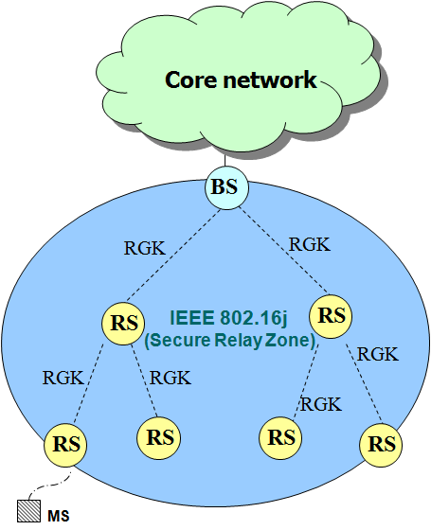
Figure 2. System Architecture

AR-RS is the edge of Secure Relay Zone and responsible for blocking malicious MSs from accessing the 802.16j multi-hop network. In order to provide the ability for AR-RS to verify frame integrity, TEK and HMAC_KEY_U/CMAC_KEY_U are distributed from serving MR-BS to the serving AR-RS via secured relay links (RGK protocol, SZK protocol).

2.2 MS’s Security Association Establishment
While an MS initially associated to any AR-RS within the SRZ, it is required to perform 802.1X authentication, SA-TEK 3-way handshake and TEK and HMAC_KEY_U/CMAC_KEY_U distribution to establish the security association with the serving MR-BS. For being compatible with conventional 802.16e MSs, the management message flows in the MS portion are identical to SRZ and 802.16e in the SA establishment. The AR-RS is responsible for forwarding all security management messages between MS and serving MR-BS. The following figure illustrates the procedure of security association establishment for an MS initially authenticating with an AR-RS with the SRZ.

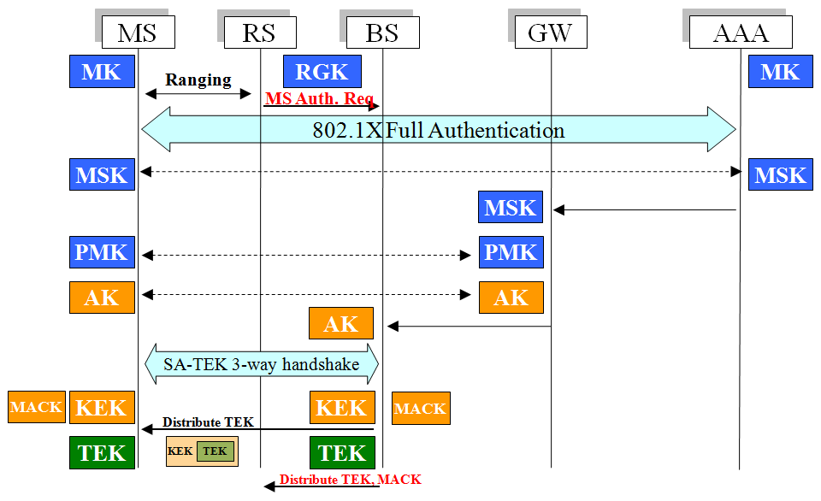
Figure 3, Security Association establishment with SRZ

- The serving AR-RS checks the Ranging frame to see is any AKID included. If not, an MS Authentication Request message is sent to the serving MR-BS to initialize 802.1X authentication.
- The MS and AAA server perform 802.1X authentication. If the result is successful, the serving MR-BS will obtain the Authorization Key (AK) from ASN-GW. Next, the MS and the serving MR-BS carry out the SA-TEK 3-way handshake procedure. All authentication management messages are forwarded via the serving AR-RS.
- The Serving MR-BS distributes the TEK to the MS for data confidentiality.
- The serving MR-BS distributes the TEK and HMAC_KEY_U/CMAC_KEY_U to the serving AR-RS for data filtering in the serving AR-RS.
- Once the serving AR-RS obtains the TEK and HMAC_KEY_U/CMAC_KEY_U, it will switch the state to the authorized state, and thus the MS is able to access the 802.16j multi-hop relay network. The serving AR-RS can take TEK to decrypt the frame and use the HMAC_KEY_U/CMAC_KEY_U verify the MAC. The Message Authentication Code (MAC) in the frame can also be verified by serving MR-BS.
- If multicast service is start, the multicast key will be distributed to the serving AR-RS as well.

2.2 Handoff Procedures
802.16j allows multiple AR-RSs reside in one 802.16j multi-hop relay network, and thus the handoff behaviors with SRZ are categorized into intra-MR-BS handoff and inter-MR-BS handoff. Moreover, the authentication procedures vary in the two types.

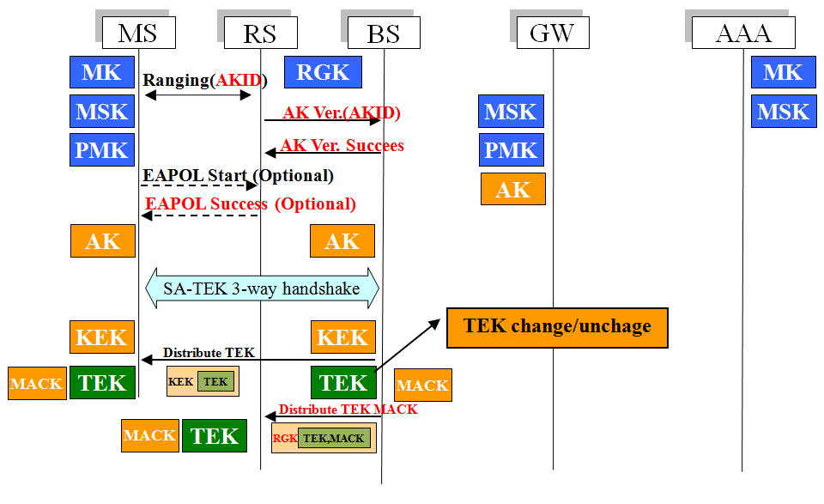
Figure 4. Intra-MR-BS handoff

2.2.1 Intra-MR-BS handoff
Intra-MR-BS handoff means that an MS drops current connection and re-associates with another AR-RS (target AR-RS) connecting to the same serving MR-BS. If the AK is cached by the serving MR-BS, 802.1X authentication will be skipped. The following figure illustrates the authentication management message flows of intra-MR-BS handoff.

- The MS re-associates with the target AR-RS. The AKID is passed to the serving MR-BS for verifying the AK cached in the MS.
- The AKID is compared with the AK cached in the serving MR-BS. If the AKID is valid, the serving MR-BS will inform the target AR-RS with an AK Verification Success Message.
- Some implementations of the MS use the EAPOL-Start message to initialize 802.1X authentication. If the target AR-RS receives an EAP-Start message, it will reply an EAP-Success message to skip the EAP authentication.
- Following the SA-TEK 3-way handshake and TEK and HMAC_KEY_U/CMAC_KEY_U distribution are identical to the security association establishment mentioned before.

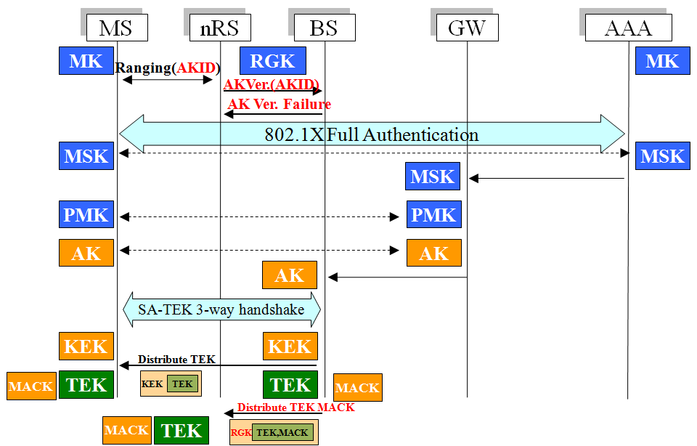
Figure 5. Inter-MR-BS handoff

2.2.2 Inter-MR-BS handoff
Inter-MR-BS handoff is performed while an MS moves from serving AR-RS to target AR-RS connecting to different MR-BS. The MS will switch to another SRZ in the inter-MR-BS handoff.
If the SRZ has not been visited by the MS or the cached AK is expired, pre-authentication will be performed. However, the MS may fail to pre-authenticate with the MR-BS, and thus the overhead of 802.1X authentication is introduced.
There are many factors cause pre-authentication to be failed, such as the moving speed of the MS, the size of the overlapping coverage area, the target AR-RS prediction, the latency of EAP authentication, etc.
The following figure illustrates the management flows of inter-MR-RS handoff and security association establishment. Detail procedures are as follows:
- The MS re-associates with the target AR-RS. The AKID is forwarded to the serving MR-BS for verifying the AK cached in the MS.
- Since the target MR-BS does not cache the AK, the AKID verification is failed, and a message will be sent to the target MR-BS for informing that following authentication message should be forwarded to the target MR-BS.
- 802.1X authentication and SA-TEK 3-way handshakes are performed, followed by the TEK distribution to the MS and TEK and HMAC_KEY_U/CMAC_KEY_U distribution to target AR-RS. The procedures are the same as the security association establishment described before.

- Suggested Remedy

Summary:
- AK only stored in MS and serving MR-BS
- Transmit MS’s TEK and MAC Key from serving MR-BS to AR-RS

Advantages:
- MS’s AK hold by MR-BS can ensure authentication and authorization of MS
- MS’s TEK and MAC Key hold by AR-RS can manage data transmission
- AR-RS can check MS’s data for integrity before data get into relay links
- For R-Link security, RSs can check confidentiality and integrity of relayed data

- Proposed Text Change
-----------------------------------------------------Start text proposal----------------------------------------------------
[Adopt the following modifications into the P802.16j/D1 document]

7.1.7 Distributed Security Control in Multihop Relay System

Change subslause 7.1.7 as indicated:

With distributed security control in multihop relay system, the authentication traffic encryption key (TEK) and C/HMAC_KEY_U/D key established between MS and MR-BS is distributed to the access RS.

During the registration process, RS can be registered as Authenticator Relay (AR) RS based on its capability and willingness to become the AR-RS. AR-RS relays initial PKM messages between the MR-BS and MS/RS. When the MSK Authorization Key (AK) for the downstream RS/MS is established and distributed between the MS/RS and MR-BS, the MR-BS shall securely transfer relevant Authorization Key (AK) TEK and C/HMAC_KEY_U/D key to the AR-RS. AR derives all necessary keys and starts SA-TEK 3-way handshake with the MS/RS if PKMv2 is used.

Insert new subclause 7.1.7.2:

7.1.7.2 MS Security Association Establishment

While an MS initially associated to any AR-RS within the SRZ, it is required to perform 802.1X authentication, SA-TEK 3-way handshake and TEK and HMAC_KEY_U/CMAC_KEY_U distribution to establish the security association with the serving MR-BS. For being compatible with conventional 802.16e MSs, the management message flows in the MS portion are identical to SRZ and 802.16e in the SA establishment. The AR-RS is responsible for forwarding all security management messages between MS and serving MR-BS. The following figure illustrates the procedure of security association establishment for an MS initially authenticating with an AR-RS with the SRZ.

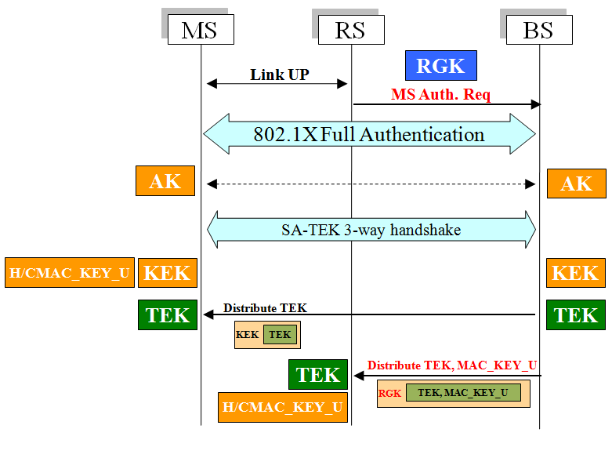
Figure 158b. The MS Security Association establishment

- The serving AR-RS checks the link up message to see is any AKID included. If not, an MS Authentication Request message is sent to the serving MR-BS to initialize 802.1X authentication.
- The MS and AAA server perform 802.1X authentication. If the result is successful, the serving MR-BS shall obtain the Authorization Key (AK) from ASN-GW. Next, the MS and the serving MR-BS carry out the SA-TEK 3-way handshake procedure. All authentication management messages are forwarded via the serving AR-RS.
- The Serving MR-BS distributes the TEK to the MS for data confidentiality.
- The serving MR-BS distributes the TEK and HMAC_KEY_U/CMAC_KEY_U to the serving AR-RS for data filtering in the serving AR-RS.
- Once the serving AR-RS obtains the TEK and HMAC_KEY_U/CMAC_KEY_U, it shall switch the state to the authorized state, and thus the MS is able to access the 802.16j multi-hop relay network. The serving AR-RS can take TEK to decrypt the frame and use the HMAC_KEY_U/CMAC_KEY_U verify the MAC. The Message Authentication Code (MAC) in the frame can also be verified by serving MR-BS.
- If multicast service is start, the multicast key shall be distributed to the serving AR-RS as well.

Authorization Key (AK) is the root key between MS and the serving MR-BS. AK should keep in the serving MR-BS. The serving MR-BS only transfer the TEK and HMAC_KEY_U/CMAC_KEY_U to the serving AR-RS via secure relay link (RGK protocol or SZK protocol). The AR-RS take MS’s TEK to read subheader and use HMAC_KEY_U/CMAC_KEY_U to filter malicious data frame.

The AR-RS would calculate a new MAC for relay link security. For Message Authentication Code (MAC) verification, the serving MR-BS still can check the MAC calculated by the MS in the data frame if the AR-RS do not drop the MAC.

Insert new subclause 7.1.7.3:

7.1.7.3 Handoff procedures

802.16j allows multiple RSs reside in one 802.16j multi-hop relay network, and thus the handoff behaviors with SRZ are categorized into intra-MR-BS handoff and inter-MR-BS handoff. Moreover, the authentication procedures vary in the two types.

Insert new subclause 7.1.7.3.1:

7.1.7.3.1 Intra-MR-BS handoff

Intra-MR-BS handoff means that an MS drops current connection and re-associates with another AR-RS (target AR-RS), which connects to the same serving MR-BS. If the AK is cached by the serving MR-BS, 802.1X authentication shall be skipped. The following figure illustrates the authentication management message flows of intra-MR-BS handoff.

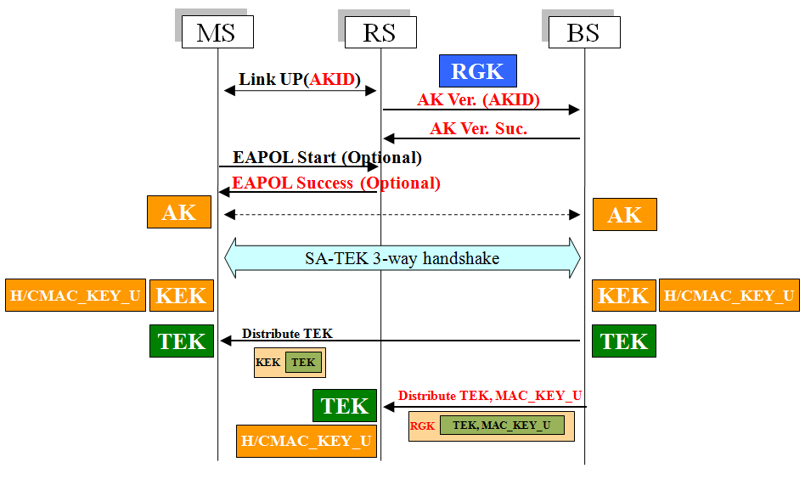
Figure 159b. Intra-MR-BS handoff

- The MS re-associates with the target AR-RS. The AKID is passed to the serving MR-BS for verifying the AK cached in the MS.
- The AKID is compared with the AK cached in the serving MR-BS. If the AKID is valid, the serving MR-BS shall inform the target AR-RS with an AK Verification Success Message.
- Some implementation of the MS uses the EAPOL-Start message to initialize 802.1X authentication. If the target AR-RS receives an EAP-Start message, it shall reply an EAP-Success message to skip the EAP authentication.
- Following the SA-TEK 3-way handshake and TEK and HMAC_KEY_U/CMAC_KEY_U distribution are identical to the security association establishment mentioned before.

The AK Verification Request Message and the AK Verification Response Message could be replaced with RNG_REQ and RNG_RSP. And TEK and HMAC_KEY_U/CMAC_KEY_U distribution could also take AK transfer protocol to distribute the TEK and HMAC_KEY_U/CMAC_KEY_U from the associated MR-BS to the serving AR-RS.

Insert new subclause 7.1.7.3.2:

7.1.7.3.2 Inter-MR-BS handoff

Inter-MR-BS handoff is performed while an MS moves from serving AR-RS to target AR-RS, which connects to different MR-BS. The MS may switch to another SRZ in the inter-MR-BS handoff.

If the SRZ has not been visited by the MS or the cached AK is expired, pre-authentication shall be performed. However, the MS may fail to pre-authenticate with the MR-BS, and thus the overhead of 802.1X authentication is introduced.

There are many factors cause pre-authentication to be failed, such as the moving speed of the MS, the size of the overlapping coverage area, the target AR-RS prediction, the latency of EAP authentication, etc.

The following figure illustrates the management flows of inter-MR-RS handoff and security association establishment. Detail procedures are as follows:

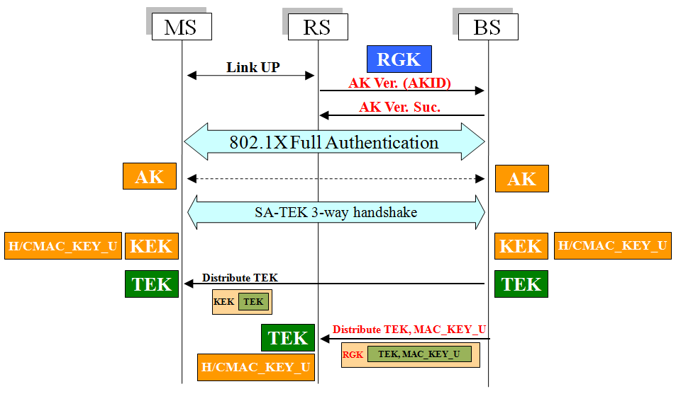
Figure 160b. Inter-MR-BS handoff

- The MS re-associates with the target AR-RS. The AKID is forwarded to the serving MR-BS for verifying the AK cached in the MS.
- Since the target MR-BS does not cache the AK, the AKID verification is failed, and a message shall be sent to the target MR-BS for informing that following authentication message should be forwarded to the target MR-BS.
- 802.1X authentication and SA-TEK 3-way handshake are performed, followed by the TEK distribution to the MS and TEK and HMAC_KEY_U/CMAC_KEY_U distribution to target AR-RS. The procedures are the same as the security association establishment described before.

-------------------------------------------------------End of text ---------------------------------------------------------

