Project | IEEE 802.16 Broadband Wireless Access Working Group <http://ieee802.org/16>
Title | Proposal for Full Duplex Relay
Date Submitted | 2008-05-15
Source(s) | Takki Yu, Seung Hee Han,  Sungyoon Jung, Jungje Son,  Youngbin Chang, Hyunjeong Kang  Samsung Electronics Co., Ltd. Korea  Rakesh Taori  Samsung Advanced Institute of Technology, Korea | Voice: +82 31 279 4978  E-mail: tk.yu@samsung.com  sh0506.han@samsung.com  jungje.son@samsung.com  E-mail: rakesh.taori@samsung.com
Re: | LB#28c
Abstract | This contribution proposes to include the full duplex relaying as one of the possible options in 802.16j standard.
Purpose | Accept proposed changes into IEEE P802.16j/D4
Notice | This document does not represent the agreed views of the IEEE 802.16 Working Group or any of its subgroups. It represents only the views of the participants listed in the “Source(s)” field above. It is offered as a basis for discussion. It is not binding on the contributor(s), who reserve(s) the right to add, amend or withdraw material contained herein.
Release | The contributor grants a free, irrevocable license to the IEEE to incorporate material contained in this contribution, and any modifications thereof, in the creation of an IEEE Standards publication; to copyright in the IEEE’s name any IEEE Standards publication even though it may include portions of this contribution; and at the IEEE’s sole discretion to permit others to reproduce in whole or in part the resulting IEEE Standards publication. The contributor also acknowledges and accepts that this contribution may be made public by IEEE 802.16.
Patent Policy | The contributor is familiar with the IEEE-SA Patent Policy and Procedures:  <http://standards.ieee.org/guides/bylaws/sect6-7.html#6> and <http://standards.ieee.org/guides/opman/sect6.html#6.3>.  Further information is located at <http://standards.ieee.org/board/pat/pat-material.html> and <http://standards.ieee.org/board/pat>.
Proposal for Full Duplex Relay
Takki Yu, Seung Hee Han, Sungyoon Jung, Jungje Son, Youngbin Chang, Hyunjeong Kang
Samsung Electronics
,Rakesh Taori
Samsung Advanced Institute of Technology

Introduction
Full duplex relay station can transmit and receive simultaneously in a single frequency band leading to the following advantages:
- Potential reduction in spectral efficiency loss : re-utilizes BS-RS link resources as RS-MS link resources
- Reduced overhead : no need for R-TTG and R-RTG, relay amble, and duplicated broadcasting information
- No loss in uplink coverage : an MS can send data over the whole UL frame to increase uplink coverage
However, full duplex relaying is not defined as relaying mechanism in the current draft. A full duplex relay station can be readily used in some of the usage models of 802.16j as shown in Figure 1. In the usage models such as underground and coverage hole where sufficient level of isolation between relay transmit and receive antennas is likely to be present, we can exploit the benefits of full duplex relaying.

This contribution proposes that full duplex relaying be included as one of the possible options in the 802.16j standard. Details of the operation and the corresponding text for inclusion in the draft is provided here.

Figure 1. Usage model of full duplex

Overall description on “Full duplex relaying”
We suggest that the following definitions be included :

* Full duplex relaying (FDR) : a capability of communicating with the superordinate station and subordinate station(s) simultaneously, on the same carrier frequency.
* Full duplex RS: a non-transparent relay station capable of full duplex relaying.

Communication with a superordinate station and subordinate station(s) is performed using two different antenna sets where one of the antenna set is used for communicating with the superordinate station while at the same time the other antenna set is used for communicating with the subordinate station(s). FDR operation may cause interference from relay transmit antenna set to relay receive antenna set because it receives and transmits simultaneously using the same time/frequency resources. Hence, in order to achieve benefits from full duplex relay, a certain degree of isolation might be needed between the relay transmit and receive antenna sets. In some usage models, because of the nature of the usage scenario, sufficient levels of isolation may be available. For example, FDR may be an efficient relay solution to the underground usage model by locating the antenna communicating with BS outside and antenna communicating with MSs inside.

Figure 2 shows the high-level frame structure of full duplex relay for a two-hop case. The approach to the frame structure is same as that in [2], which preserves the consistency with the current frame structure except simultaneous operation of transmitting and receiving on the same carrier.

Figure 2. Tx/Rx configuration of FDR in case of two hop frame structure

Full duplex RS frame structure
The frame structure of full duplex RS is shown in Figure 3. The first and second antenna sets operate on the same carrier frequency.

Figure 3. An example of frame structure for full duplex RS.

Network entry – Capability negotiation
An RS having a capability of full duplex relaying can inform the MR-BS during network entry using SBC negotiation.

Reference:
[1] IEEE P802.16j/D4 April 2008
[2] IEEE C802.16j-08/079r1 “Out-of-band relay clarification” March 2008

Proposed changes to the draft

Change part of the subclause 1.6 (line 5-13, page 3) as indicated:

1.6 Multihop relay

A transparent RS communicates with the superordinate station and subordinate station(s) using the same carrier frequency. A non-transparent RS may communicate with the superordinate station and subordinate station(s) using the same or different carrier frequencies. The former case is useful if a single frequency network is being deployed. The latter is useful if multiple carrier frequencies are being used in a network. In the case of separate carrier frequencies being used, the non-transparent RS can either be a single radio RS, where time division and carrier frequency switching is used to enable communication with the superordinate station and subordinate station(s), or it can be a dual radio RS, where simultaneous communication with the superordinate station and subordinate station(s) is possible.

Insert new definition 3.125, 3.126, 3.127, 3.128:

<Option 1>
3.125 Time-division transmit and receive (TTR) relaying : a relaying mechanism where communication with the superordinate station and subordinate station(s) is separated in time.

3.126 TTR RS : a non-transparent relay station which performs TTR relaying.

3.127 Simultaneous transmit and receive (STR) relaying : a relaying mechanism where communications with the superordinate station and subordinate station(s) are performed simultaneously.

3.128 STR RS: a non-transparent relay station capable of performing STR relaying.

<Option 2>
3.125 Time-division transmit and receive (TTR) relaying : a relaying mechanism where transmission to subordinate station(s) and reception from superordinate station, or transmission to superordinate station and reception from subordinate station(s) is separated in time.

3.126 TTR RS : a non-transparent relay station which performs TTR relaying.

3.127 Simultaneous transmit and receive (STR) relaying : a relaying mechanism where transmission to subordinate station(s) and reception from superordinate station, or transmission to superordinate station and reception from subordinate station(s) are performed simultaneously.

3.128 STR RS: a non-transparent relay station capable of performing STR relaying.

Change part of the subclause 6.3.9.18.1 (line 47-50, page 106) as indicated:

6.3.9.18.1 Parameter configuration

A non-transparent RS should maintain its synchronization by listening to the R-amble transmitted by its superordinate station (see 6.3.2.3.65). A non-transparent simultaneous transmit and receive dual radio RS may alternatively listen to the frame start preamble of its superordinate station to maintain synchronization. A transparent RS should maintain its synchronization by listening to the preamble transmission from its superordinate station.

Change part of the subclause 8.4.4.7.2 (line 21-25, page 189) as indicated:

8.4.4.7.2 Frame structure for non-transparent mode

Two approaches for supporting relaying are specified for time-division transmit and receive (TTR) single radio RSs. A TTR single radio RS shall be capable of being configured to support either one of the operations, but shall not be required to support both operations simultaneously. The DL subframe shall include at least one access zone and the UL subframe may include one or more UL access zones and one or more relay zones.

Change the title of Figure 270b as indicated:

Figure 270b—Example of minimum configuration for a single radio non-transparent time-division transmit and receive relay frame structure²

Change part of the subclause 8.4.4.7.2.2 (line 40-48, page 190) as indicated:

8.4.4.7.2.2 Time-division transmit and receive (TTR) Single radio relay frame structure

A TTR single radio relay station can either perform relaying on the same carrier frequency or on a separate carrier frequency, depending on its negotiated and configured capabilities, by time dividing communication with the superordinate station and subordinate station(s).

An example of a TTR single radio RS frame structure is shown in Figure 270b for the case of relaying on the same carrier. For the case of relaying on a separate carrier, the frame structure is the same as illustrated in Figure 270b, except that the communication with the subordinate station(s) is performed on a different carrier frequency to that used by the superordinate station.

Change the subclause 8.4.4.7.2.3 as indicated:

8.4.4.7.2.3 Simultaneous transmit and receive (STR) Dual radio relay frame structure

An STR dual radio relay station supports simultaneous communication with subordinate station(s) and the superordinate station on the same carrier frequency or on separate carrier frequencies, depending on its negotiated and configured capabilities. by using different radio hardware to communicate with the subordinate stations from that used to communicate with the superordinate station.

An example of an STR dual radio RS frame structure for the case of relaying on a different carrier is shown in Figure 270c. This frame structure can support more than two hop relaying by including a transmit DL and a receive UL relay zone on the second carrier, as shown in Figure 270c. If the RS is not supporting subordinate RSs then the DL and UL relay zones shown in Figure 270c will not be present.

The arrangement of signaling shall be the same as that described in 8.4.4.7.2.2 except that it is possible that the RS frame be configured such that the RS is both transmitting and receiving at the same time but on separate carriers.

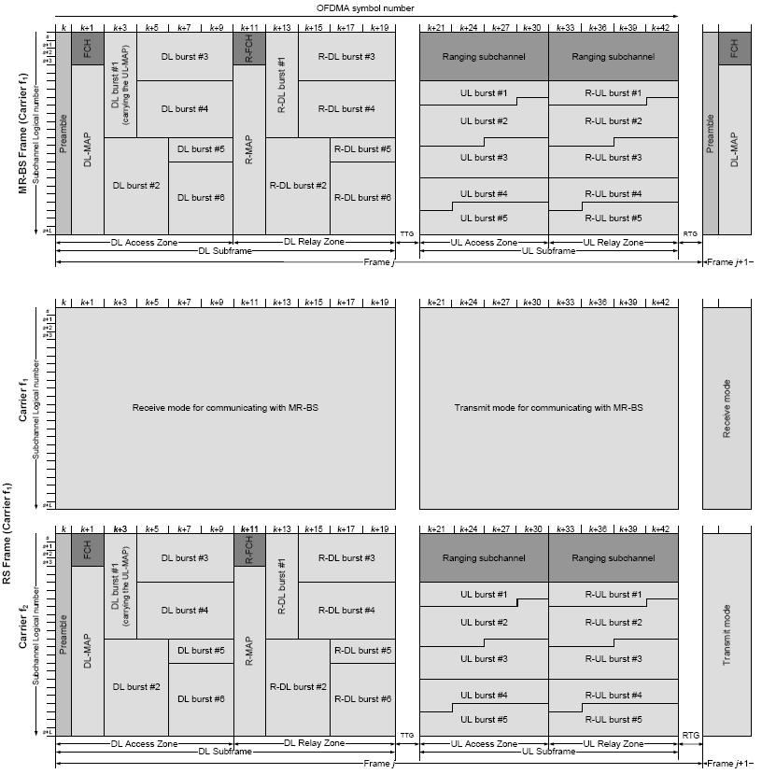

Figure 270c –Example of minimum configuration for a dual radio non-transparent simultaneous transmit and receive relay frame structure

Change the subcluase 11.8.3.7.22 as indicated:

11.8.3.7.22 MR PHY feature support

This TLV indicates the MR PHY features supported by the RS and the MR-BS.

Type | Length | Value | Scope
206 | 1 | Bit #0: Access zone preamble transmission support  Bit #1: MBS Data Synchronization with pre-defined relative transmission time (6.3.23.3)  Bit #2: MBS data synchronization with target transmission time (6.3.23.3)  Bit #3: cooperative relay support  Bit #4: support of a second carrier frequency at RS (see 8.4.4.7.2.2)  Bit #5: support STR dual radio RS operation (see 8.4.4.7.2.3)  Bits #4-7: Maximum number of HARQ channels supported in UL_DCH | SBC-REQ  SBC-RSP

If RS supports more than one carrier, Bit #4 shall be set to 1. If RS only support one carrier, Bit#4 shall be set to 0. Bit #4 can only be set to 1 if bit #0 is set to 1.
If RS supports STR and TTR, Bit #5 shall be set to 1. If RS only supports TTR, Bit #5 shall be set to 0.
Bit #5 can only be set to 1 if both bits#0 and #4 are set to 1 if bit #0 is set to 1.
If either bit #4 or bit #5 is set to 1, actual operation of an RS shall follow the setting of bit #9 and bit #10 in RS_Config-CMD which is described in subclause 11.25.1.

Change the subcluase 11.25.1 as indicated:

11.25.1 Generic configuration

This field may be used by an MR-BS to configure one or a group of RSs.

Name | Type | Length | Value | Scope
RS operational mode | 1 | 2 | Bit #0: RS scheduling mode, Bit#0=0, centralized  scheduling, Bit #0=1, distributed  scheduling  Bit #1: RS security mode, Bit #1=0, centralized  security, Bit #1=1, distributed security  Bit #2:0 = shared BSID with other access  stations, 1 = unique BSID  Bit #3:Embedded path management  Bit #4:Explicit path management  Bit #5:Burst-based forwarding  Bit #6:Tunnel mode  Bit #7:Local CID allocation mode  Bit #8: Superordinate RS of an RS group  Bit #9: Use a different carrier frequency for  subordinate station communication at the  RS  Bit #10: Operate in STR relaying dual radio mode  Bit #11~15: reserved | RS_Config-CMD
Preamble index | 2 | 1 | The preamble index assigned to the RS. | RS_Config-CMD

When Bit#9 is set to 0, RS shall use the same carrier frequency for communication with superordinate station and for communication with subordinate station(s).
When Bit#9 is set to 1, RS shall use different carrier frequencies for communication with superordinate station and for communication with subordinate station(s).
When Bit#10 is set to 0, RS shall operate in TTR relaying mode.
When Bit#10 is set to 1, RS shall operate in STR relaying mode.

