Project | IEEE 802.16 Broadband Wireless Access Working Group <http://ieee802.org/16>
Title | Proposed Signaling Overhead reduction and Text Refinements to Sections 15.3.5 (Downlink Physical Structure) of IEEE 802.16m AWD -- AWD-IMDG Clean up version
Date Submitted | 2009-07-06
Source(s) | Debdeep Chatterjee, Jong-Kae Fwu, Hujun Yin  Intel Corporation  HanGyu Cho  LG Electronics  Taeyoung Kim, Jeongho Park  Samsung Electronics  Yanfeng Guan, Huiying Fang  ZTE Corporation  Chia-Lung Tsai, Yu-Tao Hsieh, Chang-Lan Tsai, Zheng Yan-Xiu  ITRI  Gye-Tae Gil  KT Corporation | E-mail: jong-kae.fwu@intel.com  E-mail: hgcho@lge.com  *<http://standards.ieee.org/faqs/affiliationFAQ.html>
Re: | Category: AWD comments / Area: Chapter 15.3.5 (DL-PHY) “Comments on AWD 15.3.5 DL-PHY” 802.16m amendment working document
Abstract | Proposed text for the DL Physical Structure in the draft P802.16m amendment
Purpose | Discussion and adoption by TGm
Notice | This document does not represent the agreed views of the IEEE 802.16 Working Group or any of its subgroups. It represents only the views of the participants listed in the “Source(s)” field above. It is offered as a basis for discussion. It is not binding on the contributor(s), who reserve(s) the right to add, amend or withdraw material contained herein.
Release | The contributor grants a free, irrevocable license to the IEEE to incorporate material contained in this contribution, and any modifications thereof, in the creation of an IEEE Standards publication; to copyright in the IEEE’s name any IEEE Standards publication even though it may include portions of this contribution; and at the IEEE’s sole discretion to permit others to reproduce in whole or in part the resulting IEEE Standards publication. The contributor also acknowledges and accepts that this contribution may be made public by IEEE 802.16.
Patent Policy | The contributor is familiar with the IEEE-SA Patent Policy and Procedures:  <http://standards.ieee.org/guides/bylaws/sect6-7.html#6> and <http://standards.ieee.org/guides/opman/sect6.html#6.3>.  Further information is located at <http://standards.ieee.org/board/pat/pat-material.html> and <http://standards.ieee.org/board/pat>.

Proposed Signaling Overhead reduction and Text Refinements to Sections 15.3.5 (DL PHY Structure) of IEEE 802.16m AWD -- AWD-IMDG
Debdeep Chatterjee, Jong-Kae Fwu, Hujun Yin
Intel
HanGyu Cho
LG Electronics
Taeyoung Kim, Jeongho Park
Samsung Electronics
Yanfeng Guan, Huiying Fang
ZTE Corporation
Chia-Lung Tsai, Yu-Tao Hsieh, Chang-Lan Tsai, Zheng Yan-Xiu
ITRI
Gye-Tae Gil
KT Corporation

Introduction
As a decision from the IM DG, a seperate subteam is formed to address the PHY and FFR jointly related issues with the goal to produce a clean-up version of AWD PHY Structure proposal. The proposal will refine the current AWD PHY structure related text and include decisions made by the group related to the PHY signaling, overhead reduction, text clean up, etc.

Plenty of discussions in the IM DG related to the PHY Structure related signaling by both emails and conference calls. Those signalings are mainly related to different frequency partitions, CRU/DRU partition, signaling overhead reduction, etc. The final decisions are captured in this proposal.

This contribution provides updated amendment text for the DL physical structure in the Advanced Air Interface to be included in Section 15 of the IEEE 802.16m Amendment Working Document [1]. The proposed update is developed so that it can be readily combined with IEEE 802.16m-09/0010r2 [1], it is compliant to the 802.16m SRD [2] and the 802.16m SDD [3], and it follows the style and format guidelines in [4].

References
[1] IEEE 802.16m-09/0010r2, “Part 16: Air Interface for Fixed and Mobile Broadband Wireless Access Systems,” Jun. 2009.
[2] IEEE 802.16m-07/002r8, “IEEE 802.16m System Requirements Document,” Jan. 2009.
[3] IEEE 802.16m-08/003r9a, “IEEE 802.16m System Description Document,” May 2009.
[4] IEEE 802.16m-08/043, “Style guide for writing the IEEE 802.16m amendment”

Proposed Amendment Text
The following text (including tables and figures) is proposed to replace the current contents of Chapter 15.3.5 of the IEEE 802.16m Amendment Working Document [1].
[ ------------------- Proposed Text Starts --------------------]

15.3.5 Downlink physical structure

15.3.5 Downlink physical structure

Each downlink subframe is divided into 4 or fewer frequency partitions; each partition consists of a set of physical resource units across the total number of OFDMA symbols available in the subframe. Each frequency partition can include contiguous (localized) and/or non-contiguous (distributed) physical resource units. Each frequency partition can be used for different purposes such as fractional frequency reuse (FFR) or multicast and broadcast services (MBS). Figure 449 illustrates the downlink physical structure in the example of two frequency partitions with frequency partition 2 including both contiguous and distributed resource allocations, where Sc stands for subcarrier.
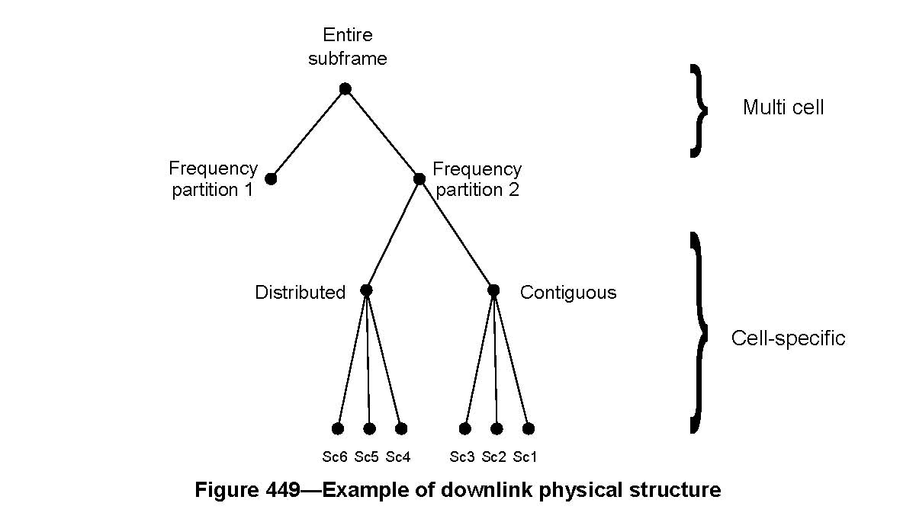15.3.5.1 Physical and logical resource unit

A physical resource unit (PRU) is the basic physical unit for resource allocation that comprises P_{sc} consecutive subcarriers by N_{sym} consecutive OFDMA symbols. P_{sc} is 18 subcarriers and N_{sym} is 6, 7, and 5 OFDMA symbols for type-1, type-2, and type-3 subframes, respectively. A logical resource unit (LRU) is the basic logical unit for distributed and localized resource allocations. An LRU is P_{sc}·N_{sym} subcarriers for type-1 subframes, type-2 subframes, and type-3 subframes. The LRU includes the pilots (as defined in 15.3.5.4) that are used in a PRU. The effective number of subcarriers in an LRU depends on the number of allocated pilots.

15.3.5.1.1 Distributed logical resource unit

The distributed logical resource unit (DLRU) contains a group of subcarriers that are spread across the distributed resource allocations within a frequency partition. The size of the DRU equals the size of PRU, i.e., P_{sc} subcarriers by N_{sym} OFDMA symbols. The minimum unit for forming the DLRU is equal to a pair of subcarriers, called tone-pair, as defined in (15.3.5.3.2). The DLRUs are obtained by subcarrier permuting the distributed resource units (DRUs).

15.3.5.1.2 Contiguous logical resource unit

The localized logical resource unit, also known as contiguous logical resource unit (CLRU) contains a group of subcarriers that are contiguous across the localized resource allocations. The size of the CLRU equals the size of the PRU, i.e., P_{sc} subcarriers by N_{sym} OFDMA symbols. The CLRUs are obtained from direct mapping of contiguous resource units (CRUs). Two types of CLRUs are supported according to the two types of CRUs, i.e. subband and miniband based CRUs.

15.3.5.2 Multi-cell resource mapping

15.3.5.2.1 Subband partitioning

The PRUs are first subdivided into subbands and minibands where a subband comprises of N₁ adjacent PRUs and a miniband comprises of N₂ adjacent PRUs, where N₁=4 and N₂=1. Subbands are suitable for frequency selective allocations as they provide a contiguous allocation of PRUs in frequency. Minibands are suitable for frequency diverse allocation and are permuted in frequency.

The number of subbands is denoted by K_{SB}. The number of PRUs allocated to subbands is denoted by L_{SB}, where L_{SB} = N₁· K_{SB}. A 5, 4 or 3-bit field called Downlink Subband Allocation Count (DSAC) determines the value of K_{SB} depending on system bandwidth. The DSAC is transmitted in the SFH. The remaining PRUs are allocated to minibands. The number of minibands in an allocation is denoted by K_{MB}. The number of PRUs allocated to minibands is denoted by L_{MB}, where L_{MB} = N₂· K_{MB}. The total number of PRUs is denoted as N_{PRU} where N_{PRU} = L_{SB} + L_{MB}. The maximum number of subbands that can be formed is denoted as N_{sub} where 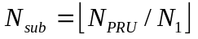.

Tables 649 through 651 show the mapping between DSAC and K_{SB} for the 20MHz, 10MHz, and 5MHz bands, respectively.

Table 649—Mapping between DSAC and K_{SB} for 20MHz

DSAC | # of subbands allocated (K_{SB}) | DSAC | # of subbands allocated (K_{SB})
0 | 0 | 16 | 16
1 | 1 | 17 | 17
2 | 2 | 18 | 18
3 | 3 | 19 | 19
4 | 4 | 20 | 20
5 | 5 | 21 | 21
6 | 6 | 22 | N. A.
7 | 7 | 23 | N. A.
8 | 8 | 24 | N. A.
9 | 9 | 25 | N. A.
10 | 10 | 26 | N. A.
11 | 11 | 27 | N. A.
12 | 12 | 28 | N. A.
13 | 13 | 29 | N. A.
14 | 14 | 30 | N. A.
15 | 15 | 31 | N. A.

Table 650—Mapping between DSAC and K_{SB} for 10MHz

DSAC | # of subbands allocated (K_{SB}) | DSAC | # of subbands allocated (K_{SB})
0 | 0 | 8 | 8
1 | 1 | 9 | 9
2 | 2 | 10 | N. A.
3 | 3 | 11 | N. A.
4 | 4 | 12 | N. A.
5 | 5 | 13 | N. A.
6 | 6 | 14 | N. A.
7 | 7 | 15 | N. A.

Table 651—Mapping between DSAC and K_{SB} for 5MHz

DSAC | # of subbands allocated (K_{SB}) | DSAC | # of subbands allocated (K_{SB})
0 | 0 | 4 | N. A.
1 | 1 | 5 | N. A.
2 | 2 | 6 | N. A.
3 | 3 | 7 | N. A.

PRUs are partitioned and reordered into two groups: subband PRUs and miniband PRUs, denoted by PRU_{SB} and PRU_{MB}, respectively. The set of PRU_{SB} is numbered from 0 to (L_{SB} – 1). The set of PRU_{MB} are numbered from 0 to (L_{MB} – 1). Equation (174) defines the mapping of PRUs to PRU_{SB}s. Equation (176) defines the mapping of PRUs to PRU_{MB}s. Figure 450 illustrates the mapping from PRU to PRU_{SB} and PRU_{MB} for a 10 MHz bandwidth with K_{SB} equal to 7.

(174)

where:
(175)
where {x} mod {y} is modulus when dividing x by y, and GCD(x,y) is the greatest common divisor of x and y.

(176)

where:

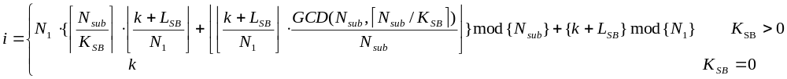 (177)

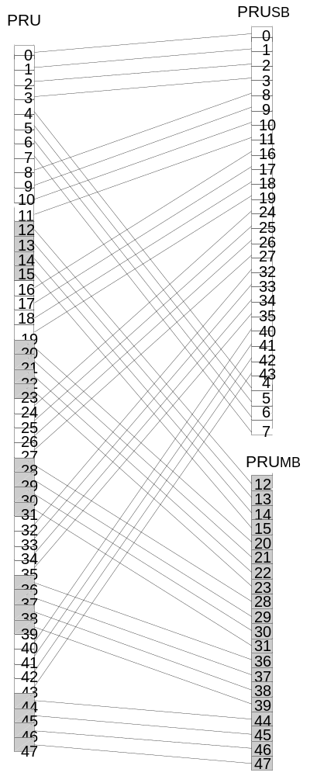
Figure 450 - PRU to PRU_{SB} and PRU_{MB} mapping for BW=10 MHz, K_{SB}=7.

15.3.5.2.2 Miniband permutation

The miniband permutation maps the PRU_{MB}s to Permuted PRU_{MB}s (PPRU_{MB}s) to insure frequency diverse PRUs are allocated to each frequency partition. Equation (178) describes the mapping from PRU_{MB} to PPRU_{MB}s:

(178)

where:
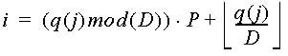 (179)
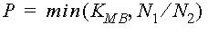 (180)
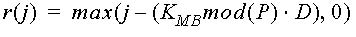 (181)
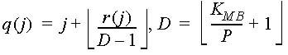 (182)

Figure 451 depicts the mapping from PRUs to PRU_{SB} and PPRU_{MB}.

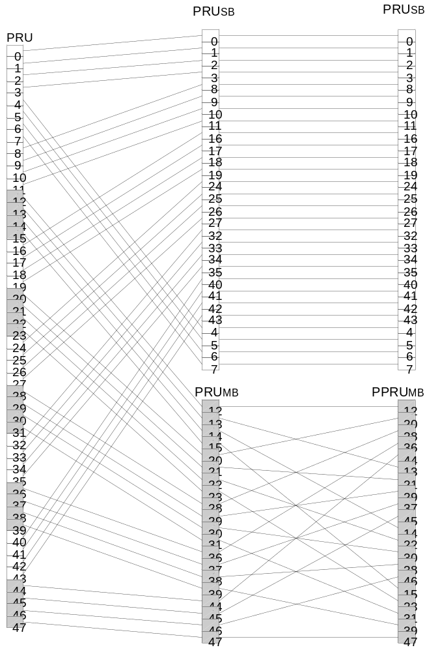
Figure 451 - Mapping from PRUs to PRU_{SB} and PPRU_{MB} for BW=10 MHz, K_{SB}=7.

15.3.5.2.3 Frequency partitioning

The PRU_{SB}s and PPRU_{MB}s are allocated to one or more frequency partitions. By default, only one partition is present. The maximum number of frequency partitions is 4. The frequency partition configuration is transmitted in the SFH in a 4 or 3-bit field called the Downlink Frequency Partition Configuration (DFPC) depending on system bandwidth. The Frequency Partition Count (FPCT) defines the number of frequency partitions. The Frequency Partition Size (FPS_{i}) defines the number of PRUs allocated to FP_{i}. FPCT and FPS_{i} are determined from DFPC as shown in Table 652 through Table 654. A 3, 2, or 1-bit called the Downlink Frequency Partition Subband Count (DFPSC) defines the number of subbands allocated to FP_{i}, i>0.

Table 652—Mapping between DFPC and frequency partitioning for 20MHz

DFPC | Freq. Partitioning  (FP₀:FP₁:FP₂:FP₃) | FPCT | FPS₀ | FPS_{i} (i>0)
0 | 1 : 0 : 0 : 0 | 1 | N_{PRU} | 0
1 | 0 : 1 : 1 : 1 | 3 | 0 | N_{PRU} * 1/3
2 | 1 : 1 : 1 : 1 | 4 | N_{PRU} * 1/4 | N_{PRU} * 1/4
3 | 3 : 1 : 1 : 1 | 4 | N_{PRU} * 1/2 | N_{PRU} * 1/6
4 | 5 : 1 : 1 : 1 | 4 | N_{PRU} * 5/8 | N_{PRU} * 1/8
5 | 9 : 1 : 1 : 1 | 4 | N_{PRU} * 9/12 | N_{PRU} * 1/12
6 | 9 : 5 : 5 : 5 | 4 | N_{PRU} * 3/8 | N_{PRU} * 5/24
7-15 | Reserved

Table 653—Mapping between DFPC and frequency partitioning for 10MHz

DFPC | Freq. Partitioning  (FP₀:FP₁:FP₂:FP₃) | FPCT | FPS₀ | FPS_{i} (i>0)
0 | 1 : 0 : 0 : 0 | 1 | N_{PRU} | 0
1 | 0 : 1 : 1 : 1 | 3 | 0 | N_{PRU} * 1/3
2 | 1 : 1 : 1 : 1 | 4 | N_{PRU} * 1/4 | N_{PRU} * 1/4
3 | 3 : 1 : 1 : 1 | 4 | N_{PRU} * 1/2 | N_{PRU} * 1/6
4 | 5 : 1 : 1 : 1 | 4 | N_{PRU} * 5/8 | N_{PRU} * 1/8
5 | 9 : 5 : 5 : 5 | 4 | N_{PRU} * 3/8 | N_{PRU} * 5/24
6-7 | Reserved

Table 654—Mapping between DFPC and frequency partitioning for 5MHz

DFPC | Freq. Partitioning  (FP₀:FP₁:FP₂:FP₃) | FPCT | FPS₀ | FPS_{i} (i>0)
0 | 1 : 0 : 0 : 0 | 1 | N_{PRU} | 0
1 | 0 : 1 : 1 : 1 | 3 | 0 | N_{PRU} * 1/3
2 | 1 : 1 : 1 : 1 | 4 | N_{PRU} * 1/4 | N_{PRU} * 1/4
3 | 3 : 1 : 1 : 1 | 4 | N_{PRU} * 1/2 | N_{PRU} * 1/6
4 | 9 : 5 : 5 : 5 | 4 | N_{PRU}*3/8 | N_{PRU}*5/24
5-7 | Reserved

The number of subbands in i^{th} frequency partition is denoted by K_{SB,FPi}. The number of minibands is denoted by K_{MB,FPi}, which is determined by the FPS_{i} and DFPSC fields. The number of subband PRUs in each frequency partition is denoted by L_{SB,FPi}, which is given by L_{SB,FPi} = N₁·K_{SB,FPi}. The number of miniband PRUs in each frequency partition is denoted by L_{MB,FPi}, which is given by L_{MB,FPi} = N₂·K_{MB,FPi}. The number of subbands for each frequency partition when FPCT = 1 or FPCT = 4, is given by equation (183).
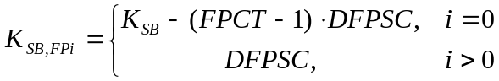 (183)
When DFPC = 1 and FPCT = 3, the number of subbands in FP_{i} (for i>0) is given by K_{SB,FPi} = DFPSC. The number of minibands for each frequency partition is given by equation (184).
(184)

The mapping of subband PRUs and miniband PRUs to the frequency partition i is given by Equation (185):
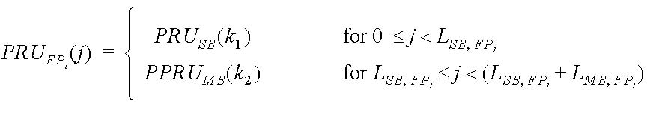 (185)
where

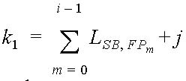

and

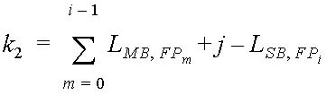.

Figure 452 depicts the frequency partitioning for BW=10MHz, K_{SB}=7, FPCT=4, FPS₀=FPS_{i}=12, and DFPSC=2.

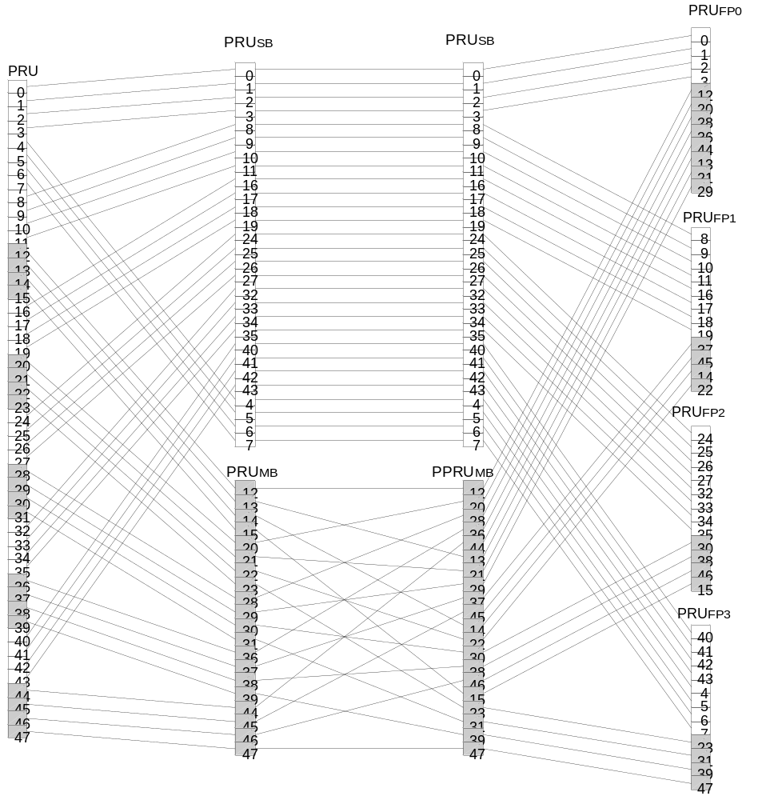
Figure 452 - Frequency partition for BW=10 MHz, K_{SB}=7, FPCT=4, FPS₀= FPS_{i}=12, DFPSC=2

15.3.5.3 Cell-specific resource mapping

PRU_{FPi}s are mapped to LRUs. All further PRU and subcarrier permutation are constrained to the PRUs of a frequency partition.

15.3.5.3.1 CRU/DRU allocation

The partition between CRUs and DRUs is done on a sector specific basis. Let L_{SB,FPi} and L_{MB,FPi} denote the numbe of allocated subband CRUs and miniband CRUs for FP_{i} (i > 0). The number of total allocated subband and miniband CRUs, in units of a subband (i.e. N₁ PRUs), for FP_{i} (i > 0) is given by the downlink CRU allocation size, DCAS_{i.} The numbers of subband-based and miniband-based CRUs in FP₀ are given by DCAS_{SB,0} and DCAS_{MB,0}, in units of a subband and miniband, respectively.

For FP₀, the value of DCAS_{SB,0} is explicitly signaled in the SFH as a 5, 4 or 3-bit field. A 5, 4 or 3-bit Downlink miniband-based CRU allocation size (DCAS_{MB,0}) is sent in the SFH only for partition FP₀, depending on system bandwidth. The mapping between DCAS_{MB,0} and the number of miniband-based CRUs for FP₀ is shown in the Tables xx through zz for system bandwidths of 20MHz, 10MHz, and 5MHz respectively.

Table xx - Mapping between DCAS_{MB,0} and number of miniband-based CRUs for FP₀ for 20MHz

DCAS_{MB,0} | # of miniband-based CRU for FP₀ (i.e. L_{MB,FP0}) | DCAS_{MB,0} | # of miniband-based CRU for FP₀ (i.e. L_{MB,FP0})
0 | 0 | 16 | 16
1 | 1 | 17 | 17
2 | 2 | 18 | 18
3 | 3 | 19 | 19
4 | 4 | 20 | 20
5 | 5 | 21 | 21
6 | 6 | 22 | 22
7 | 7 | 23 | 23
8 | 8 | 24 | 24
9 | 9 | 25 | 28
10 | 10 | 26 | 32
11 | 11 | 27 | 36
12 | 12 | 28 | 40
13 | 13 | 29 | 44
14 | 14 | 30 | 48
15 | 15 | 31 | 52

Table yy - Mapping between DCAS _{MB,0} and number of miniband-based CRUs for FP₀ for 10MHz

DCAS_{MB,0} | # of miniband-based CRU for FP₀ (i.e. L_{MB,FP0}) | DCAS_{MB,0} | # of miniband-based CRU for FP₀ (i.e. L_{MB,FP0})
0 | 0 | 8 | 8
1 | 1 | 9 | 9
2 | 2 | 10 | 10
3 | 3 | 11 | 11
4 | 4 | 12 | 12
5 | 5 | 13 | 16
6 | 6 | 14 | 20
7 | 7 | 15 | 24

Table zz - Mapping between DCAS _{MB,0} and number of miniband-based CRUs for FP₀ for 5MHz

DCAS_{MB,0} | # of miniband-based CRU for FP₀ (i.e. L_{MB,FP0}) | DCAS_{MB,0} | # of miniband-based CRU for FP₀ (i.e. L_{MB,FP0})
0 | 0 | 4 | 4
1 | 1 | 5 | 6
2 | 2 | 6 | 8
3 | 3 | 7 | 10

For FP_{i} (i > 0), only one value for DCAS_{i} is explicitly signaled for all i > 0, in the SFH as a 3, 2 or 1-bit field to signal the same numbers of allocated CRUs for FP_{i} (i>0).

For FP_{i} (i > 0), the number of subband CRUs (L_{SB,FPi})and miniband CRUs (L_{MB,FPi}) are derived using equations XYZ and YYZ respectively.

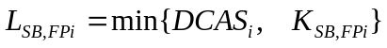 (XYZ)

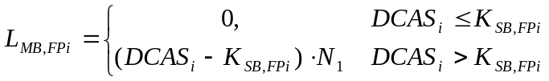 (YYZ)

The total number of CRUs in frequency partition FP_{i}, for 0 ≤ i < FPCT, is denoted by L_{CRU,FPi}, where

(186)

The number of DRUs in each frequency partition is denoted by L_{DRU,FPi}, where

and FPS_{i} is the number of PRUs allocated to FP_{i}.

The mapping from PRU_{FPi} to CRU_{FPi} (for 0 ≤ i < FPCT) is given by:

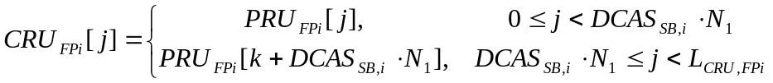 (187)

where k = s[j - DCAS_{SB,i} · N₁].
s[] is the CRU/DRU allocation sequence defined in Equation (188) and 0 ≤ s[j] < FPS_{i} -DCAS_{SB,i} · N₁.

(188)

In Equation (188), PermSeq() is the permutation sequence of length (FPS_{i}-DCAS_{SB,i}·N₁) and is determined by SEED = {IDcell*343} mod 2¹⁰. The permutation sequence is generated by the random sequence generation algorithm specified in Section 15.3.5.3.3. DL_PermBase is an integer ranging from 0 to 31(TBD), which is set to preamble IDcell.

The mapping of PRU_{FPi} to DRU_{FPi} is given by:

(189)

where k = s[j + L_{CRU,FPi} - DCAS_{SB,i} · N₁].

Figure xxx presents an example to illustrate the various steps of subband partitioning, miniband permutation, frequency partitioning, and CRU/DRU allocation for the case of 10MHz system bandwidth. For this example, K_{SB} = DSAC = 7, FPCT = 4, FPS_{i} = 12 (for i≥0), DFPSC = 2, DCAS_{SB,0} = 1, DCAS_{MB,0} = 2, and DCAS_{i}=2.

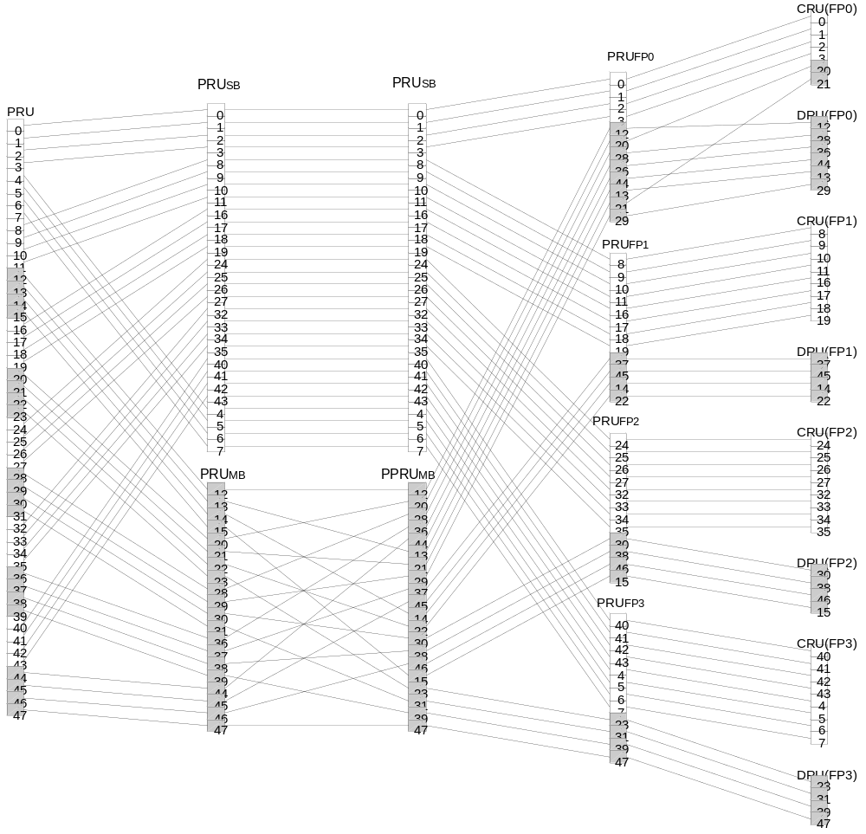
Figure xxx - CRU/DRU allocation for BW=10 MHz, K_{SB} = DSAC = 7, FPCT = 4, FPS_{i} = 12 (for i≥0), DFPSC = 2, DCAS_{SB,0} = 1, DCAS_{MB,0} = 2, and DCAS_{i}=2

15.3.5.3.2 Subcarrier permutation

The subcarrier permutation defined for the DL distributed resource allocations within a frequency partition spreads the subcarriers of the DRU across the whole distributed resource allocations. The granularity of the subcarrier permutation is equal to a pair of subcarriers.
After mapping all pilots, the remaining used subcarriers are used to define the distributed LRUs. To allocate the LRUs, the remaining subcarriers are paired into contiguous tone-pairs. Each LRU consists of a group of tone-pairs.

Let L_{SC,l} denote the number of data subcarriers in l^{th} OFDMA symbol within a PRU, i.e., L_{SC,l} = P_{sc} - n_{l}, where n_{l} denotes the number of pilot subcarriers in the l^{th} OFDMA symbol within a PRU. Let L_{SP,l} denote the number of data subcarrier-pairs in the l^{th} OFDMA symbol within a PRU and is equal to L_{SC,l}/2. The permutation sequence PermSeq() is defined in Section 15.3.5.3.3. The DL subcarrier permutation is performed as follows:

For each l^{th} OFDMA symbol in the subframe:

1) Allocate the n_{l} pilots within each DRU as described in section 15.3.5.4. Denote the data subcarriers of DRU_{FPi}[j] in the l^{th} OFDMA symbol as 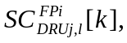 for 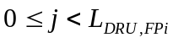 and 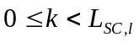.

2) Renumber the L_{DRU, FPi} · L_{SC,l} data subcarriers of the DRUs in order, from 0 to L_{DRU,,FPi} · L_{SC,l} - 1. Group these contiguous and logically renumbered subcarriers into L_{DRU,FPi} · L_{SP,l} pairs and renumber them from 0 to L_{DRU,FPi} · L_{SP,l} - 1. The renumbered subcarrier pairs in the l^{th} OFDMA symbol are denoted by RSP_{FPi,l}.
where 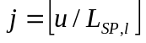 and 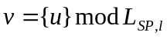.

3) Apply the subcarrier permutation formula Equation (190) to map RSP_{FPi,l} into the s^{th} distributed LRUs s = 0,1,..., L_{DRU,FPi} - 1. The subcarrier permutation formula is given by
(190)
where
—
— 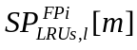 is the m^{th} subcarrier pair in the l^{th} OFDMA symbol in the s^{th} distributed LRU of the t^{th} subframe
— m is the subcarrier pair index, 0 to L_{SP,l}-1
— l is the OFDMA symbol index, 0 to N_{sym}-1
— s is the distributed LRU index, 0 to L_{DRU,FPi}-1
— PermSeq() is the permutation sequence of length L_{DRU,FPi} and is determined by SEED={IDcell*343} mod 2¹⁰. The permutation sequence is generated by the random sequence generation algorithm specified in Section 15.3.5.3.3
— g(PermSeq(),s,m,l) is a function with value from the set [0, L_{DRU,FPi}-1], which is defined according to Equation (191)
— f(m,s)=(m+13*s) mod L_{SP,l}.

(191)

15.3.5.3.3 Random sequence generation

The permutation sequence generation algorithm with 10-bit SEED (Sn-10, Sn-9,…,Sn-1) generates a permutation sequence of size M as described below:

1) Initialization
a) Initialize the variables of the first order polynomial equation with the 10-bit seed, SEED. Set d₁ = floor(SEED/2⁵) + 1 and d₂ = SEED mod 2⁵.
b) Initialize the maximum iteration number, N=4.
c) Initialize an array A with size M with the numbers 0, 1, … , M-1 (i.e. A[0]=0, A[1]=1, … , A[M-1]=M-1).
d) Initialize the counter i to M-1.
e) Initialize x to -1.

2) Repeat the following steps if i > 0
a) Initialize the counter j to 0.
b) Increment x and j by 1.
c) Calculate the output variable of y = {(d₁*x + d₂) mod 1031} mod M.
d) Repeat the above steps 2.b and 2.c if y ≥ i and j<N.
e) If y ≥ i, set y = y mod i.
f) Swap A[i] and A[y].
g) Decrement i by 1.

3) PermSeq[i] = A[i], where 0 ≤ i < M.

15.3.5.3.5 Formation of MLRU

To form MLRUs for the assignment A-MAP,

1) Renumber all tone pairs in the distributed LRUs in the A-MAP region in a time first manner. Assuming that each LRU has L_{SP} tone-pairs per symbol, the renumbered A-MAP tone-pairs are denoted by RMP[u], where u ranges from 0 to L_{AMAP} · N_{sym} · L_{SP} - 1.
L_{AMAP} is the number of LRU allocated to the A-MAP.

2) A distributed tone-pair, 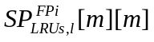, is mapped to RMP[u], where u = s · N_{sym} · L_{SP} + m · N_{sym} + l. is the tone-pair index of the m^{th} tone-pair in the l^{th} OFDMA symbol in the s^{th} distributed LRU of frequency partition i as defined in Section 15.3.5.3.2.

3) Suppose RMP[v] is the first tone-pair for allocation A-MAP. The k^{th} MLRU is formed by tone-pairs from RMP[v + k · N_{MLRU} / 2] to RMP[v + (k+1) · N_{MLRU} / 2 - 1], where N_{MLRU} is the size of an MLRU.

15.3.5.3.6 Logical Resource Unit Mapping

Both contiguous and distributed LRUs are supported in the downlink. The CRUs are directly mapped into contiguous LRUs, including subband LRUs and miniband LRUs. The DRUs are permuted as described in 15.3.5.3.2 to form distributed LRUs.

15.3.5.4 Pilot structure

The transmission of pilot subcarriers in the downlink is necessary for enabling channel estimation, measurements of channel quality indicators such as the SINR, frequency offset estimation, etc. To optimize the system performance in different propagation environments and applications, IEEE 802.16m supports both common and dedicated pilot structures. The categorization in common and dedicated pilots is done with respect to their usage. The common pilots can be used by all MSs. Dedicated pilots can be used with both localized and distributed allocations. The dedicated pilots are associated with a specific resource allocation, can be only used by the MSs allocated to said specific resource allocation, and therefore can be precoded or beamformed in the same way as the data subcarriers of the resource allocation. The pilot structure is defined for up to eight transmission (Tx) streams and there is a unified pilot pattern design for common and dedicated pilots. There is equal pilot density per Tx stream, while there is not necessarily equal pilot density per OFDMA symbol of the downlink subframe. Further, within the same subframe there is equal number of pilots for each PRU of a data burst assigned to one MS.

15.3.5.4.1 Pilot patterns

Pilot patterns are specified within a PRU.

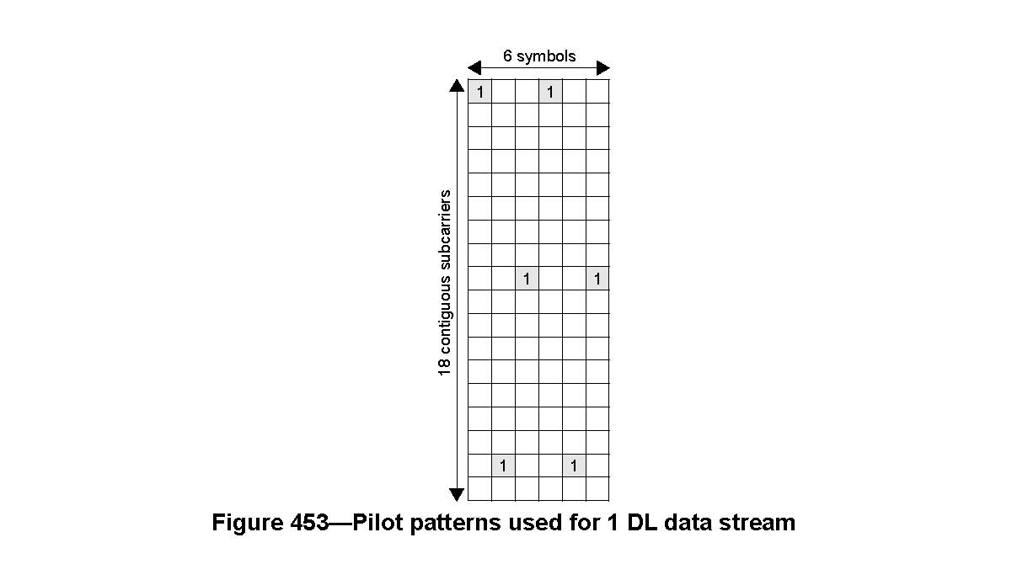

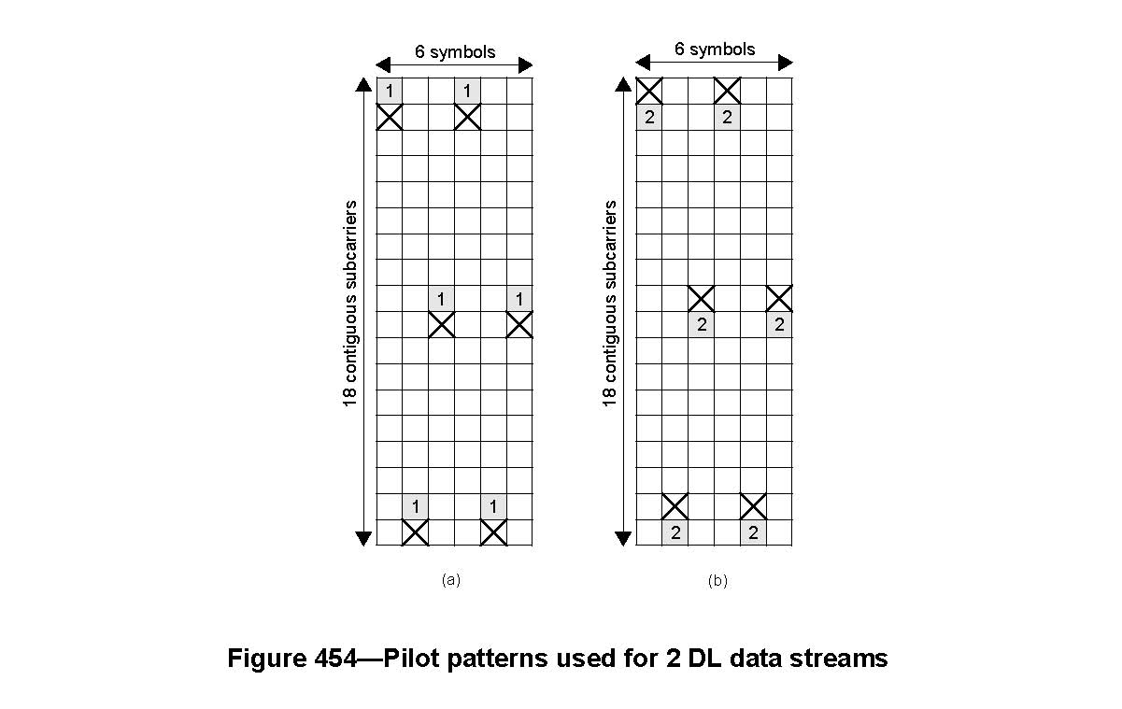
Base pilot patterns used for one and two DL data streams in dedicated and common pilot scenarios are shown in Figure 453 and Figure 454 respectively, with the subcarrier index increasing from top to bottom and the OFDM symbol index increasing from left to right. The numbers on the pilot locations indicate the stream they correspond to. Subfigure (a) and Subfigure (b) in Figure 454 are used on DL data stream 1 and DL data stream 2, respectively, where ‘X’ stands for the null symbol, which means that no pilot or data is allocated on that time-frequency resource.
The interlaced pilot patterns are generated by cyclic shifting the base pilot patterns. The interlaced pilot patterns are used by different BSs for one and two streams. Interlaced pilot patterns for one stream is shown in Figure 455 and interlaced pilot patterns on stream 0 and stream 1 for two streams are shown in Figure 456and Figure 457, respectively. Each BS chooses one of the three pilot pattern sets (pilot pattern set 0, 1, and 2) as shown in Figure 455 and Figure 456. The index of the pilot pattern set used by a particular BS with Cell_ID = k is denoted by p_{k}. The index of the pilot pattern set is determined by the Cell_ID according to the following equation:

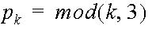

For the subframe consisting of 5 symbols, the last OFDM symbol in each pilot pattern set shown in Figure 454 is deleted. For the subframe consisting of 7 symbols, the first OFDM symbol in each pilot pattern set shown in Figure 454 is added as 7th symbol.

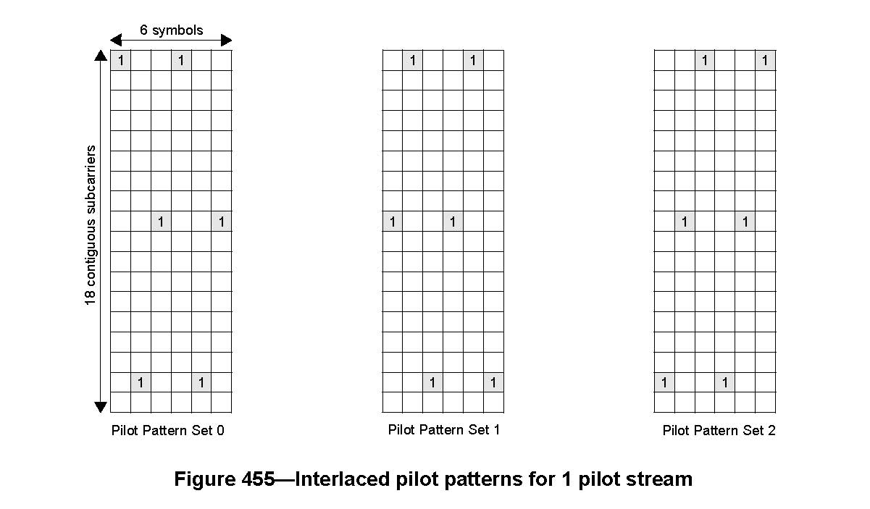

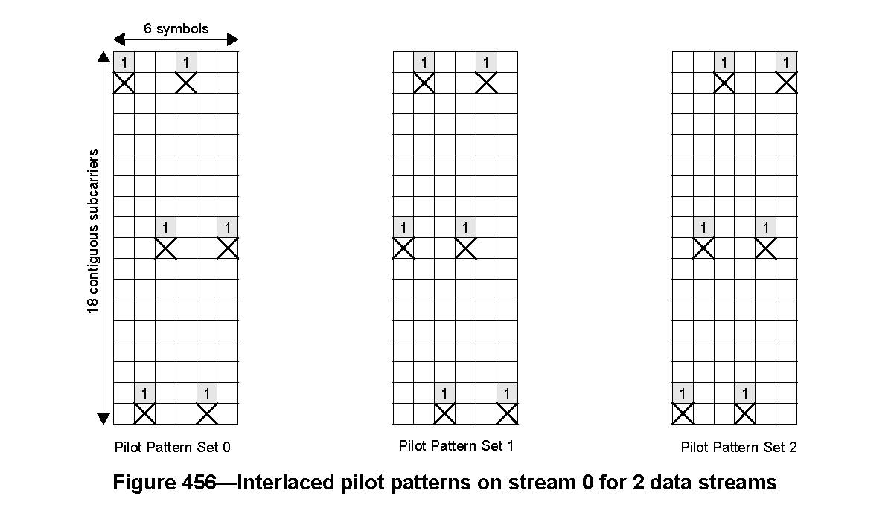

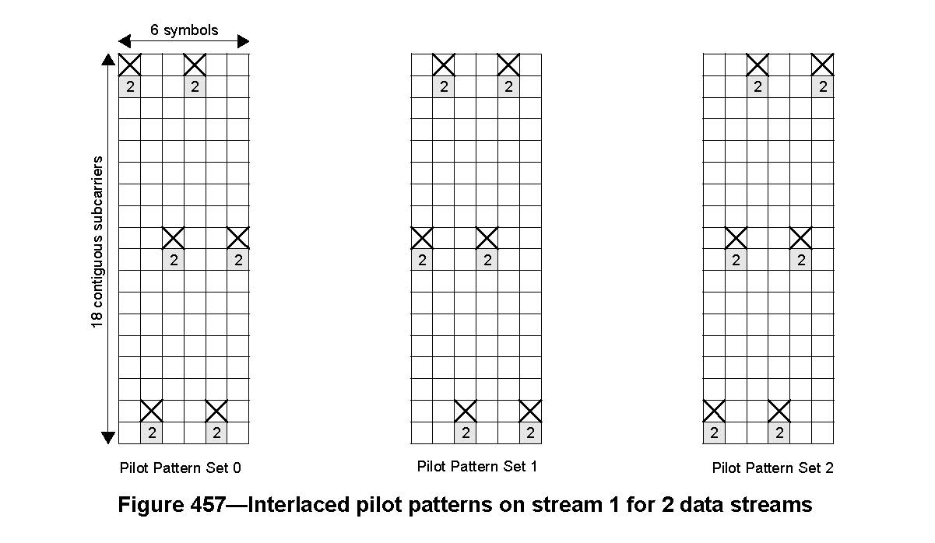
The pilot patterns on stream 0 - stream 3 for four pilot streams are shown in Figure 458 through Figure 461— respectively, with the subcarrier index increasing from top to bottom and the OFDM symbol index increasing from left to right. Subfigure (a) in Figure 458 through Figure 461— show the pilot pattern for four pilot streams in subframe with six OFDM symbols; Subfigure (b) in Figure 458 through Figure 461—show the pilot pattern for four pilot streams in subframe with five OFDM symbols; Subfigure (c) in Figure 458 through Figure 461— show the pilot pattern for four pilot streams in subframe with seven OFDM symbols.

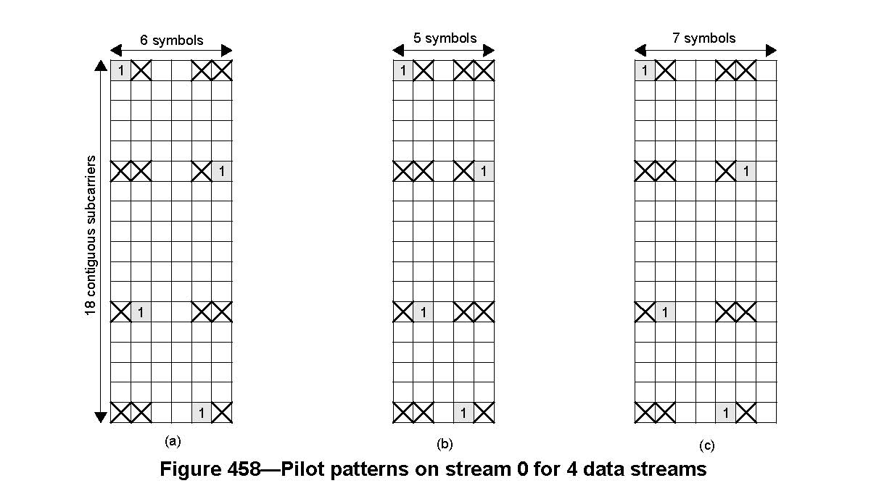

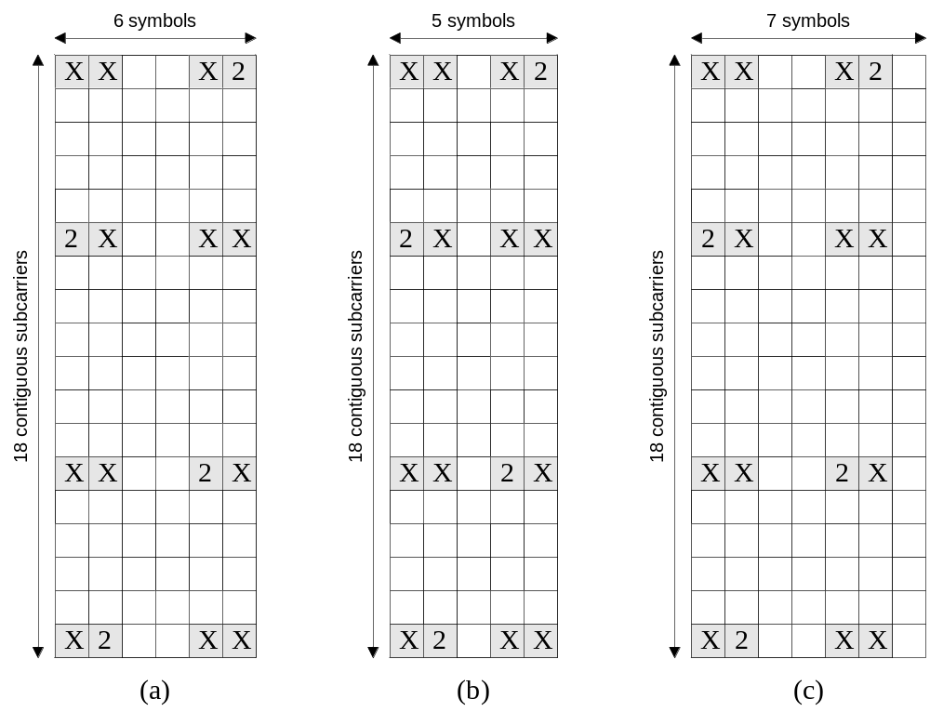
Figure 459 – Pilot patterns on stream 1 for 4 data streams

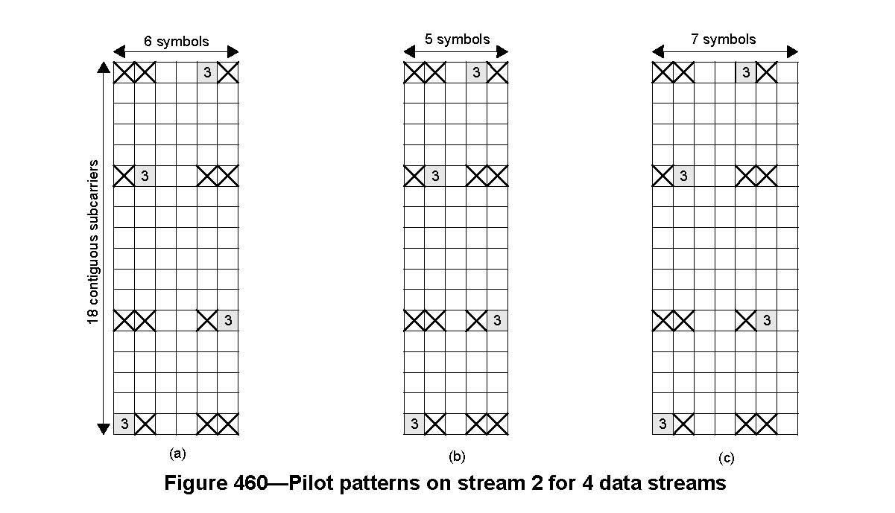

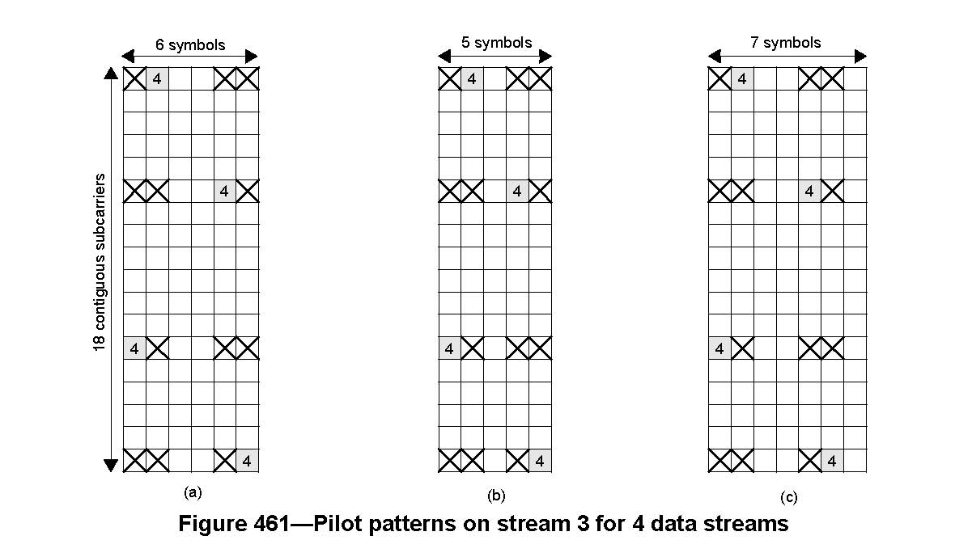

The pilot patterns for eight pilot streams are shown in Figure 462— with the subcarrier index increasing from top to bottom and the OFDM symbol index increasing from left to right. Subfigure (a) in Figure 462—shows the pilot pattern for eight pilot streams in subframewith six OFDM symbols; Subfigure (b) in Figure 462 shows the pilot pattern for eight pilot streams in subframewith five OFDM symbols; Subfigure (c) in Figure 462 shows the pilot pattern for eight pilot streams in subframewith seven OFDM symbols.

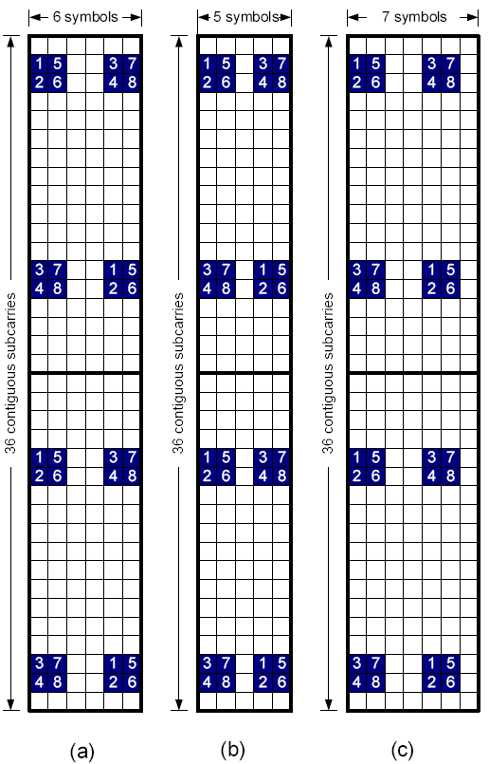
Figure 462 – Pilot patterns for 8 data streams

[ ------------------- Proposed Text Ends --------------------]

