Project | IEEE 802.16 Broadband Wireless Access Working Group <http://ieee802.org/16>
Title | Dynamic Multicast Service Support for the IEEE 802.16m E- MBS
Date Submitted | 2009-11-18
Source(s) | Yongjoo Tcha, Byung Moo Lee, Se-Jun Park, Seong-Choon Lee  KT  Youngsoo Yuk, Kiseon Ryu, Jeongki Kim  LG Electronics  Eunkyung Kim  ETRI  Kamran Etemad  Intel Corporation | E-mail: yjtcha@kt.com  Voice : +82-31-450-7808  E-mail: sixs@lge.com, ksryu@lge.com, chegal@lge.com  ekkim@etri.re.kr  Kamran.etemad@intel.com
Re: | IEEE P802.16m/D2 ( IEEE Letter Ballot Recirc #30a) (15.9 Support for Enhanced Multicast Broadcast Service)
Abstract | The contribution proposes the P802.16m/D2 Amendment text for E-MBS
Purpose | Proposed to be discussed and adopted by TGm for the P802.16m/D2Amendment text
Notice | This document does not represent the agreed views of the IEEE 802.16 Working Group or any of its subgroups. It represents only the views of the participants listed in the “Source(s)” field above. It is offered as a basis for discussion. It is not binding on the contributor(s), who reserve(s) the right to activate, amend or withdraw material contained herein.
Release | The contributor grants a free, irrevocable license to the IEEE to incorporate material contained in this contribution, and any modifications thereof, in the creation of an IEEE Standards publication; to copyright in the IEEE’s name any IEEE Standards publication even though it may include portions of this contribution; and at the IEEE’s sole discretion to permit others to reproduce in whole or in part the resulting IEEE Standards publication. The contributor also acknowledges and accepts that this contribution may be made public by IEEE 802.16.
Patent Policy | The contributor is familiar with the IEEE-SA Patent Policy and Procedures:  <http://standards.ieee.org/guides/bylaws/sect6-7.html#6> and <http://standards.ieee.org/guides/opman/sect6.html#6.3>.  Further information is located at <http://standards.ieee.org/board/pat/pat-material.html> and <http://standards.ieee.org/board/pat>.

Dynamic Multicast Service Support for the IEEE 802.16m E-MBS
Yongjoo Tcha, Byung Moo Lee, Se-jun Park and Seong-Choon Lee (KT),
Youngsoo Yuk, Kiseon Ryu and Jeongki Kim (LG Electronics),
Eunkyung Kim (ETRI), Kamran Etemad (Intel)

Problem definition

In current E-MBS, the contents are always transmitted through one or more MBS connections that would have been pre-established prior to the user(s) join and leave a MBS session at one or more MBS zone. It is defined as Static multicast service by WiMAX Forum. The Static multicast has strong points for mobility and macro diversity gain. But it is not efficient to manage radio resource; because the radio resources for MBS are pre-allocated and are always transmitted over the air regardless of existence of MS in a cell.
Figure 1 shows the static multicasting with one MBS zone. All cells in the MBS zone transmit their MBS bursts even though the numbers of MBS users are small and they are distributed in 4 of total 24 cells.

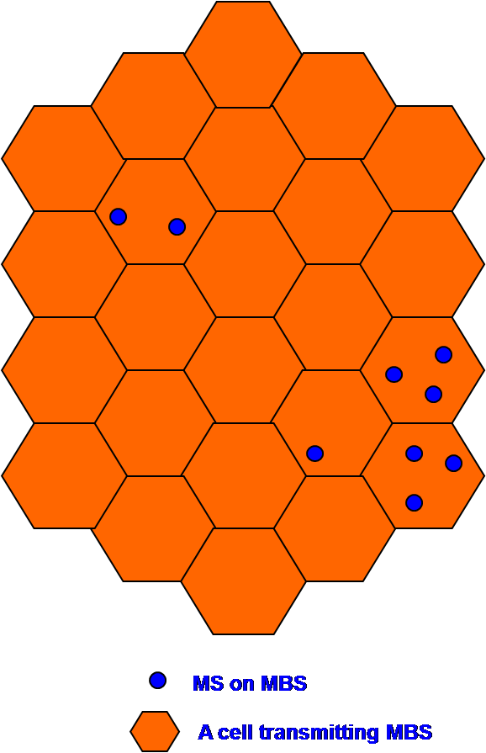
Figure 1 Example of static multicasting in an MBS zone

As compared with Static multicast, the contents are only transmitted through one or more MBS connections that would have been joined by the user(s) after user’s subscription at one or more MBS zone in Dynamic multicast environment. The Dynamic multicast has an advantage point for radio resource management for MBS. But it has some problems to support user’s mobility and macro-diversity among cells in an MBS zone. And in addition, inter cell interference might be happen if a neighbor cell does not transmit MBS bursts or allocates the MBS bursts to other unicast traffics. Figure 2 illustrates some problem in existing dynamic multicast service. Even though 4 cells out of total 24 cells transmit MBS bursts, it might be difficult to support mobility and macro diversity.
Therefore, some mechanism to solve the problems happening in dynamic multicast is needed.

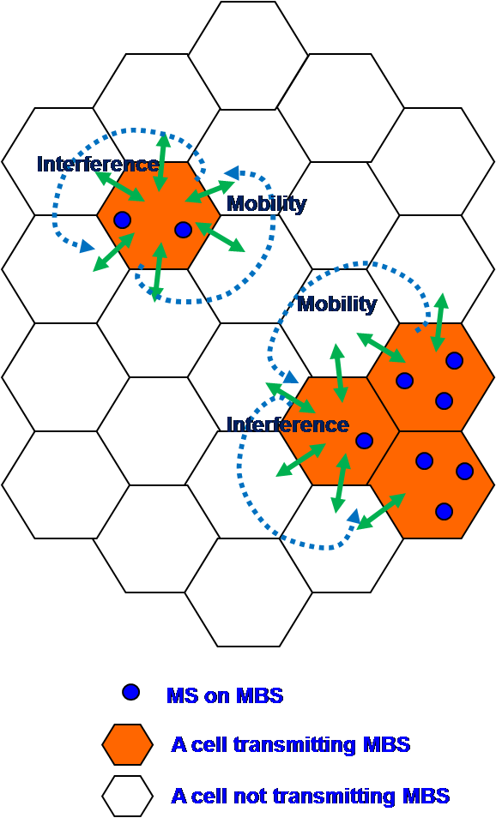
Figure 2 Example of existing dynamic multicasting in an MBS zone

Dynamic multicast depending on MBS status of neighboring cells
In this contribution, we propose the dynamic multicasting method which a cell decides whether it’s transmitting MBS or not in accordance with the MBS status of its neighbor cells.
In traditional dynamic multicast, a BS that is transmitting MBS bursts monitors whether there are MSs receiving MBS in its cell or not. If there is no MS receiving MBS, the BS will stop transmitting MBS burst. But, in the proposed dynamic multicast, a BS that is transmitting MBS bursts monitors the existence of MS receiving MBS in its neighbor cells as well as in its own cell. Figure 3 is a state diagram for a BS that is transmitting MBS bursts. If there is no MS that is receiving MBS in its cell, then the BS has to check up the existence of MS in its neighbor cells before it stops MBS transmitting. If there is no MS in its neighbor cells regardless of transmitting MBS in neighbor cells, the BS and its neighbor BSs should broadcast the paging message to find out idle mode MSs that is receiving MBS. If there is no reply, the BS can stop its MBS burst and allocate the resource to unicast traffic in the cell.
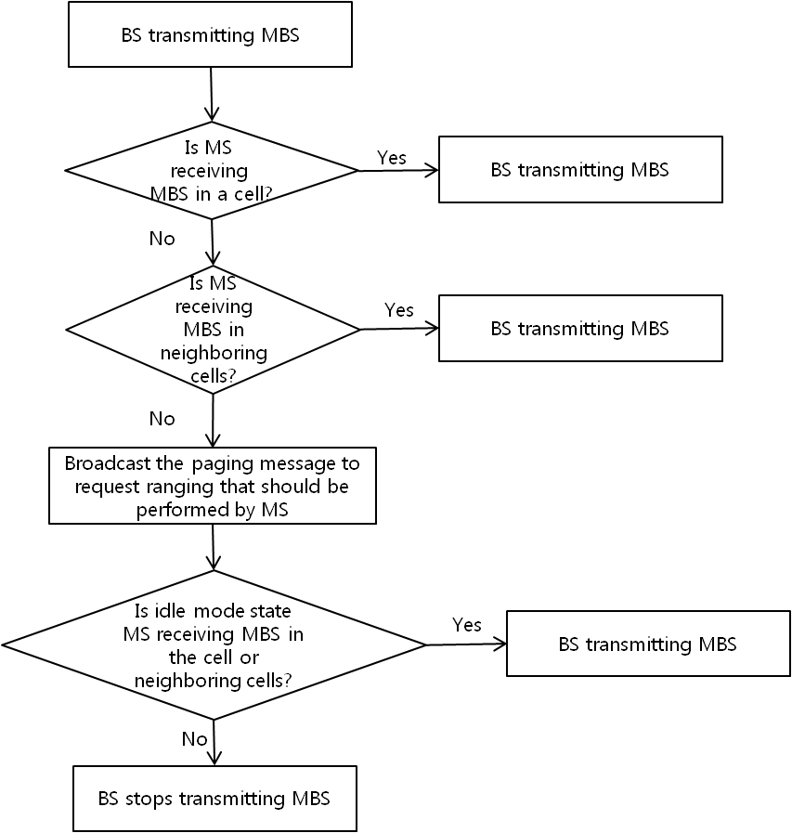
Figure 3 State Diagram of BS transmitting MBS

In case of BS that is not transmitting MBS, if there is an MS moving into one of its neighboring cells or an MS powering on in the cell, the BS has to re-start transmitting MBS burst immediately as Figure 4. To support Idle Mode, BS should broadcast the paging message to find out MS receiving MBS in idle mode state.

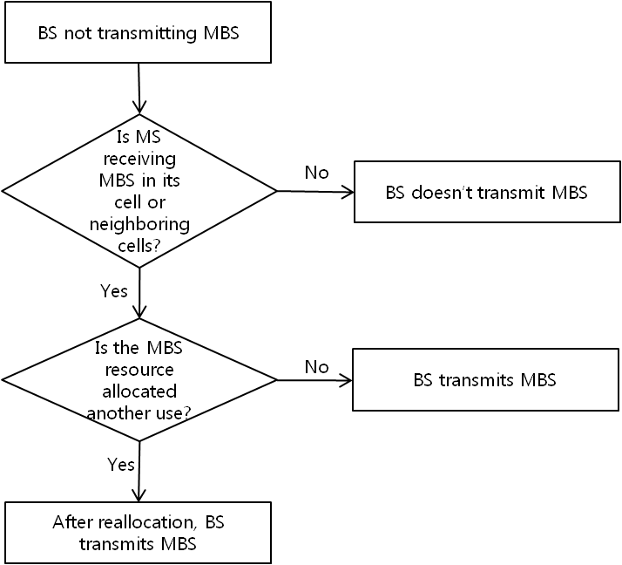
Figure 4 State Diagram of BS not transmitting MBS

Figure 5 illustrates the effect of proposed dynamic multicast.

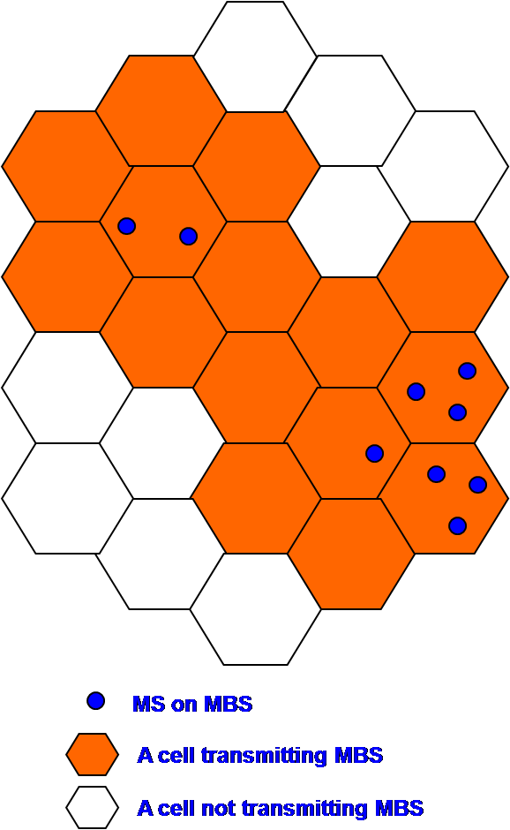
Figure 5 An example to illustrate proposed dynamic multicasting effect

We can save 9 cells out of total 24 cells (37.5%) using dynamic multicast considering neighbor cells’ service status. In addition to the effect of radio resource, the proposed dynamic multicast can support mobility and macro diversity like static multicast does. And there is no interference among cell edges within MBS zone also.

To adopt the method, BS has to monitor the existence of MS for MBS in neighboring cells as well as in the cell. BS can also calculate the number of MS receiving MBS from handover or location update process in the cell and maintain it, but we suggest some messages to monitor;
AAI_RNG_REQ message is modified as appending Raging Purpose Indication bits and (STID+FID) for MBS.
Message to inform of MBS status to its neighbor BSs is performed through the backhaul network.

Text Proposal for the IEEE 802.16m
----------------------------------------------------------- Text Start ---------------------------------------------------------------
[Add the following proposed text in the end of the Section 15.9.2.]
In order to improve the efficiency of radio resource utilization, dynamic multicast service may be supported, in which the transmission of the multicast service data should be decided based on the number of the AMSs within the ABS. Dynamic multicast service may be supported regardless of the AMS operating state – Connected State and Idle State.

----------------------------------------------------------- Text End ---------------------------------------------------------------

