Project | IEEE 802.16 Broadband Wireless Access Working Group <http://ieee802.org/16>
Title | Reducing Uplink Feedback for Channel-dependent Scheduling with Relays
Date Submitted | 2009-11-06
Source(s) | Karthik Sundaresan, Sampath Rangarajan, Linghang Fan, Mohammad A. (Amir) Khojastepour  NEC | karthiks@nec-labs.com
Re: | P802.16m/D2 Relay
Abstract | This contribution proposes text for facilitating feedback reduction with the help of relays for centralized scheduling.
Purpose | To be discussed and adopted by TGm for use in IEEE 802.16m
Notice | This document does not represent the agreed views of the IEEE 802.16 Working Group or any of its subgroups. It represents only the views of the participants listed in the “Source(s)” field above. It is offered as a basis for discussion. It is not binding on the contributor(s), who reserve(s) the right to add, amend or withdraw material contained herein.
Release | The contributor grants a free, irrevocable license to the IEEE to incorporate material contained in this contribution, and any modifications thereof, in the creation of an IEEE Standards publication; to copyright in the IEEE’s name any IEEE Standards publication even though it may include portions of this contribution; and at the IEEE’s sole discretion to permit others to reproduce in whole or in part the resulting IEEE Standards publication. The contributor also acknowledges and accepts that this contribution may be made public by IEEE 802.16.
Patent Policy | The contributor is familiar with the IEEE-SA Patent Policy and Procedures:  <http://standards.ieee.org/guides/bylaws/sect6-7.html#6> and <http://standards.ieee.org/guides/opman/sect6.html#6.3>.  Further information is located at <http://standards.ieee.org/board/pat/pat-material.html> and <http://standards.ieee.org/board/pat>.

Reducing Uplink Feedback for Channel-dependent Scheduling with Relays
Karthik Sundaresan, Sampath Rangarajan, Linghang Fang, Amir Khojastepour
NEC

1. Introduction
The support for multi-hop relay has been included in the current 16m SDD [1]. Most of the application scenarios for 802.16m relays, which are in turn derived from 802.16j relays, consist mainly of two–hop networks [2]. While the relay stations (RS) can be static or mobile (nomadic), the user terminals (MS) are assumed to be mobile as represented in figure 1. While the current draft explicitly supports only distributed scheduling, we would like to emphasize the importance of centralized scheduling for two hop relay networks with the following two arguments.

- One of the main reason a relay system is different and more sophisticated from a femto system is that the ABS has control over the data going to the ARS and AMS unlike in a femto system, where operation is not directly coordinated and the macro BS has no access to the data going to the femto ABS. Hence, interference mitigation (IM) is a big issue in femto systems. However, in relay systems, we have the advantage of taking care of the problem of interference effectively for two hops through centralized scheduling, where the ABS has control of the data being forwarded to the AMS. If centralized scheduling is not supported, then we are effectively forcing the relay system to be only as good as a femto system and putting ourselves in a disadvantageous position.

- Irrespective of where the control plane functionality is terminated (ABS or ARS), the data path has been agreed to be L2, which means that the BS has access to the data to be forwarded to the MS. Hence, the problem of scheduling is completely decoupled from control plane functionalities. Given that, this makes it easier to allow both the options of centralized and distributed scheduling. This does not interfere with the decision on control plane functionality. In addition, there are lots of merits to having centralized scheduling for two hops especially for addressing IM and effective flow matching between relay and access hops.

In the rest of this contribution, we consider the centralized scheduling service. This allows for leveraging multi-user diversity (MUD) on the access and relay links. However, to exploit this MUD gain, the BS would have to obtain CQI from all the MS on all sub-channels, as is currently achieved in 3G cellular networks and exploited in the form of channel-dependent scheduling. These CQI from the MS will be relayed to the BS by the RS. The CQI reports from the RS alone will not help avail MUD gain since MUD gains are available mainly from the dynamic access links resulting from user mobility unlike the relatively static relay links. Thus, CQI reports from all the MS will be required, which will require a lot of feedback overhead. Our contribution in this proposal is to help the BS leverage the MUD gain on the access links without incurring a large feedback overhead, by making the RS assist in the centralized scheduling service.

BS
MS
MS
MS
MS
MS
MS
MS
….
RS
RS
RS
access links
relay links

Figure 1. Topology Illustration

2. Centralized Scheduling Service
In centralized scheduling service, the RS are assumed to be simplified in terms of their functionality and all scheduling decisions are made at the BS. The RS will simply forward the scheduling requests and grants, report requests and grants, UL and DL maps, etc. between the BS and MS. The BS has user queues (buffers) for each of the MS in its cell. Further, while exploiting MUD gains on the access links that are several hops away from the BS may not be feasible in centralized scheduling service due to latency constraints, it is very much feasible in two-hop relay networks, which are the main focus and in fact mandatory for several important applications; including those conceived in 802.16J [3]. In the case of access links being situated several hops away from the BS, MUD gains may be leveraged through the distributed scheduling service.

3. Proposed Relay-Assisted Scheduling Service
Currently, whenever the BS requires CQI information from a MS, it transmits a request towards the MS. The intermediate RS forwards the request. Similarly, when the MS sends back the response, it is once again forwarded by the intermediate RS to the BS. In TDD systems, it is possible for the RS to estimate the CQI for each of the MS served by it. However, it would still need to send back the response for each of the MS on each subchannel when requested by the BS. This incurs a significant feedback overhead. We propose a relay-assisted scheduling service, whereby the RS assists the BS in its scheduling decision, thereby making it possible for the BS to exploit MUD on the access links without having to obtain the information from all the MS and hence avoid the large feedback overhead.

3.1. Proposed Mechanism
The BS may choose to exploit MUD by requesting CQI from all its MS on each subchannel. This is unchanged to allow for backward compatibility. However, if the BS would prefer to exploit MUD without incurring the large feedback overhead and the resulting wastage of bandwidth resources, it allows the RS to assist it in its scheduling decision through notification in the CQI request message. Instead of forwarding the CQI from all the MS associated with it on each subchannel, it forwards the CQI of only a small subset (one or two) of its MS on each subchannel. The RS can determine the subset of MS whose CQI needs to be fed back for a given subchannel, by running its own (virtual) scheduling algorithm. It does not however, schedule the user(s) once the outcome is obtained from the algorithm. Instead, it uses the outcome to generate a consolidated response that provides the consolidated CQI of the user(s) that the RS has identified to be candidates for being scheduled in the particular frame. The BS collects this consolidated CQI information along with the set of users determined by its relay stations as potential candidates for the schedule. It then runs its own scheduling algorithm with the candidate set of users to determine the final set of user(s) who will transmit in the frame. This information is passed on to the RS as in the normal centralized scheduling process. Thus, the RS performs assisted scheduling in determining the candidate set of MS to exploit MUD, and providing consolidated CQI information to the BS to leverage these MUD gains without increasing the feedback overhead.

4. Advantages
- The fact that RS have more important information on the channel state of access links is exploited at the BS through relay-assisted scheduling to leverage MUD gains. If ‘M’ is the number of mobile stations per relay and if ‘R’ is the number of relays, the total diversity order that can be obtained is ‘MR’.
- Feedback overhead does not increase with number of users unlike in the conventional centralized scheduling service, where it is of order ‘MR’. However, in relay-assisted scheduling, every relay sends back only a consolidated CQI, reducing the feedback overhead to order of ‘R’, which is an order of ‘M’ reduction.
- Complete backward compatibility with existing 802.16e is maintained. Relay-assisted scheduling is leveraged only if BS requests for the functionality from RS.
- Additional MUD gain is possible with multiple paths to MS, which in turn are required for fault tolerance and load balancing. If ‘k’ is the number of multiple paths to every MS, the potential MUD order now increases to ‘kMR’. In this case, the corresponding overhead of the conventional scheduling scheme will also increase to order of ‘kMR’. However, the overhead for the relay-assisted scheme will continue to remain the same, order of ‘R’, thereby proving to be highly scalable when compared to conventional scheme with an overhead reduction order of ‘kM’.
- The reduction in overhead is achieved for every subchannel.

A schematic representation of the potential gains is presented in Figure 2.
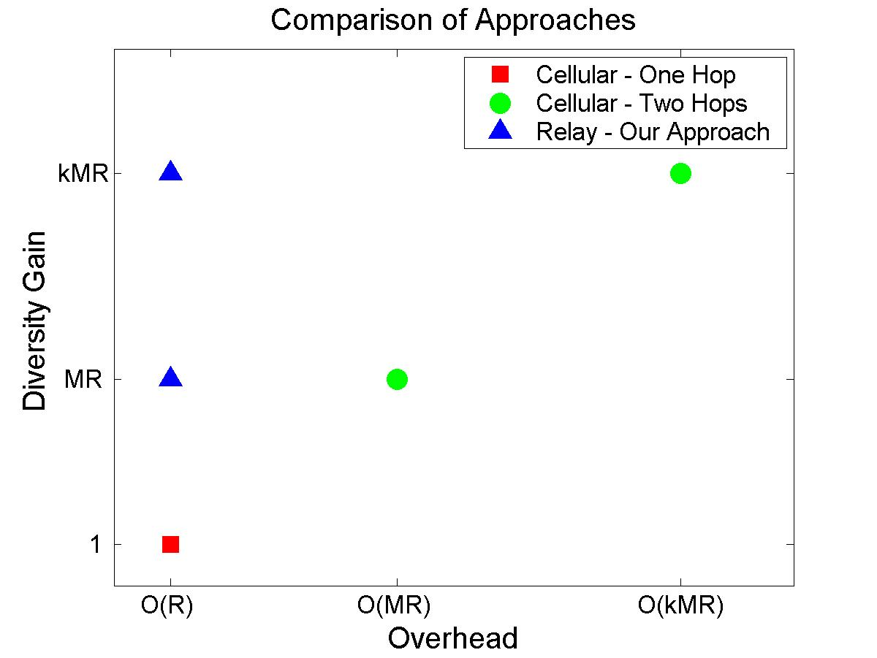
Figure 2. Potential Gain Illustration for each subchannel.
Consider a single sub-channel. “Cellular – One Hop” represents the conventional centralized scheduling service, where the MMR-BS exploits only the CQI on the relay links in its scheduling algorithm for scheduling the relay links in its cell. “Cellular – Two Hops” represents the conventional centralized scheduling service but with the MMR-BS obtaining information from all the MS on the access links through the RS; and exploiting this information in the schedule of the relay links in order to exploit MUD on the access links. “Relay – Our Approach” represents the relay-assisted centralized scheduling service at the MMR-BS, where relay-consolidated CQI is used in the scheduling of the relay links in order to exploit MUD on the access links.

5. Proposed text
------------------ Start of Proposed Text --------------------------------------------

15.6.2.6.1. Consolidated Relay Feedback
In centralized scheduling, to reduce the feedback overhead on the uplink when large number of AMS is associated with an ARS, the ABS should be capable of instructing the ARS to provide CQI feedback that is consolidated over all AMS associated with the ARS.
When the consolidated relay feedback mode is activated, the ARS will collect the feedback reports from its associated AMS, perform a pre-selection process to determine a small candidate set of AMS, and only forward the feedback reports of the selected candidate set back to the ABS.

-------------------- End of Proposed Amendment Text -------------------------------------------

6. References
[1] IEEE 802.16m-08/003r9, “The Draft IEEE 802.16m System Description Document”.
[2] Usage Models (IEEE 802.16j-06/015)

[3] Technical requirement (IEEE 802.16j-06/016r1)

