Consultation response form
Please complete this form in full and return to Elizabeth.Press@ofcom.org.uk or:
Elizabeth Press
Spectrum Management and Authorisation
Spectrum Group, Ofcom
Riverside House
2A Southwark Bridge Road
London SE1 9HA

Consultation title | 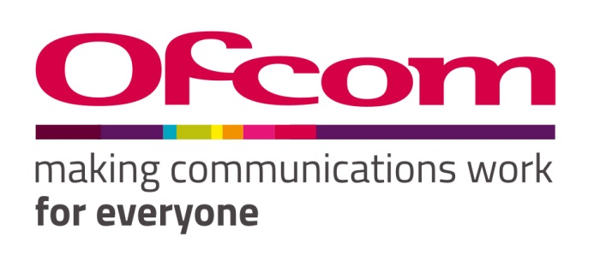  Notice of Ofcom’s proposals for changes to the licence exemption for Wireless Telegraphy Devices
Full name | Paul Nikolich, Chair of IEEE 802
Contact phone number | ______
Representing (delete as appropriate) | Organisation
Organisation name | IEEE 802 LAN/MAN Standards Committee
Email address | IEEE802radioreg@ieee.org

Confidentiality
We ask for your contact details along with your response so that we can engage with you on this consultation. For further information about how Ofcom handles your personal information and your corresponding rights, see Ofcom’s General Privacy Statement.
Your details: We will keep your contact number and email address confidential. Is there anything else you want to keep confidential? Delete as appropriate. | Nothing
Your response: Please indicate how much of your response you want to keep confidential. Delete as appropriate. | None
For confidential responses, can Ofcom publish a reference to the contents of your response? | Yes

Your response
IEEE 802 LAN/MAN Standards Committee (LMSC) respectfully submits these responses to Ofcom.
IEEE 802 LMSC is a leading consensus-based industry standards body, producing standards for wireless networking devices, including wireless local area networks (“WLANs”), wireless specialty networks (“WSNs”), wireless metropolitan area networks (“Wireless MANs”), and wireless regional area networks (“WRANs”). We appreciate the opportunity to provide these comments to Ofcom.
IEEE 802 is a committee of the IEEE Standards Association and Technical Activities, two of the Major Organizational Units of the Institute of Electrical and Electronics Engineers (IEEE). IEEE has about 420,000 members in about 190 countries and supports the needs and interests of engineers and scientists broadly. In submitting this document, IEEE 802 acknowledges and respects that other components of IEEE Organizational Units may have perspectives that differ from, or compete with, those of IEEE 802. Therefore, this submission should not be construed as representing the views of IEEE as a whole.

Question | Your response
Question 1: Do you agree with Ofcom’s proposals to implement changes, that are consistent with the SRD Decision, within the 874 to 876 and 915 to 921 MHz frequency bands for SRDs? | Confidential? – N  Yes  IEEE 802 LMSC commends Ofcom for its ongoing work in the area of spectrum management and harmonization. Allocation of spectrum for SRDs in the 874-876 and 915-921 MHz bands enables a variety of new power-efficient sensor and metering use cases in the areas of Smart Homes, connected cars, digital healthcare, industrial and retail automation, agriculture and Smart Cities. These use cases can be addressed by a variety of technologies, such as those based on IEEE Std 802.15.4, the Sub 1 GHz specification of IEEE Std 802.11 Clause 23, and other industry standards. Harmonization globally enables much faster deployment of these technologies at lower cost to the community.
Question 2: Do the proposed Regulations and proposed changes to IR 2030 correctly implement our proposals? | Confidential? – N  Yes  In addition, according to Ofcom IR 2030, 870-873 MHz is already available and the proposal here includes releasing 874-874.4 MHz for non-specific short range devices. We would encourage Ofcom to consider extending the existing 870-873 MHz operation up to 874.4 MHz inclusive, including 873-874 MHz which appears to be unused.
Question 3: Do you agree with Ofcom’s proposals to remove the licence exemption currently in the 2010 Regulations for Railway Level Crossing Radar Sensor Systems? | Confidential? – N  IEEE 802 does not have a comment on this question #3.

Please complete this form in full and return to Elizabeth.Press@ofcom.org.uk or:
Elizabeth Press
Spectrum Management and Authorisation
Spectrum Group, Ofcom
Riverside House
2A Southwark Bridge Road
London SE1 9HA

This document solely represents the views of the IEEE 802 LAN/MAN Standards Committee and does not necessarily represent a position of either the IEEE, the IEEE Standards Association or IEEE Technical Activities.

