IEEE P802.15
Wireless Personal Area Networks

Project | IEEE P802.15 Working Group for Wireless Personal Area Networks (WPANs)
Title | Non-Collaborative MAC Mechanisms
Date Submitted | 25 June 2001
Source | Nada Golmie  NIST  100 Bureau Dr. Stop 8920  Gaithersburg MD 20899 | Voice: (301) 975-4190  Fax: (301) 590-0932  E-mail: nada@nist.gov
 | Jie Liang  Texas Instruments  12500 TI Boulevard, MS8649  Dallas, TX 75243 | Voice: (214) 480-4105  E-mail: liang@ti.com
 | This is proposed text for clause 14.2 of the Recommended Practice Document
Abstract | []
Purpose | []
Notice | This document has been prepared to assist the IEEE P802.15. It is offered as a basis for discussion and is not binding on the contributing individual(s) or organization(s). The material in this document is subject to change in form and content after further study. The contributor(s) reserve(s) the right to add, amend or withdraw material contained herein.
Release | The contributor acknowledges and accepts that this contribution becomes the property of IEEE and may be made publicly available by P802.15.

Adaptive Packet Selection and Scheduling

Introduction

In this section, we introduce several methods that enhance the performance of the IEEE 802.15.1 and 802.11 networks through the use of adaptive packet selection and scheduling for the Bluetooth devices. These methods do not require the collaboration between the 802.11 devices and the Bluetooth devices. Therefore, they belong to the general category of non-collaborative coexistence mechanisms.

The key idea for adaptive packet selection and scheduling methods is to adapt the transmission according to channel conditions. For instance, if the channel is dominated by interference from 802.11b network, packet loss will be mainly due to collisions between IEEE 802.15.1 and 802.11 systems, instead of bit errors resulting from noise. Packet types that do not include FEC protection could provide better throughput if combined with intelligent packet scheduling. The foundation for the effectiveness of these types of methods is to be able to figure out the current channel conditions accurately and timely. Channel estimation can be done in a variety of ways: RSSI, HEC decoding profile, BER and PER profile, and an intelligent combination of all of the above.

Adaptive Packet Selection

Bluetooth specifies a variety of packet types with different combinations of payload length, slots occupied, FEC codes, and ARQ options. The motivation there is to provide the necessary flexibility for the implementers and applications so that the packets can be chosen optimized for the traffic and channels presented. In this section, we describe mechanism to take advantages of these different packet types for improving network capacity for coexistence scenarios.

- Bluetooth packet types for SCO and ACL

Bluetooth provides 4 types of packets that can be sent over an SCO link: HV1, HV2, HV3, and DV packet. The following table summarizes the different configurations for these packets.

Packet Types | HV1 | HV2 | HV3 | DV
Packet header (bytes) | None | None | None | 1D
Payload Length (bytes) | 10 | 20 | 30 | 20
Channel Utilization (%) | 100% | 50% | 33% | 100%
FEC Code | 1/3 | 2/3 | None | 2/3D
Note: D refers to the data portion only.
Table 1. Bluetooth SCO Packet Types

The different packets differ mostly in FEC code used and the amount of channel occupied by the SCO link. Choice of different packet types provides intriguing tradeoffs of error protection at the bit level and the amount of interference generated (or the bandwidth available for other links).

The ACL link, in addition to the use of different FEC protections, adds the choice of multi-slot packets. The following table summarizes the packets for ACL link.

Packet Types | DH1 | DM1 | DH3 | DM3 | DH5 | DM5
Slot Time | 1 | 1 | 3 | 3 | 5 | 5
Packet header (bytes) | 1 | 1 | 2 | 2 | 2 | 2
Payload Length (bytes) | 0-27 | 0-17 | 0-183 | 0-121 | 0-224 | 0-339
FEC Code | None | 2/3 | None | 2/3 | None | 2/3
Table 2. Bluetooth ACL Packet Types

Again the different ACL packets allow the applications to make tradeoffs among different considerations of traffic flow, channel conditions of the current hop, duty cycles and interference generated to neighboring network.

- Methods of adaptive packet selection

The basic idea here is to adaptively select packet types, given either an ACL or SCO link, so that maximal total network capacity is achieved. This implies not only optimizing throughput for the Bluetooth piconet but also reducing interference to the coexisting 802.11b network, which will increase the throughput of the 802.11b network.

For SCO links, when the network performance is range limited, that is, the stations are separated by a distance such that only small noise margin is maintained. In this case, random bit errors are the dominant problem for dropping packets. By choosing a packet type that uses more error protection will increase the performance of the SCO link. Therefore, for range limited applications, HV1 packet is preferred over HV2 packet, and HV2 packet is preferred over HV3 packet. By monitoring the RSSI and SNR of the Bluetooth radio, the Bluetooth can determine if the choice of more error protection is beneficial.

For SCO links in the coexistence scenarios, usually the dominant reason for packet drop is not due to noise or range, but rather is due to the strong interference produced by the collocated network such as 802.11b network. In this case, by increasing FEC protection will cause Bluetooth device to generate more packets (HV1 packets occupy the channel 3 times more often than HV3 packets), and thus a lot more interference to the 802.11b network. As shown by the simulation results in the following figure, the total network throughput is severely degraded. The figure demonstrated the performance of the 802.11b network before and after the initiation of an HV1 SCO link by the Bluetooth piconet. The 802.11b throughput dropped from 5.8Mbps to around 1Mbps. Therefore, in interference-limited scenarios (as in Bluetooth and 802.11b coexistence scenarios), we should prefer HV3 packet over HV2 packet, and HV2 packet over HV1 packet.

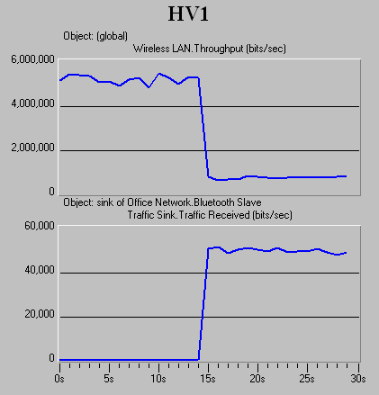

Figure 1. Impact of Bluetooth HV1 packets on the performance of an 802.11b network

For similar reasons, the same guidelines apply to the selection of ACL packets. When the Bluetooth network performance is range-limited, we should use ACL packets with FEC protections, which include DM1, DM3 and DM5. On the other hand, when the system is interference limited, we should try to reduce the number of bits transmitted by choosing more bandwidth efficient packet format such as DH1, DH3 or DH5.

Packet Scheduling for SCO Links
Ed. Note: what does SCO scheduling mean? Does it require a Bluetooth specs change?

SCO Scheduling algorithm for coexistence enhancement

Key idea is to allow the SCO link the flexibility of choosing the hops that are out-of-band with the collocating 802.11b network spectrum for transmission. The duty cycle or channel utilization of the SCO link does not change. For HV3 packets, we will send one HV3 packet every 6 slots, which uses 33% of the total available bandwidth. The only change proposed is to allow the piconet master the flexibility of choosing when to initiate the transmission.

In particular, given that only the original HV3 packet allows for sufficient flexibility in moving the transmission slots around (2 additional choices), we are focusing on modifying the HV3 packet. We define a new SCO packet type – EV3 packet, which has the following features:

- no FEC coding
- 240 bits payload
- one EV3 packet for every 6 slots (delay<3.75ms)
- slave will only transmit when addressed by master

The following figures show the difference between HV3 packet and EV3 packet. For HV3 packets, the transmission for master and slave must happen at the fixed slots, no matter if the hops are good or bad. In the example below, the first pair of packets will be lost since they are transmitted in bad channels. For the EV3 packet, we do not transmit during the two bad hops and wait for the next pair of slots, which happen to be good channel. The throughput for Bluetooth will be higher while interference is reduced.

B
B
G
G
G
G
B
G
B
G
G
G
G
B
G
B
HV3
EV3

Figure 2. Comparisons of HV3 and EV3 packet

The algorithms for selecting the best pair of slots out of the total 3 available locations are pretty straightforward. We give a score of 0 to 3 to each pair and select the pair with the highest score.

Score(n) = 0, if hop(2*n) and hop(2*n+1) are both bad channels
1, if hop(2*n) is bad and hop(2*n+1) is good
2, if hop(2*n) is good and hop(2*n+1) is bad
3, if both are good channels

TxSlot=0; MaxScore=0;
For(n=0;n<3;n++)
if(Score(n)>MaxScore)
TxSlot=2*n;
MaxScore = Score(n);
Algorithm for selecting the best TX slots

Performance simulation

In this section, we provide simulation results comparing the new EV3 packet to the original HV3 and HV1 packet in coexistence environments. The simulation results are obtained with OPNET. We only considered collisions in radio link, which are in-band packets that overlap in time. We assume that collision results in result packet loss for both packets. These are valid assumption for the considered scenario (<3 feet separation).two 802.11b stations and two BT stations in simulations. We turn on the Bluetooth devices after 15 seconds.

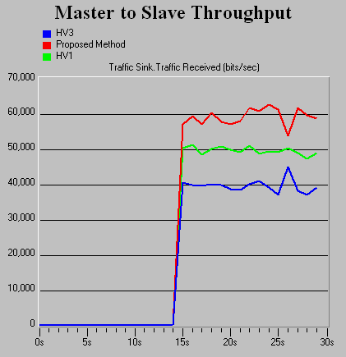

Figure 3. Comparisons in Bluetooth throughput for EV3, HV3, and HV1 packets.

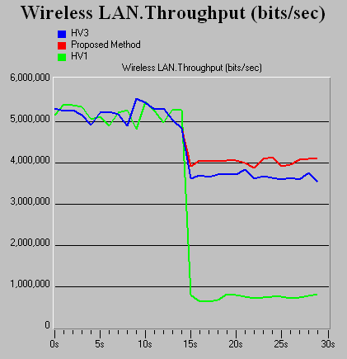

Figure 4. Throughput comparisons for 802.11b network when collocated Bluetooth network uses EV3, HV3, or HV1 packet.

We can see that the EV3 packet, which does SCO packet scheduling, provides improvements in throughput for both the 802.11b and Bluetooth devices. Since the SCO packets avoid the 802.11b band, the improvement for the 802.11b throughput is especially significant.

Packet Scheduling for ACL Links

In this section, we describe a packet scheduling technique that can be used to alleviate the impact of interference. We devise a mechanism for the Bluetooth MAC scheduler consisting of two components:
- Interference Estimation
- Master Delay Policy

In the Interference Estimation phase, the Bluetooth device detects the presence of an interfering device occupying a number of frequencies in the band. Based on either a Bit Error Rate (BER) measurement or Frame Error Rate (FER), or RSSI, each Bluetooth device maintains a Frequency Usage Table where frequencies are classified according to a criterion that measure the level of interference in the channel and marked used or unused. More details on channel estimation are given in section (?).
This Frequency Usage Table is maintained at each receiver's side for both master and slave devices. In Figure 1, the BER is used to measure the interference in the channel.
Figure 5: Frequency Usage Table

The Master Delay Policy makes use of the measurements collected during the Interference Estimation phase in order to avoid a packet transmission in a "bad" receiving channel, or a channel with a high level of interference. The basic idea is to "wait" for or choose an unused frequency for the receiver in the frequency hopping pattern. Thus the transmitter needs to consult the receiver's Frequency Usage Table before transmitting any packets. Alternatively, the receiver can send status updates on its usage table to the transmitter.
In Bluetooth, since the master device controls all transmissions in the piconet, the delay rule has to be implemented only in the master device. Furthermore, since following each master's transmission, there is a slave transmission, the master checks both the slave's receiving frequency and its own receiving frequency before choosing to transmit a packet in a given frequency hop as illustrated in Figure 2.
Figure 6: Delay Scheduling Policy at Bluetooth Master

The main steps of the scheduling policy are summarized as follows.
- Slave's End.
- For every packet received, update BER_f which is an average value of the BER per frequency.
- Every update interval, U, refresh the Frequency Usage Table by marking the frequencies, and
- Send a status update message to the Master;
- Master's End.
- For every packet received, update BER_f which is an average value of the BER per frequency.
- Every update interval, U, refresh the Frequency Usage Table, and
- Before sending a packet, check slave's receiving frequency and master's following receiving frequency, delay transmission until both master and slave's receiving frequencies are available.

1.4.1 Numerical Results

We simulate our proposed scheduling policy. We use a 4-node topology consisting of two Bluetooth nodes (1 master and 1 slave) and two WLAN devices (1 Access Point and 1 Mobile device). The Bluetooth devices are located at (0,0) meters for the slave device and (1,0) meters for the master device. The WLAN devices are located at (0,15) meters for the AP and (0,d) for the mobile device. We assume that WLAN devices implement the IEEE 802.11b specifications at 11 Mbits/s. The WLAN mobile is assumed to be transmitting data to the AP which responds with ACK messages. The WLAN offered load is assumed to be 50% of the channel capacity, the data packet size is set to 8000 bits (including the MAC header) and the packet interarrival time is assumed to be exponential with a mean equal to 1.86 ms.
We use three types of Bluetooth packet encapsulations, namely, DM1, DM3, and DM5 that occupy 1, 3 and 5 slots respectively. The offered load for Bluetooth is set to 30% of the
channel capacity, which corresponds to a packet interarrival of 2.91 ms, 8.75 ms and 14.58 ms for DM1, DM3 and DM5 packets respectively.
The transmitted power for Bluetooth and WLAN is fixed at 1mW and 25 mW respectively.

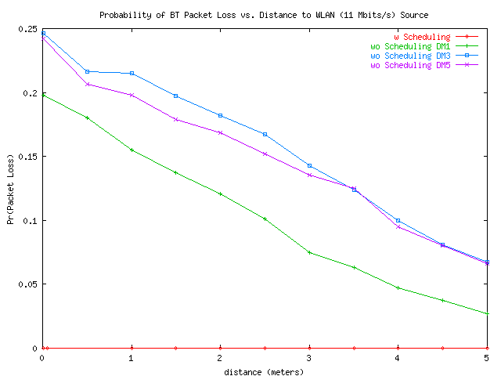

Figure 7: Effect of Scheduling on Bluetooth - Probability of Packet Loss
Figures 4 and 5 give the packet loss and the mean access delay respectively measured at the Bluetooth slave for varying distances of the interference source from the Bluetooth receiver.
From Figure 4 we observe that using the scheduling policy, leads to a packet loss of zero. We are basically able to avoid the channels occupied by the interfering system. When no scheduling policy is used the packet loss is ~ 24% for DM5, and DM3, and 19% for and DM1 packets respectively when the Bluetooth receiver is at a distance of 0.005 meters from the interference source. As the distance from the interference source is increased the packet loss drops to around 2.7% for DM1 packets. It is still around 6.7% for DM3 and DM5 packets.

For DM1, we observe an increase in delay from 1.6ms to 2.6ms when the scheduling policy is applied. On average the scheduling policy yields to a delay increase of 1ms (~1.6 Bluetooth slots). On the other hand, the scheduling policy reduces the delays by 0.8 ms and 2.6 ms for DM3 and DM5 respectively. Thus, delaying transmission to avoid bad channels pays off for packets occupying more than one slot. Note that, when bad channels are used, packets are dropped and have to be retransmitted, which yields large delays. This effect does not apply to DM1 packets since they occupy only one slot.

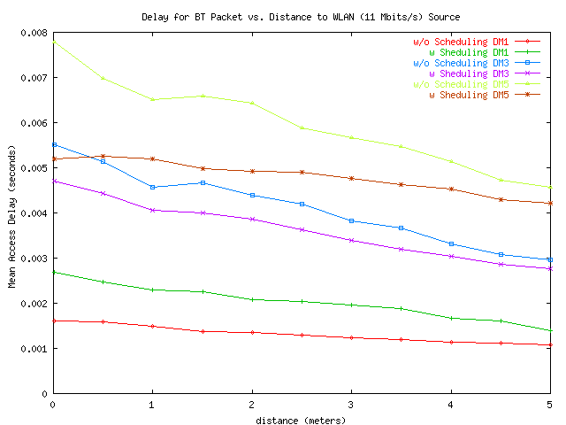

Figure 8: Effect of Scheduling on Bluetooth - Mean Access Delay

In summary, we note that the scheduling policy is effective in reducing packet loss and delay (especially for multi-slot Bluetooth packets). Another advantage worth mentioning, are the additional savings in the transmitted power since packets are not transmitted when the channel is bad. Moreover, we note that by avoiding channels occupied by other devices, we eliminate interference on the other system sharing the same spectrum band. Figure ~\ref{wlan-pk} shows the packet loss for the WLAN Mobile device (receiving ACKs). We note that scheduling reduces the ACK packet loss to zero. Therefore scheduling can be considered as a neighbor friendly policy. Note that the packet loss at the WLAN AP located at (0,15) m is negligible in this case since the Bluetooth signal is too weak.

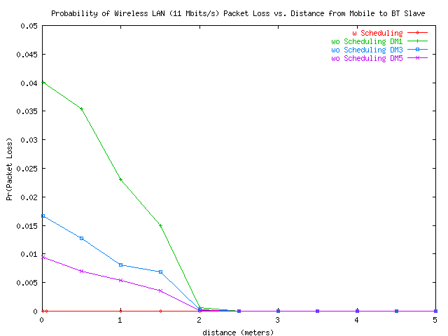

Figure 9: Impact of MAC Scheduling on the WLAN Mobile Device

Finally, we note that scheduling policy proposed here works only with data traffic since voice packets need to be sent at fixed intervals. However, if the delay variance is constant and the delay can be limited to a slot (as was shown here), it may be worthwhile to use DM packets for voice using the same scheduling technique proposed here. This will constitute the basis of future work.

References

- Jie Liang, “Proposal for Non-Collaborative BT and 802.11b MAC Mechanisms for Enhanced Coexistence”, March 2001, Doc. Number IEEE802.15 01/026r1, contributions to IEEE 802.15.

