Project | IEEE 802.16 Broadband Wireless Access Working Group <http://ieee802.org/16>  C80216m-07_282r2
Title | Updated Proposal for IEEE 802.16m System Architecture and Protocol Structure
Date Submitted | January 21, 2008
Source(s) | Sassan Ahmadi (sassan.ahmadi@intel.com)  Papathanassiou, Apostolos; Choi, Yang-seok; Yin, Hujun; Venkatachalam, Muthaiah; Ho, Minnie; Vannithamby, Rath; Sydir, Jerry; Riess, Eilon; Lomnitz, Yuval; Talwar, Shilpa; Wu, May; Etemad, Kamran; Puthenkulam, Jose P; Johnston, DJ  Intel Corporation
Re: | Call for Contributions on IEEE 802.16m System Description Document (SDD)  Topic: System Architecture and Protocol Structure
Abstract | Updated Proposal for IEEE 802.16m System Architecture and Protocol Structure
Purpose | Discussion and Approval
Notice | This document does not represent the agreed views of the IEEE 802.16 Working Group or any of its subgroups. It represents only the views of the participants listed in the “Source(s)” field above. It is offered as a basis for discussion. It is not binding on the contributor(s), who reserve(s) the right to add, amend or withdraw material contained herein.
Release | The contributor grants a free, irrevocable license to the IEEE to incorporate material contained in this contribution, and any modifications thereof, in the creation of an IEEE Standards publication; to copyright in the IEEE’s name any IEEE Standards publication even though it may include portions of this contribution; and at the IEEE’s sole discretion to permit others to reproduce in whole or in part the resulting IEEE Standards publication. The contributor also acknowledges and accepts that this contribution may be made public by IEEE 802.16.
Patent Policy | The contributor is familiar with the IEEE-SA Patent Policy and Procedures:  <http://standards.ieee.org/guides/bylaws/sect6-7.html#6> and <http://standards.ieee.org/guides/opman/sect6.html#6.3>.  Further information is located at <http://standards.ieee.org/board/pat/pat-material.html> and <http://standards.ieee.org/board/pat>.

Updated Proposal for IEEE 802.16m System Architecture and Protocol Structure
Sassan Ahmadi et al.

Introduction
This contribution provides an updated proposal for IEEE 802.16m system architecture and protocol structure. This proposal is consistent with IEEE 802.16m system requirements document. All functional features that have been provisioned in the latter document are appropriately included in the proposed architecture.
The main objective of this proposal is to achieve distinction and high performance through the use of advanced features while maintaining strict backward compatibility with the legacy systems. In addition, the description of the features is provided using more organized, efficient, and simpler methods.

Salient Features of the Proposed Architecture
The following is summary of the major functionalities and features proposed in this document:
- Maintain backward compatibility with the 802.16e Reference System through maximal reuse of existing functional components/protocols and at the same time using new features where necessary to achieve the performance targets.
- Multi-radio coexistence-aware system architecture which allows efficient coordination of collocated radio access technologies on the user device.
- Relay-enabled architecture with unified access and relay links for optimal two-hop operation.
- Different multi-carrier deployment options including support of contiguous and non-contiguous RF bands with single MAC instantiation.
- Flexibility for future enhancements and extensions
- Data and control plane protocols are specified separately.
- Unified support of FDD, TDD, and H-FDD duplex mode with common baseband processing
- Unified single-user and multi-user MIMO structure (single stream and/or multi-stream processing) for support of advanced multi-antenna techniques.
- Provisions for data-plane and control-plane ciphering protocols.
- Structured layer 2 functionalities where MAC common part sub-layer is extended and split into two functional groups (alternatively MAC CPS functions are softly classified into two categories).

Overall Network Architecture (informative)
The Network Reference Model (NRM) is a logical representation of the network architecture. The NRM identifies functional entities and reference points over which interoperability is achieved between functional entities. The following figure illustrates the NRM, consisting of the following logical entities: MS, ASN, and CSN.
Access Service Network (ASN) is defined as a complete set of network functions needed to provide radio access to an IEEE 802.16e/m subscriber. The ASN provides the following mandatory functions:
- IEEE 802.16e/m Layer-2 (L2) connectivity with IEEE 802.16e/m MS
- Transfer of AAA messages to IEEE 802.16e/m subscriber’s Home Network Service Provider (H-NSP) for authentication, authorization and session accounting for subscriber sessions
- Network discovery and selection of the IEEE 802.16e/m subscriber’s preferred NSP
- Relay functionality for establishing Layer-3 (L3) connectivity with a IEEE 802.16e/m MS (i.e. IP address allocation)
- Radio Resource Management

In addition to the above mandatory functions, for a portable and mobile environment, an ASN further supports the following functions:
- ASN anchored mobility
- CSN anchored mobility
- Paging
- ASN-CSN tunneling
- ASN comprises network elements such as one or more Base Station(s), and one or more ASN Gateway(s). An ASN MAY be shared by more than one Connectivity Service Networks (CSN)
Connectivity Service Network (CSN) is defined as a set of network functions that provide IP connectivity services to the IEEE 802.16e/m subscriber(s). A CSN MAY provide the following functions:
- MS IP address and endpoint parameter allocation for user sessions
- Internet access
- AAA proxy or server
- Policy and Admission Control based on user subscription profiles
- ASN-CSN tunneling support,
- IEEE 802.16e/m subscriber billing and inter-operator settlement
- Inter-CSN tunneling for roaming
- Inter-ASN mobility
- IEEE 802.16e/m services such as location based services, connectivity for peer-to-peer services, provisioning, authorization and/or connectivity to IP multimedia services and facilities to support lawful intercept services such as those compliant with Communications Assistance Law Enforcement Act (CALEA) procedures.

CSN may further comprise network elements such as routers, AAA proxy/servers, user databases, Interworking gateway MSs. A CSN may be deployed as part of a Greenfield IEEE 802.16e/m NSP or as part of an incumbent IEEE 802.16e/m NSP.
In addition to the existing network reference model defined in WiMAX Network Architecture (http://www.wimaxforum.org/technology/documents) the IEEE 802.16m relay entity is also included to enable use of relay stations for improvement of coverage and performance in IEEE 802.16m networks.

Access Service Network
R8
R6
R1
R2 (logical interface)
Access Service Network
Gateway
R6
802.16e
MS
BS
BS
R1’
802.16m
MS
Other Access Service Networks
R4
Connectivity
Service
Network
Connectivity
Service
Network
R3
R5
Access Service Provider Network
(Internet)
Access Service Provider Network
(Internet)
Home Network Service Provider
Visited Network Service Provider
Layer 1 and Layer 2 to be specified by IEEE 802.16m

System Reference Model

IEEE 802.16e-2005 Reference Model
The IEEE 802.16 standard describes both the MAC and PHY for fixed and mobile broadband wireless access systems. The MAC and PHY functions can be classified into three categories namely data plane, control plane, and management plane. The data plane comprises functions in the data processing path such as header compression as well as MAC and PHY data packet processing functions. A set of layer 2 control functions is needed to support various radio resource configuration, coordination, signaling, and management. This is set of functions are collectively referred to as control plane functions. A management plane is also defined for external management and system configuration. Therefore, all management entities fall into the management plane category.

802.16e-2005
Data/Control Plane

IEEE 802.16f/g NetMAN
Management Plane
Physical Layer
(PHY)
PHY SAP
Security Sub-Layer
MAC Common Part
Sub-Layer
(MAC CPS)
MAC SAP
Service Specific
Convergence Sub-Layer
(CS)
CS SAP
Security Sub-Layer
Management Layer
MAC Common Part
Sub-Layer
Management Entity
Service Specific
Convergence Sub-Layer
Management Entity
Physical Layer

RAN
Control
and
Transport
Functions

WiMAX NWG
RAN
Architecture

External
Networks

IEEE 802.16m Reference Model
As shown in the following figure, the proposed reference model for IEEE 802.16m is very similar to that of IEEE 802.16e with the exception of soft classification of MAC common part sub-layer (i.e., no SAP is required between the two classes of functions) into resource control and management functions and medium access control functions. The CS SAP, MAC SAP, and PHY SAP also need modifications to appropriate interface the new functionalities across vertical layers. Considering the new functionalities that are defined in IEEE 802.16m, it is further expected that the management plane entities be modified to accommodate those changes.

IEEE 802.16m Data/Control Plane

IEEE 802.16f/g NetMAN
Physical Layer
(PHY)
PHY SAP
Security Sub-Layer

Medium Access Control Functions

Radio Resource
Control
and
Management Functions
MAC SAP

Convergence
Sub-Layer
CS SAP
Security Sub-Layer

Management Layer
Common Part
Sub-Layer
Management Entity
Physical Layer
Management Entity
Service Specific
Convergence Sub-Layer

RAN
Control
and
Transport
Functions

WiMAX NWG
RAN
Architecture

External
Networks
MAC Common-Part Sub-Layer

Functional Split between IEEE 802.16m and the Access Network (informative)
The functional split between the IEEE 802.16m and the access network has been illustrated in the following figure. The figure shows the main functions that are performed in the BS and the access network and whether WiMAX Forum or IEEE specifications define those functions. It is obvious that the interaction of these functions and the impacts on the network interfaces and entities as a result of IEEE 802.16m enhancements require a close collaboration between IEEE and WiMAX forum to define, refine, or update of the new or existing specifications and reference points.
BS
ASN-GW
PHY
PHY
Data Path Function
Medium Access Control Functions
Handover Function
Key Receiver
Context Function
Service Flow Management Functions
CS
R6
Interface
Authentication Function
Proxy MIP Client
Paging Controller/Location Register
Data Path Function
RRM Relay
Handover Function
Key Distributor
AAA Client/Authenticator

Context Function

Service Flow Anchor
DHCP Proxy/Relay
MIP FA
To be specified by WiMAX Forum Network Architecture
To be specified by IEEE 802.16m
Paging Agent
Radio Resource Control
& Management Functions

Mobile Station State Diagram

IEEE 802.16e System State Diagram
Currently, IEEE802.16REV2 system does not include an explicit state diagram in the standard. However, a state diagram (i.e., a set of states and procedures between which the mobile station transits when start operating in the system to receive and transmit data) for the current IEEE802.16REV2 system based on our understanding of the operation of the current reference system can be illustrated as follows:

There are 4 states from the point of view of an MS when scanning and attaching to a BS in IEEE802.16REV2, as follows:

- Initial State
- Access State
- Connected State
- Idle State

Initial State
Initial State is where an MS performs BS selection as described in the sections 6.3.9.1 to 6.3.9.4 of IEEE802.16REV2. When the MS is turned on, the MS scans BSs and synchronizes to the DL transmissions of a BS via preamble detection. If it is synchronized to the BS, the MS acquires the DL-MAP and obtains the DL and UL transmission parameters (DCD/UCD). If it is ready to perform a ranging process to the BS, the MS enters Access State. The MS can return back to scanning step in case that it fails to perform action required to each step.

Access State
Access State is where the MS performs network entry to the selected BS as described in the sections starting from 6.3.9.5. During Access State, the MS performs the following processes sequentially:

- Ranging
- Basic Capability Negotiation
- Authorization and Key Exchange
- Registration

Scanning and DL Synchronization
(Preamble Detection)
Broadcast Channel Acquisition (DCD/UCD)
Ranging and UL Synchronization
(RNG-REQ/RSP)
Basic Capability Negotiation
(SBC-REQ/RSP)
Registration with Serving BS
(REG-REQ/RSP)
MS Authentication, Authorization & Key Exchange (PKMv2/ EAP)
Sleep Mode
Neighbor Scanning
Active Mode
DL/UL Data Transmission with Serving BS
Idle State
DL MAP (Common Control Channel) Acquisition
Cell Selection Decision
Power ON/OFF
Connected State
Handoff/ Network Re-entry
IP Address Assignment
(DHCP/MIP)
MAC CIDs Establishment (DSA-REQ/RSP)
Fast Network Re-entry
Initialization State
Access State

Finally, the MS establishes a basic connection with the BS. Afterwards, the MS will acquire an IP address from the network before beginning service on this connection. By the end of this process, the MS is ready to communicate with the remote entity as well as the BS.

After establishing the connection and setting up the IP address, the MS will enter Active Mode in Connected State (The operation of the MS and the BS in Active Mode is the same as normal operation in the current standard)

Connected State
During Connected State, MS maintains at least one connection as established during Access State.
For other services, MS and BS may establish additional transport connections. Connected State is composed of three modes as follows:

- Active Mode
- Sleep Mode
- Scanning Mode
- Active Mode

During Active Mode, the MS and the BS perform normal operation as specified in the current standard. MS and BS may perform the following actions in Active Mode

- L1/L2 assignment and signaling (CQICH, ACKCH)
- New connection establishment/maintenance/release
- PDU transmission/reception between the MS and the serving BS
- Entry and return of Scanning Mode or Sleep Mode

Sleep Mode
This mode has been considered for power saving of the MS as described in section 6.3.21 of the current standard. When there is a message from/to the MS in the Sleep Mode, it transits to Active Mode for the transmission and reception of the message.

Scanning Mode
During Connected State, MS may perform scanning as described in section 6.3.21 and 6.3.22. After scanning, the MS will resume the operation in the Active Mode. Based on the scanning result, if the MS makes handover to a target BS, it may leave Connected State and perform Network Re-Entry to re-enter Active Mode at the target BS. Fast Network Re-Entry allows the MS back to Active Mode directly. If that is not possible, the MS goes through Normal Network Re-Entry, which passes Access State before returns Connected State, both with the target BS.

Idle State
During Idle state, the MS switches between Paging Availability and Paging Unavailability periods. The MS performs power saving or scans a BS for paging and location update as described in section 6.3.24. The MS returns to Idle State after location update. If it is paged by a BS, the MS will perform Network Re-Entry for entering Active Mode for data transmission and reception. Similar to the handover case, if it cannot make Fast Network Re-Entry, the MS shall transit to Access State and perform the operations for Normal Network Entry.

IEEE 802.16m System State Diagram
The proposed state diagram for IEEE 802.16m MS consists of 4 states similar to that of IEEE 802.16e state diagram with the exception that initialization state has been simplified to reduce the scan latency and to enable fast cell selection or reselection.
If the location of the system configuration information (also known as DCD/UCD messages) is fixed so that upon successful DL synchronization and preamble detection, the broadcast channel containing the system configuration information can be acquired (as shown in the following modified state diagram), this would enable the MS to make decision for attachment to the BS without acquiring and decoding FCH and DL MAP and waiting for the DCD/UCD arrival. The proposed modification would further result in power saving in the MS due to shortening and simplification of the initialization procedure.
While the number and interconnection/transition paths of the mobile states remain the same, each individual process will be enhanced and optimized to ensure overall system improvements, reduced latencies, reduced complexity, etc.
Scanning and DL Synchronization
(Preamble Detection)
Ranging and UL Synchronization
(RNG-REQ/RSP)
Basic Capability Negotiation
(SBC-REQ/RSP)
Registration with Serving BS
(REG-REQ/RSP)
MS Authentication, Authorization & Key Exchange (PKMv2/ EAP)
Sleep Mode
Neighbor Scanning
Active Mode
DL/UL Data Transmission with Serving BS
Idle State
Power ON/OFF
Connected State
Handoff/ Network Re-entry
IP Address Assignment
(DHCP/MIP)
MAC CIDs Establishment (DSA-REQ/RSP)
Fast Network Re-entry
Initialization State
Access State
Broadcast Channel Acquisition (DCD/UCD)
DL MAP Acquisition
Cell Selection Decision

Air-Interface Protocol Stack
Let’s begin with the protocol structure of IEEE 802.16e which will be used as reference system. The MAC layer is composed of two sub-layers: Convergence Sublayer (CS) and MAC Common Part Sublayer (MAC CPS).

For convenience, we logically classify MAC CPS functions into two groups based on their characteristics. The upper one is named as resource control and management functions group, and the lower one is named as medium access control functions. Also the control plane functions and data plane functions are also separately classified. This would allow more organized, more efficient, more structure way of specifying the MAC services in IEEE 802.16m standard specification.

The resource control and management functional group includes several functional blocks that are related with radio resource functions such as

- Radio Resource Management
- Mobility Management
- Network-entry Management
- Location Management
- Idle Mode Management
- Security Management
- System Configuration Management
- MBS
- Connection Management

Radio Resource Management block adjusts radio network parameters related to the traffic load, and also includes function of load control (load balancing), admission control and interference control.

Mobility Management block handles related to handover procedure. Mobility Management block manages candidate neighbor target BSs based on PHY signaling report, and also decides whether MS performs handover operation.

Network-entry Management block is in charge of initialization procedures. Network-entry Management block may generate management messages which needs during initialization procedures, i.e., ranging (this does not mean physical ranging, but ranging message in order to identification, authentication, and CID allocation), basic capability, registration, and so on.

Location Management block is in charge of supporting location based service (LBS). Location Management block may generate messages including the LBS information. The Location Management block also manages location update operation during idle mode.
Idle Mode Management block controls idle mode operation, and generates the paging advertisement message based on paging message from paging controller in the core network side.

Security Management block is in charge of key management for secure communication. Using managed key, traffic encryption/decryption and authentication are performed.
System Configuration Management block manages system configuration parameters, and generates broadcast control messages such as downlink/uplink channel descriptor (DCD/UCD).

MBS (Multicast and Broadcasting Service) block controls management messages and data associated with broadcasting service.

Connection Management block allocates connection identifiers (CIDs) during initialization/handover/ service flow creation procedures. Connection Management block interacts with convergence sublayer to classify MAC Service Data Unit (MSDU) from upper layer, and maps MSDU onto a particular transport connection.

The medium access control functional group includes function blocks which are related with physical layer and link controls such as

- PHY Control
- Control Signaling
- Sleep Mode Management
- QoS
- Scheduling and Resource and Multiplexing
- ARQ
- Fragmentation/Packing
- MAC PDU formation

PHY Control block handles PHY signaling such as ranging, measurement/feedback (CQI), and HARQ ACK/NACK. Based on CQI and HARQ ACK/NACK, PHY Control block estimates channel environment of MS, and performs link adaptation via adjusting modulation and coding scheme (MCS) or power level.

Control Signaling block generates resource allocation messages such as DL/UL-MAP as well as specific control signaling messages, and also generates other signaling messages not in the form of general MAC messages (e.g., DL frame prefix also known as FCH).

Sleep Mode Management block handles sleep mode operation. Sleep Mode Management block may also generate management messages related to sleep operation, and may communicate with Scheduler block in order to operate properly according to sleep period.
QoS block handles rate control based on QoS parameters input from Connection Management function for each connection, and scheduler shall operate based on the input from QoS block in order to meet QoS requirement.

Scheduling and Resource and Multiplexing block schedules and multiplexes packets based on properties of connections. In order to reflect properties of connections Scheduling and Resource and Multiplexing block receives QoS information from QoS block for each connection.

ARQ block handles MAC ARQ function. For ARQ-enabled connections, ARQ block logically splits MAC SDU to ARQ blocks, and numbers to each logical ARQ block. ARQ block may also generate ARQ management messages such as feedback message (ACK/NACK information).

Fragmentation/Packing block performs fragmenting or packing MSDUs based on scheduling results from Scheduler block.

MAC PDU formation block constructs MAC protocol data unit (PDU) so that BS/MS can transmit user traffic or management messages into PHY channel. MAC PDU formation block may add sub-headers or extended sub-headers. MAC PDU formation block may also add MAC CRC if necessary, and add generic MAC header.
IEEE 802.16m is expected to the MAC architecture of current IEEE 802.16e and will have some additional functional blocks for newly proposed features. In our proposed MAC architecture for 802.16m, we include additional functional blocks

- Routing
- Self Organization
- Multi-Carrier
- Multi-Radio Coexistence

QoS

Convergence Sub-Layer

Physical Layer
PHY Protocol (FEC Coding, Signal Mapping, Modulation, MIMO processing, etc.)

Medium Access Control Functions
Data Forwarding
MAC PDU Formation

Radio Resource
Control &
Management
Functions
L2
L1
Idle Mode Management
Routing
Mobility Management
Radio Resource Management
Network Entry
Management
Multi-Carrier Support
MBS
Data and Control Bearers
CS SAP
Multi-Radio Coexistence
Location Management
ARQ
Control and Signaling
Security Sub-Layer
MAC Common Part Sub-Layer
Physical Channels
Fragmentation/Packing
Ranging
Control Plane
Data Plane
Self-Organization
Security Management
System Configuration
Management
Link Adaptation
Interference
Management
PHY Control

Sleep Mode Management
Scheduling & Resource
Multiplexing
The detailed description of proposed additional functional blocks will be provided later. Self Organization block performs functions to support self configuration and self optimization mechanisms. The functions include procedures to request MSs to report measurements for self configuration and self optimization and receive the measurements from the MSs. A special reference signal can be defined to enhance the self configuration and self optimization mechanisms. The block may determine to send the reference signal and manages the control signal block to transmit the signal.

Protocol Structure for Multi-carrier Support
A generalization of that protocol structure to multi-carrier support using a single MAC instantiation is shown in the following figure. The load balancing functions and RF carrier mapping and control are performed via radio resource control and management functional class.
Data Plane
Control Plane
Radio Resource Control
& Management Functions
CS Sub-Layer

Medium Access Control Functions
PHY 1
RF Carrier 1
PHY 2
RF Carrier 2
PHY n
RF Carrier n
CS SAP
Data and Control Bearers
Physical Channels
Physical Channels
…
Physical Channels
L2
L1
MAC Common Part Sub-Layer
Security Sub-Layer
Dynamic/Static Mapping
The figure below illustrates the proposed generalized multi-carrier scheme for TDD duplex scheme. Note that if RF1 and RF2 are adjacent RF carriers, their corresponding DL/UL sub-frames shall be aligned to reduce inter-carrier interference. The alignment of DL/UL sub-frames across non-adjacent RF carriers is not necessary.

Depending on the design of terminal RF front-end and baseband processing, the preamble (or the synchronization channel) may be included only on the primary RF carrier. The use of separate synchronization channels on each RF carrier is necessary, if the terminal can only process one RF carrier at the time and not capable of maintaining synchronization while switching from one RF carrier to another. In addition, if the RF carriers are far apart in frequency, channel estimation and DL synchronization may not be feasible using a single synchronization channel and use of separate per-carrier synchronization channels may be necessary.

It must be further noted that the proposed multi-carrier support equally applies to both TDD and FDD systems and use of TDD mode is for example only.
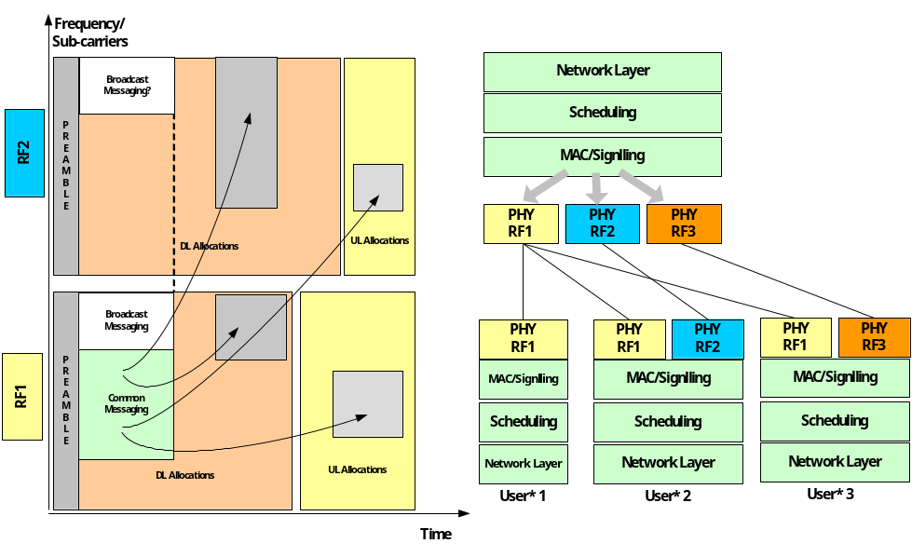

IEEE 802.16m Protocol Stack in BS/RS/MS
The figure below shows the protocol stack for the data plane, where CS sub-layer terminates in BS on the network side and the MAC functions are terminated in the RS or the BS. The functions listed for the data plane in Section 8; e.g., header compression, ciphering, scheduling, ARQ and H-ARQ, etc.

MS
PHY

Medium Access Control Functions
CS
RS
PHY

Medium Access Control Functions
BS
PHY

Medium Access Control Functions
CS
IEEE 802.16m Air-Interface
IEEE 802.16m Air-Interface
Security
Security
Security*
* Security functions may be limited in certain nodes of the network that are outside of direct control of the operator (also known as security zone)
MAC CPS
Note that the access and relay links are defined by IEEE 802.16m standard. Depending on the functionalities specified for the relay stations, the termination points of certain protocols may differ. The dotted lines in the figure indicate that those functions may be included.

The following figure illustrates the control plane protocol stack in the BS/RS/MS. It must be noted that certain radio resource control and management functions may not exist in the relay station. Furthermore, in order to ensure that the security of the network will not be compromised by hackers, having access to small BS or femto-cell access points, security functions may be limited in the nodes that are outside of the direct control of the network operator.
MS

PHY

Medium Access Control Functions

Radio Resource Control & Management Functions
RS

PHY

Medium Access Control Functions

Radio Resource Control & Management Functions
BS

PHY

Medium Access Control Functions

Radio Resource Control & Management Functions
IEEE 802.16m Air-Interface
IEEE 802.16m Air-Interface
Security
Security
Security*
Certain Management Functions messages may be ciphered
MAC CPS
The new function in the control plane protocol stack is the security sub-layer that would enable ciphering certain management messages.

Functional Block Diagram of Unified Open-loop/Closed-loop SU/MU-MIMO
The proposed multi-user (MU) MIMO structure shown in the following figure is unified with single-user (SU) MIMO structure, where the former can collapse into the latter as a special case.

The main functional components shown are as follows. Note that in the following, CL and OL in parenthesis refer to functions that are applicable to closed-loop or open-loop modes, respectively. New or modified functional blocks are marked with dotted lines in the figure below.

- Scheduling
- Unified scheduler for SU/MU MIMO
- One spatial stream in one subchannel is minimum resource unit for scheduling
- Schedule one or multiple users on a certain subchannel according to their CQI and CSI (CL), QoS parameters, channel condition, etc.
- SU/MU cooperative scheduling

- Mode/Rank/Link adaptation
- Select suitable MIMO mode (STBC, SM, CL) and rank for certain users to satisfy the throughput while maximize the spectral efficiency.

- MIMO Encoder and Precoder
- Use suitable precoder V matrix for precoding signals after MIMO encoder
- The V matrix can be calculated from CSI (CL case) or fixed/semi-fixed (OL case)

- OFDM Symbol construction
- Pilot insertion, preamble, permutation, etc.

- Feedback inputs
- SINR (long-term), CQI (short-term), Traffic type (QoS parameters)
- Channel Quality, ACK/NACK, etc.

- Control outputs
- CQICH BW for each User
- Selected V matrix

- Scheduling
- Basic scheduling
  - Downlink scheduling for SU/MU MIMO: user selection/grouping, resource allocation
  - Uplink scheduling for CQICH BW allocation and resource allocation for all users
- User Scheduling/Resource allocation
- MIMO Mode/Rank/Link Adaptation Input Control to decide the MIMO stream number, supported MCS, etc
- Retransmission Indicator to decide if retransmits
- User grouping/resource allocation decides the user pairing and resource sharing
  - MIMO Encoder Processing
- STBC/SM

- Beamforming /Precoding
- Scheduling decision
- Beamforming vector index

Procedure for SU/MU Open-loop/Closed-loop MIMO
MS Procedures
- Users initially feed back their best CQIs corresponding to the beamforming vector to BS (OL/CL)
- Users also feed back their beamforming vectors with best CQIs to BS (OL)
BS Procedures
- BS decides the user grouping based on long-term SINR, short-term CQIs and feedback beamform vectors (OL/CL)
- BS allocates the OFDM time-frequency resource with the proportional fair scheduling criteria (OL/CL)
- BS decides the MCS level based on the feedback CQIs (OL/CL)
- BS selects the MIMO mode based on the different CQI type with different MIMO mode, for example, SU-MIMO or MU-MIMO, STBC or SM for SU-MIMO, etc. (OL/CL)
- BS decides if data will be retransmitted and the H-ARQ mode (OL/CL)

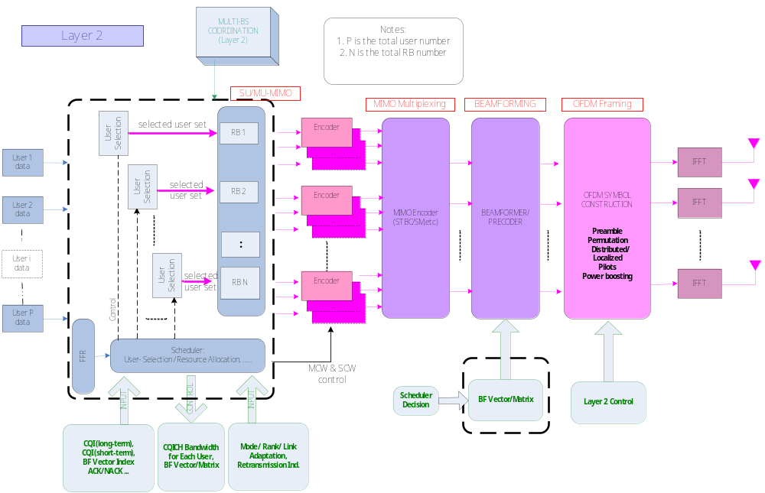

Interference Mitigation Functional Partition
IEEE 802.16m standard will support active management of interference in reuse 1 scenarios. Interference management (IM) requires multi-function cross-layer design encompassing PHY, MAC, and network layers. The key IM functions are briefly described below:

PHY
Medium Access Control Functions
Radio Resource Control & Management Functions
TX Beamforming
Interference Randomization

Uplink
Power
Control
RX Interference Mitigation

Interference-Aware Scheduling
FFR (semi-static)

FFR (dynamic)
Interference-aware BS Coordination

- Interference-aware BS co-ordination: BS exchanges information across network backbone to manage radio resources such that inter-cell interference is minimized.
- Fractional frequency reuse: Restrict usage of certain frequencies or power level of these frequencies in a sector to minimize interference, and to effectively enable multiple reuse settings within a sector; e.g., 1, 3, and 3/2. The restrictions may change over time as a function of BS co-ordination:
  - Semi-static - on order of 100 ms to seconds
  - Dynamic - on order of frame duration
- Interference aware scheduling: scheduler allocates resources based on interference aware CQI metrics
- Uplink power control: subscribers adjust transmit power based on interference caused to other cells.
- Interference randomization: transmitted signal is randomly spread the across entire frequency band such that aggregate interference from multiple transmitters on the average looks like Gaussian white noise.
- TX Beamforming: transmitter forms spatial beams and nulls to improve SINR particularly for cell-edge users
- RX Interference Mitigation: interference aware spatial processing at receiver to mitigate interference.

Goals of IM are different for data versus control functions:

- Data: IM techniques improve average and cell-edge capacity
- Control: IM techniques improve reliability of sensitive information. Control signals can be 2 types:
  - Dedicated: unicast to 1 user or multicast to group of users
  - Common: broadcast to all users in sector/cell
- Dedicated control signals can be treated similar to data, with different distribution of sub-channels used for FFR; typically higher number of sub-channels is reserved in reuse groups 3 and 3/2 to offer more protection for control signals. Also, it is expected that reuse sets will change very slowly for control signals.

The figure below shows data path for IM downlink, where
- Interference-aware scheduler allocates OFDMA resources to multiple users based in interference-aware statistics (SINR/throughput) of these users. The resources are sub-channels with different reuse values or power levels, as determined by FFR partitioning.
- The distribution of sub-channels for FFR may change over time as a function of multi-BS coordination.
- The data/control signals of allocated users are mapped to 1 or more symbol streams based on MIMO mode. In case of transmit Beamforming, a single stream of data per user is multiplied by a beamforming vector, resulting in 2 or 4 weighted output streams, depending on number of transmit antennas.
- The weighted streams are mapped to OFDM symbol, including: permutation mapping, insertion of pilots and zero padding, power gains for pilots or certain FFR sub-channels, etc. Each stream is sent to IFFT, then RF path.

Broadcast control signals are treated differently dedicated control since they need to reach all users. The key differences include

- FFR algorithm: default is reuse 3 for all sub-channels
- Transmit Diversity instead of Beamforming: CDD is preferred since it is transparent to users
- Permutation: PUSC to maximize frequency diversity

Power: since reuse 3 and PUSC is used, it may also help to boost power on broadcast channels.
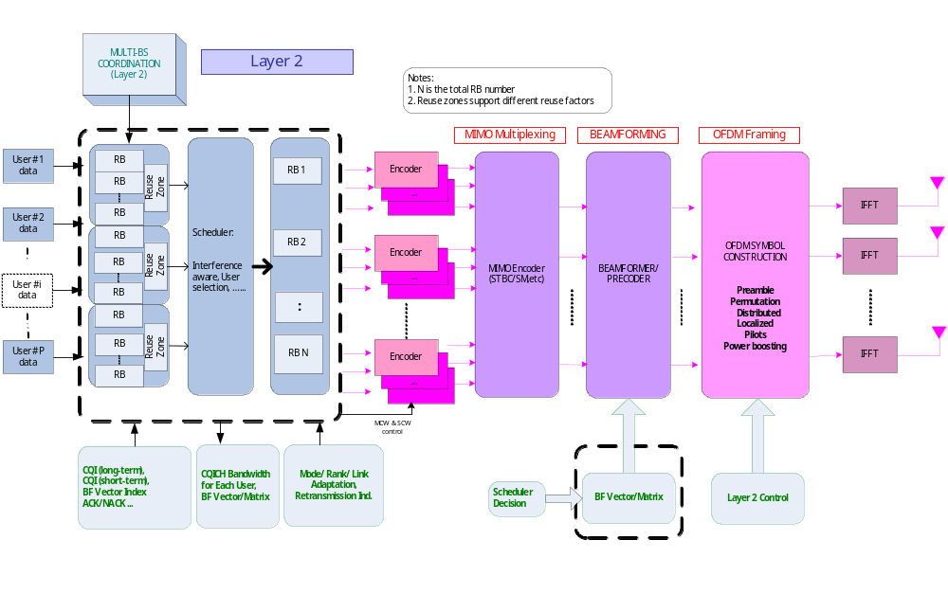

Multi-Radio Coexistence-Aware System Architecture
The multi-radio coexistence is defined as the ability of one system to perform a task in a given shared environment where other systems have an ability to perform their tasks and may or may not be using the same set of rules. The coexistence system is defined as the set of sub-systems that need to coexist with each other. The coexistence sub-system is defined as the sub-system in a coexistence system.

An activity of the individual sub-system that has impact on other sub-system and the impact could be no TX, no RX, or no TX and no RX is referred to as coexistence activity.

The following figure shows a collocated coexistence system, where multiple radio interfaces are co-located on the same physical device, also known as multi-radio user terminal. Radio activity in one coexistence sub-system will impact or be impacted by another sub-system due to cross-radio (in-band or out-band) interference or resource sharing. Coexistence activity in such case occurs locally and is not detectable from the other end of the air-link. The main functions of the coexistence control logic therefore are as follows:

- collecting the information of coexistence activities from subsystems
- coordinating these activities over the air-link in a subsystem

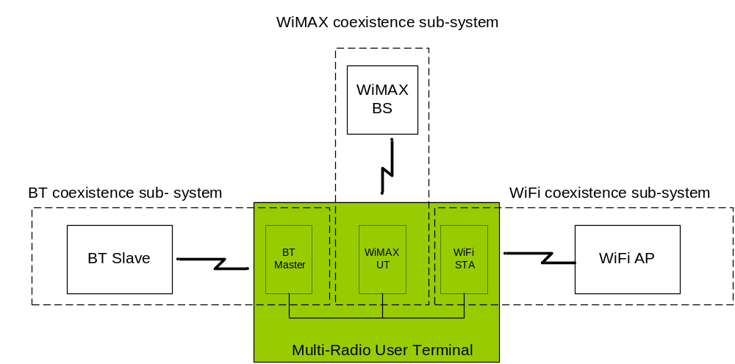
Collocated Coexistence System

Unlike the legacy MAC design, which only interacts with upper / lower layers within a sub-system, the proposed architecture allows for information exchange between different sub-systems to collaboratively coordinate their media access activities. As far as the IEEE 802.16m standard is concerned, only the air interface for coexistence coordination needs to be specified, providing definitions for the following:

- coexistence activity configurations
- messages to manage coexistence activities
- actions (in media access control) in response to a coexistence activity

An example of multi-radio coexistence system is shown below, where Bluetooth master, Wi-Fi station, and WiMAX MS radio interfaces are co-located on the same multi-radio user terminal. Radio activity including transmission (TX) and reception (RX) in WiMAX sub-system may impact or be impacted by the radio activities of other sub-systems (e.g. Bluetooth and Wi-Fi) due to cross-radio (in-band or out-band) interference or resource sharing (e.g. antenna), when they are simultaneously operated. There are two interfaces at WiMAX MS: inter-radio interface and air interface. The inter-radio interface is used for exchanging information among different radios. Its implementation is proprietary and vendor specific. The air-interface is used for exchanging information between BS and MS, and needs to be specified in IEEE 802.16m.

IEEE 802.16m will provide explicit coexistence control at the MAC layer to support multi-radio coexistence. Specifically, MS coexistence control will interface with other collocated radios/logic to collect coexistence activities of its collocated radios, and advertise/negotiate these activities with BS coexistence control.

Coexistence-Aware Air Interface
Coexistence
Control
Inter-Radio Interface
Radio x
Coexistence Control Logic
(Proprietary)
Arbitrator
802.16m Radio
Coexistence
Information Service
Activity Notification
Collocated Interference Report
Coordination
/
Negotiation
Grant
Activity
Request
To be specified in the 802.16m Standard

Proposed Text for SDD
Insert the following text into IEEE 802.16m System Reference Model sub-clause (i.e. Chapter 5 in [1]):
------------------------------- Text Start ---------------------------------------------------
Insert the text and the figures from Section 4 of this contribution here.
------------------------------- Text End ---------------------------------------------------
Insert the following text into IEEE 802.16m Mobile Station State Diagrams sub-clause (i.e. Chapter 6 in [1]):
------------------------------- Text Start ---------------------------------------------------
Insert the text and the figures from Section 6 of this contribution here.
------------------------------- Text End ---------------------------------------------------
Insert the following text into IEEE 802.16m Air-Interface Protocol Structure sub-clause (i.e. Chapter 8 in [1]):
------------------------------- Text Start ---------------------------------------------------
Insert the text and the figures from Sections 7 and 8 of this contribution here.
------------------------------- Text End ---------------------------------------------------

References
[1] IEEE C802.16m-07/320r1, “Draft Table of Content for the IEEE 802.16m System Description Document.”, November 2007.

