Project | IEEE 802.16 Broadband Wireless Access Working Group <http://ieee802.org/16>
Title | IEEE 802.16m CTC block sizes and interleaver
Date Submitted | 2009-01-07
Source(s) | Seunghyun Kang, Sukwoo Lee  LG Electronics | Voice: +82-31-450-1918  E-mail: sh_kang@lge.com, sugoo@lge.com
Re: | “802.16m amendment text”: IEEE 802.16m-08/053r1, “Call for Contributions on Project 802.16m Draft Amendment Content” for the topic of “Channel Coding”
Abstract | This contribution proposes IEEE 802.16m CTC block sizes and their interleaver parameters.
Purpose | To be discussed by TGm for use in the IEEE 802.16m amendment text.
Notice | This document does not represent the agreed views of the IEEE 802.16 Working Group or any of its subgroups. It represents only the views of the participants listed in the “Source(s)” field above. It is offered as a basis for discussion. It is not binding on the contributor(s), who reserve(s) the right to add, amend or withdraw material contained herein.
Release | The contributor grants a free, irrevocable license to the IEEE to incorporate material contained in this contribution, and any modifications thereof, in the creation of an IEEE Standards publication; to copyright in the IEEE’s name any IEEE Standards publication even though it may include portions of this contribution; and at the IEEE’s sole discretion to permit others to reproduce in whole or in part the resulting IEEE Standards publication. The contributor also acknowledges and accepts that this contribution may be made public by IEEE 802.16.
Patent Policy | The contributor is familiar with the IEEE-SA Patent Policy and Procedures:  <http://standards.ieee.org/guides/bylaws/sect6-7.html#6> and <http://standards.ieee.org/guides/opman/sect6.html#6.3>.  Further information is located at <http://standards.ieee.org/board/pat/pat-material.html> and <http://standards.ieee.org/board/pat>.

IEEE 802.16m CTC block sizes and interleaver
Seunghyun Kang, Sukwoo Lee
LG Electronics

Introduction
This contribution proposes the CTC (Convolutional Turbo Codes) information block sizes and their interleaver (both CTC inner interleaver and CTC subblock interleaver) parameters for IEEE 802.16m CTC based on the IEEE 802.16m SDD [2].

CTC information block size
According to the current SDD [2], the FEC block sizes are regularly increased with pre-determined block size resolutions. In addition, the FEC block sizes which are multiple of 7 shall be removed for the tail-biting encoding structure of CTC. Also, when the size of a data burst including a burst CRC exceeds the maximum FEC block size of 4800 bits, it is partitioned into a number of FEC blocks, each of which is encoded separately. Note that an information block consists of all the input bits of FEC encoders. Since information block comprises one or more FEC blocks, it is natural that information block sizes have the same resolutions as those of FEC block sizes. Table 1 specifies the proposed information block size (or FEC block size) resolutions and their block size ranges.

Table 1 ─ Information block size resolutions
Block size range | Resolution
48 ~ 512 | 8
512 ~ 1024 | 16
1024 ~ 2048 | 32
2048 ~ | 64

For the data burst size N_{Burst}, information block size N_{Info} is specified by following steps:

Step 1: Number of FEC blocks

When the amount of N_{Burst} data burst bits and CRC_{Burst} burst CRC bits exceeds the maximum FEC block size N_{MaxEP}, the data burst including data burst CRC is partitioned into N_{FEC} FEC blocks, and an FEC block CRC is appended to each FEC block before the FEC encoding. Considering CRC_{FEC} bits FEC block CRC, the number of FEC blocks N_{FEC} is specified as follows.

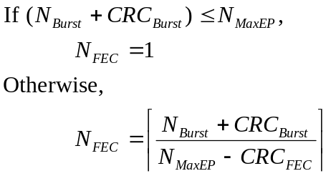

Step 2: Information block size

When the size of data burst including burst CRC is less than 48 bits, N_{Info} shall be forced to be 48 bits which is the minimum FEC block size of CTC. When there exists only one FEC block in an information block, an information block size represents an FEC block size. Also, an information block size which is multiple of 7 shall be removed. When the burst partition is performed, so there exist N_{FEC} FEC blocks, an information block includes N_{FEC} FEC block CRCs as a part of itself. Also, the information block sizes which are larger than 4800 bits include the sizes of multiple of 7 since it is able to partition each of them into several FEC block sizes, (see 15.13.1.5.1.1.4.1 in [3]). Note that δ is a block size resolution in Table 1 and it shall be specified by using (N_{Burst} + CRC_{Burst}) instead of the information block size for chasing its range.

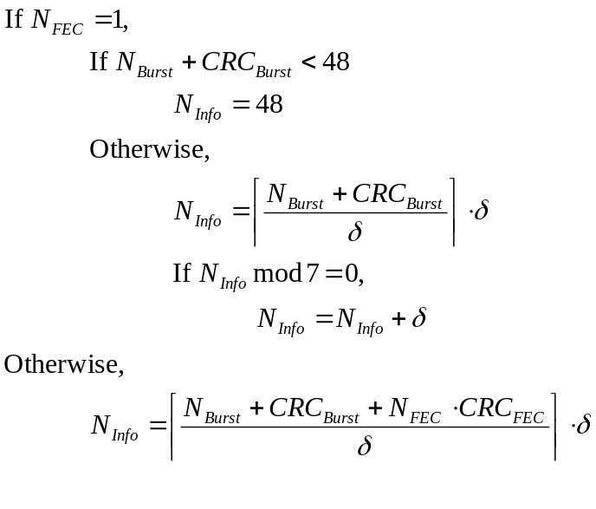 (1)

When the total amount of data burst bits, burst CRC bits and FEC block CRC bits does not fit exactly the amount of information bits, a number of padding bits shall be added to the data burst. The amount of padding bits N_{Padding} is given as follows.

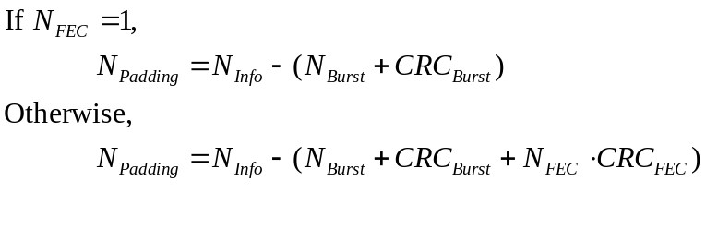 (2)
By using the information block size resolutions in Table 1 and equation (1), the information block sizes shall be specified for IEEE 802.16m CTC. In Table 2 and Table 3, CTC block sizes have been provided with their interleaver parameters.

Padding overhead analysis
Figure 1shows the average padding bit overhead for the CTC block sizes in Table 2 and Table 3. As compared with IEEE 802.16e CTC block sizes, the proposed CTC block sizes have much reduced padding overhead since they have finer granularities.
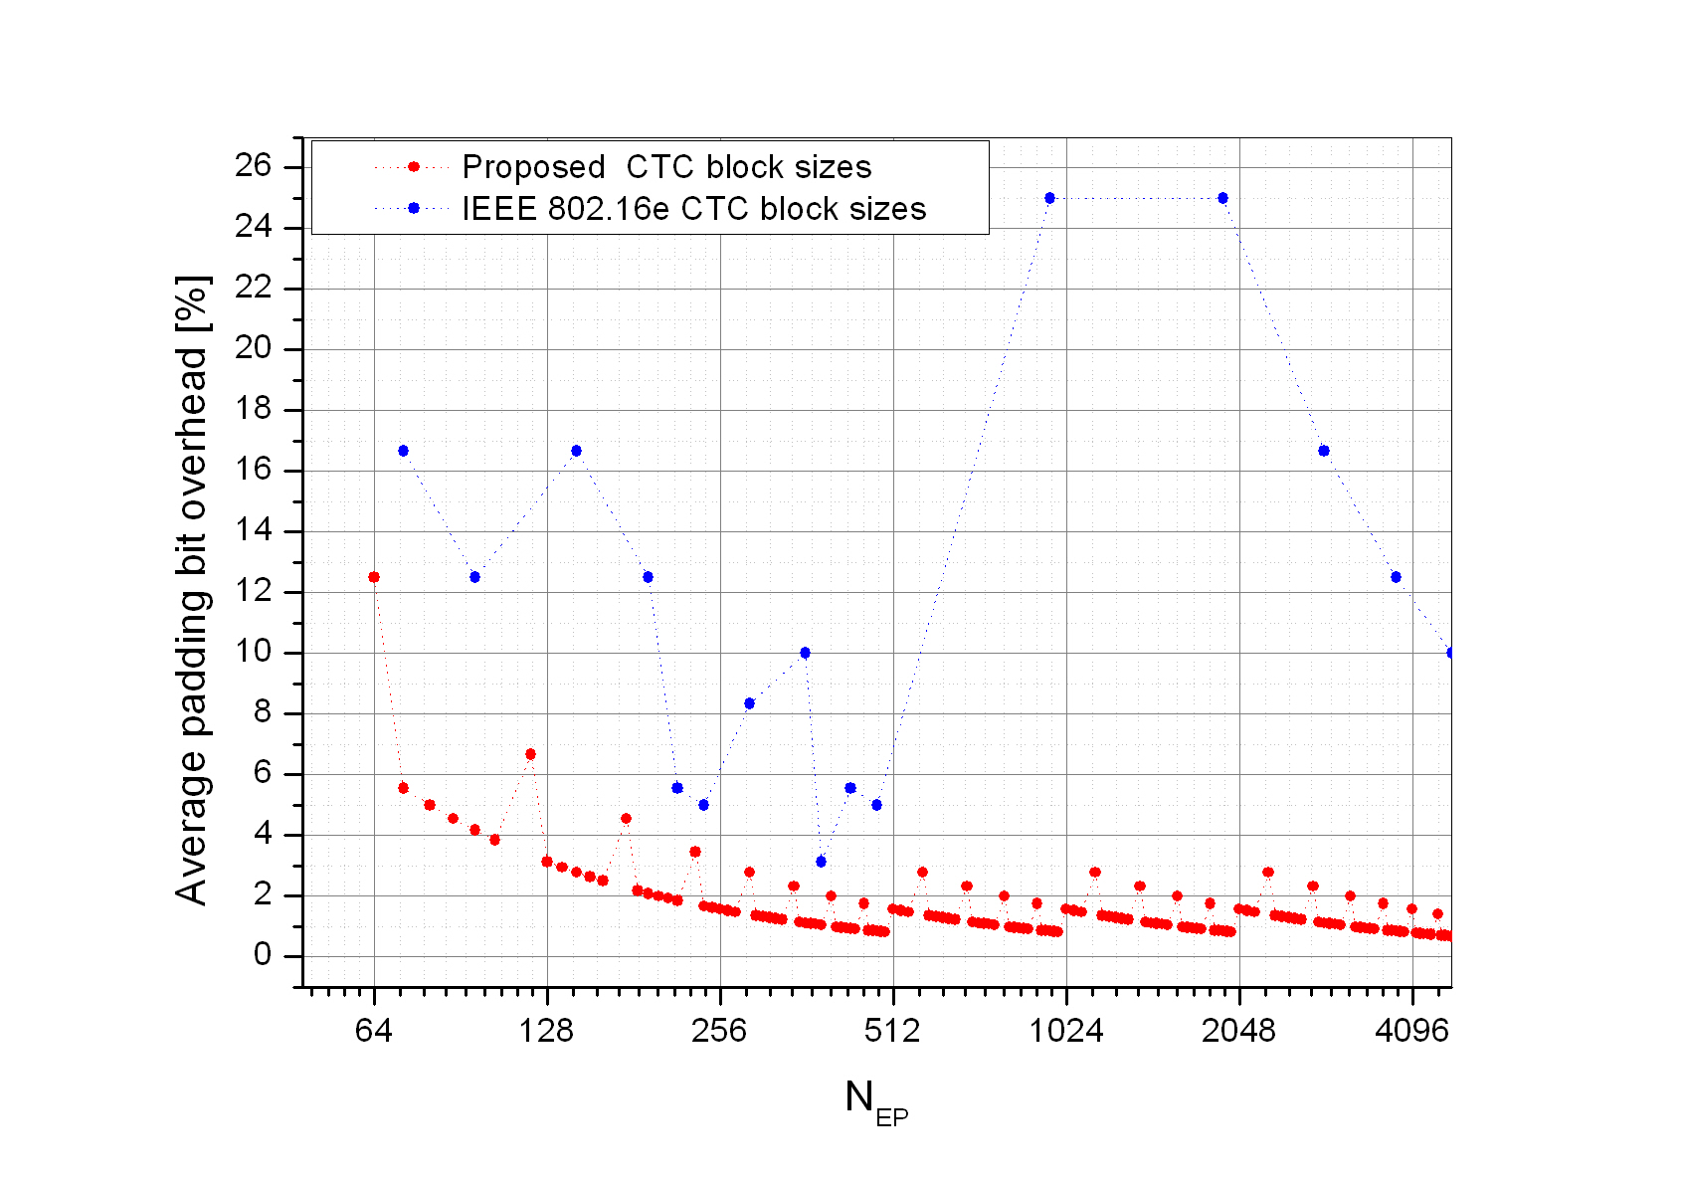
Figure 1 ─ Average padding bit overhead for the proposed CTC block sizes

Proposed CTC interleavers
In the current SDD [2], the CTC inner interleaver parameters for additional FEC block sizes are FFS while maintaining IEEE 802.16e CTC interleaver. For IEEE 802.16m CTC block sizes, we propose the CTC inner interleaver parameters in section 4.1. Also, we propose CTC subblock interleaver parameters in section 4.2.

CTC inner interleaver
We propose the CTC inner interleaver parameters which consist of 4 values P₀, P₁, P₂ and P₃ in Table 2.
Table 2 ─ CTC inner interleaver parameters
N_{EP} | N | P₀ | P₁ | P₂ | P₃ | N_{EP} | N | P₀ | P₁ | P₂ | P₃ | N_{EP} | N | P₀ | P₁ | P₂ | P₃
48 | 24 | 5 | 0 | 0 | 0 | 488 | 244 | 17 | 140 | 92 | 220 | 1696 | 848 | 37 | 722 | 136 | 698
64 | 32 | 11 | 12 | 0 | 12 | 496 | 248 | 17 | 194 | 0 | 58 | 1728 | 864 | 31 | 176 | 152 | 516
72 | 36 | 11 | 18 | 0 | 18 | 512 | 256 | 19 | 64 | 52 | 124 | 1760 | 880 | 23 | 646 | 484 | 850
80 | 40 | 7 | 4 | 32 | 36 | 528 | 264 | 17 | 36 | 196 | 100 | 1824 | 912 | 41 | 774 | 548 | 898
88 | 44 | 13 | 36 | 36 | 32 | 544 | 272 | 19 | 222 | 248 | 134 | 1856 | 928 | 47 | 576 | 212 | 728
96 | 48 | 13 | 24 | 0 | 24 | 576 | 288 | 23 | 76 | 220 | 92 | 1888 | 944 | 39 | 342 | 596 | 798
104 | 52 | 7 | 4 | 8 | 48 | 592 | 296 | 23 | 96 | 172 | 36 | 1920 | 960 | 43 | 318 | 556 | 778
120 | 60 | 11 | 30 | 0 | 34 | 608 | 304 | 23 | 288 | 244 | 140 | 1952 | 976 | 35 | 94 | 144 | 686
128 | 64 | 13 | 46 | 44 | 30 | 624 | 312 | 23 | 286 | 220 | 70 | 1984 | 992 | 43 | 84 | 488 | 92
136 | 68 | 13 | 58 | 4 | 58 | 640 | 320 | 23 | 84 | 296 | 236 | 2048 | 1024 | 31 | 2 | 332 | 622
144 | 72 | 11 | 6 | 0 | 6 | 656 | 328 | 23 | 24 | 300 | 52 | 2112 | 1056 | 43 | 96 | 720 | 980
152 | 76 | 11 | 38 | 12 | 74 | 688 | 344 | 19 | 320 | 4 | 324 | 2176 | 1088 | 37 | 428 | 976 | 28
160 | 80 | 13 | 68 | 76 | 64 | 704 | 352 | 19 | 52 | 76 | 256 | 2304 | 1152 | 41 | 16 | 484 | 888
176 | 88 | 17 | 52 | 68 | 32 | 720 | 360 | 23 | 130 | 156 | 238 | 2368 | 1184 | 47 | 228 | 440 | 724
184 | 92 | 13 | 2 | 0 | 2 | 736 | 368 | 29 | 126 | 208 | 270 | 2432 | 1216 | 43 | 452 | 888 | 96
192 | 96 | 7 | 58 | 48 | 10 | 752 | 376 | 23 | 26 | 24 | 230 | 2496 | 1248 | 43 | 0 | 208 | 528
200 | 100 | 11 | 76 | 0 | 24 | 768 | 384 | 29 | 252 | 0 | 8 | 2560 | 1280 | 53 | 264 | 488 | 824
208 | 104 | 11 | 10 | 32 | 42 | 800 | 400 | 23 | 150 | 216 | 150 | 2624 | 1312 | 47 | 378 | 1092 | 1250
216 | 108 | 11 | 54 | 56 | 2 | 816 | 408 | 29 | 342 | 132 | 42 | 2752 | 1376 | 37 | 430 | 880 | 970
232 | 116 | 11 | 70 | 60 | 58 | 832 | 416 | 23 | 354 | 164 | 198 | 2816 | 1408 | 31 | 624 | 704 | 400
240 | 120 | 13 | 60 | 0 | 60 | 848 | 424 | 29 | 234 | 388 | 82 | 2880 | 1440 | 43 | 720 | 360 | 540
248 | 124 | 13 | 6 | 84 | 46 | 864 | 432 | 29 | 216 | 272 | 180 | 2944 | 1472 | 41 | 338 | 650 | 646
256 | 128 | 11 | 64 | 8 | 8 | 880 | 440 | 29 | 410 | 328 | 218 | 3008 | 1504 | 43 | 916 | 1136 | 912
264 | 132 | 13 | 72 | 68 | 8 | 912 | 456 | 29 | 14 | 264 | 94 | 3072 | 1536 | 53 | 184 | 824 | 1368
272 | 136 | 13 | 82 | 44 | 38 | 928 | 464 | 23 | 446 | 392 | 186 | 3200 | 1600 | 43 | 1382 | 632 | 1086
288 | 144 | 17 | 74 | 72 | 2 | 944 | 472 | 23 | 356 | 68 | 332 | 3264 | 1632 | 49 | 142 | 828 | 1354
296 | 148 | 13 | 0 | 84 | 64 | 960 | 480 | 53 | 62 | 12 | 2 | 3328 | 1664 | 37 | 258 | 28 | 1522
304 | 152 | 13 | 130 | 112 | 46 | 976 | 488 | 31 | 134 | 124 | 366 | 3392 | 1696 | 51 | 460 | 56 | 1608
312 | 156 | 11 | 32 | 124 | 108 | 992 | 496 | 29 | 358 | 480 | 362 | 3456 | 1728 | 43 | 170 | 920 | 1518
320 | 160 | 17 | 84 | 108 | 132 | 1024 | 512 | 29 | 320 | 236 | 324 | 3520 | 1760 | 57 | 776 | 1232 | 1012
328 | 164 | 17 | 148 | 160 | 76 | 1056 | 528 | 31 | 86 | 380 | 250 | 3648 | 1824 | 49 | 132 | 720 | 276
344 | 172 | 17 | 160 | 116 | 52 | 1088 | 544 | 31 | 432 | 216 | 524 | 3712 | 1856 | 41 | 1328 | 772 | 1036
352 | 176 | 17 | 106 | 56 | 50 | 1152 | 576 | 31 | 534 | 372 | 246 | 3776 | 1888 | 53 | 772 | 256 | 408
360 | 180 | 17 | 40 | 132 | 128 | 1184 | 592 | 31 | 2 | 568 | 94 | 3840 | 1920 | 53 | 92 | 1124 | 476
368 | 184 | 19 | 88 | 0 | 172 | 1216 | 608 | 31 | 368 | 584 | 524 | 3904 | 1952 | 51 | 664 | 200 | 64
376 | 188 | 13 | 110 | 92 | 14 | 1248 | 624 | 31 | 88 | 404 | 608 | 3968 | 1984 | 57 | 1296 | 760 | 1360
384 | 192 | 11 | 96 | 48 | 144 | 1280 | 640 | 29 | 152 | 8 | 24 | 4096 | 2048 | 55 | 148 | 808 | 308
400 | 200 | 19 | 142 | 0 | 142 | 1312 | 656 | 31 | 214 | 160 | 506 | 4160 | 2080 | 79 | 214 | 308 | 262
408 | 204 | 23 | 42 | 20 | 46 | 1376 | 688 | 31 | 218 | 20 | 670 | 4224 | 2112 | 59 | 14 | 668 | 1474
416 | 208 | 17 | 102 | 132 | 178 | 1408 | 704 | 29 | 474 | 584 | 118 | 4288 | 2144 | 57 | 662 | 1516 | 42
424 | 212 | 17 | 138 | 56 | 18 | 1440 | 720 | 41 | 288 | 556 | 672 | 4352 | 2176 | 59 | 2052 | 712 | 1804
432 | 216 | 17 | 126 | 92 | 74 | 1472 | 736 | 29 | 164 | 424 | 76 | 4416 | 2208 | 59 | 1342 | 1968 | 1562
440 | 220 | 19 | 48 | 20 | 144 | 1504 | 752 | 31 | 254 | 416 | 474 | 4544 | 2272 | 65 | 1380 | 1068 | 1036
456 | 228 | 17 | 184 | 0 | 48 | 1536 | 768 | 31 | 34 | 564 | 710 | 4608 | 2304 | 67 | 954 | 1140 | 1566
464 | 232 | 17 | 62 | 52 | 114 | 1600 | 800 | 31 | 454 | 216 | 234 | 4672 | 2336 | 67 | 410 | 1020 | 114
472 | 236 | 19 | 40 | 104 | 28 | 1632 | 816 | 29 | 334 | 564 | 66 | 4736 | 2368 | 59 | 2 | 956 | 458
480 | 240 | 13 | 120 | 60 | 180 | 1664 | 832 | 31 | 156 | 568 | 56 | 4800 | 2400 | 53 | 66 | 24 | 2

CTC subblock interleaver
We propose the CTC subblock interleaver parameters which consist of 2 values m and J in Table 3.
Table 3 ─ CTC subblock interleaver parameters
N_{EP} | N | m | J | N_{EP} | N | m | J | N_{EP} | N | m | J
48 | 24 | 3 | 3 | 488 | 244 | 7 | 2 | 1696 | 848 | 8 | 4
64 | 32 | 4 | 3 | 496 | 248 | 7 | 2 | 1728 | 864 | 8 | 4
72 | 36 | 4 | 3 | 512 | 256 | 7 | 2 | 1760 | 880 | 8 | 4
80 | 40 | 4 | 3 | 528 | 264 | 7 | 3 | 1824 | 912 | 8 | 4
88 | 44 | 4 | 3 | 544 | 272 | 7 | 3 | 1856 | 928 | 8 | 4
96 | 48 | 4 | 3 | 576 | 288 | 7 | 3 | 1888 | 944 | 8 | 4
104 | 52 | 5 | 3 | 592 | 296 | 7 | 3 | 1920 | 960 | 9 | 2
120 | 60 | 5 | 3 | 608 | 304 | 7 | 3 | 1952 | 976 | 9 | 2
128 | 64 | 5 | 3 | 624 | 312 | 7 | 3 | 1984 | 992 | 9 | 2
136 | 68 | 5 | 3 | 640 | 320 | 7 | 3 | 2048 | 1024 | 9 | 2
144 | 72 | 5 | 3 | 656 | 328 | 7 | 3 | 2112 | 1056 | 9 | 3
152 | 76 | 5 | 3 | 688 | 344 | 7 | 3 | 2176 | 1088 | 9 | 3
160 | 80 | 5 | 3 | 704 | 352 | 7 | 3 | 2304 | 1152 | 9 | 3
176 | 88 | 5 | 3 | 720 | 360 | 7 | 3 | 2368 | 1184 | 9 | 3
184 | 92 | 5 | 3 | 736 | 368 | 7 | 3 | 2432 | 1216 | 9 | 3
192 | 96 | 5 | 3 | 752 | 376 | 7 | 3 | 2496 | 1248 | 9 | 3
200 | 100 | 6 | 2 | 768 | 384 | 7 | 3 | 2560 | 1280 | 9 | 3
208 | 104 | 6 | 2 | 800 | 400 | 7 | 4 | 2624 | 1312 | 9 | 3
216 | 108 | 6 | 2 | 816 | 408 | 7 | 4 | 2752 | 1376 | 9 | 3
232 | 116 | 6 | 2 | 832 | 416 | 7 | 4 | 2816 | 1408 | 9 | 3
240 | 120 | 6 | 2 | 848 | 424 | 7 | 4 | 2880 | 1440 | 9 | 3
248 | 124 | 6 | 2 | 864 | 432 | 7 | 4 | 2944 | 1472 | 9 | 3
256 | 128 | 6 | 2 | 880 | 440 | 7 | 4 | 3008 | 1504 | 9 | 3
264 | 132 | 6 | 3 | 912 | 456 | 8 | 2 | 3072 | 1536 | 9 | 3
272 | 136 | 6 | 3 | 928 | 464 | 8 | 2 | 3200 | 1600 | 9 | 4
288 | 144 | 6 | 3 | 944 | 472 | 8 | 2 | 3264 | 1632 | 9 | 4
296 | 148 | 6 | 3 | 960 | 480 | 8 | 2 | 3328 | 1664 | 9 | 4
304 | 152 | 6 | 3 | 976 | 488 | 8 | 2 | 3392 | 1696 | 9 | 4
312 | 156 | 6 | 3 | 992 | 496 | 8 | 2 | 3456 | 1728 | 9 | 4
320 | 160 | 6 | 3 | 1024 | 512 | 8 | 2 | 3520 | 1760 | 9 | 4
328 | 164 | 6 | 3 | 1056 | 528 | 8 | 3 | 3648 | 1824 | 9 | 4
344 | 172 | 6 | 3 | 1088 | 544 | 8 | 3 | 3712 | 1856 | 9 | 4
352 | 176 | 6 | 3 | 1152 | 576 | 8 | 3 | 3776 | 1888 | 9 | 4
360 | 180 | 6 | 3 | 1184 | 592 | 8 | 3 | 3840 | 1920 | 10 | 2
368 | 184 | 6 | 3 | 1216 | 608 | 8 | 3 | 3904 | 1952 | 10 | 2
376 | 188 | 6 | 3 | 1248 | 624 | 8 | 3 | 3968 | 1984 | 10 | 2
384 | 192 | 6 | 3 | 1280 | 640 | 8 | 3 | 4096 | 2048 | 10 | 2
400 | 200 | 6 | 4 | 1312 | 656 | 8 | 3 | 4160 | 2080 | 10 | 3
408 | 204 | 6 | 4 | 1376 | 688 | 8 | 3 | 4224 | 2112 | 10 | 3
416 | 208 | 6 | 4 | 1408 | 704 | 8 | 3 | 4288 | 2144 | 10 | 3
424 | 212 | 6 | 4 | 1440 | 720 | 8 | 3 | 4352 | 2176 | 10 | 3
432 | 216 | 6 | 4 | 1472 | 736 | 8 | 3 | 4416 | 2208 | 10 | 3
440 | 220 | 6 | 4 | 1504 | 752 | 8 | 3 | 4544 | 2272 | 10 | 3
456 | 228 | 6 | 4 | 1536 | 768 | 8 | 3 | 4608 | 2304 | 10 | 3
464 | 232 | 6 | 4 | 1600 | 800 | 8 | 4 | 4672 | 2336 | 10 | 3
472 | 236 | 6 | 4 | 1632 | 816 | 8 | 4 | 4736 | 2368 | 10 | 3
480 | 240 | 7 | 2 | 1664 | 832 | 8 | 4 | 4800 | 2400 | 10 | 3

BLER performance evaluation
In Figure 2, the BLER performance of the proposed CTC block sizes has been performed with the required SNR values versus CTC block sizes at target BLER 10%, 1%, and 0.1%. For this performance evaluation, the CTC inner interleaver parameters and sub block interleaver parameters in Table 2 and Table 3 have been used. Also, the simulation environment includes the code rate of 1/3, AWGN channel, QPSK modulation and Max-log-MAP (with No scaling factor) decoding with 8 iterations. As shown in Figure 2, the interleaver parameters make a good performance enhancement while increasing the CTC block sizes from 48 bits to 4800 bits.
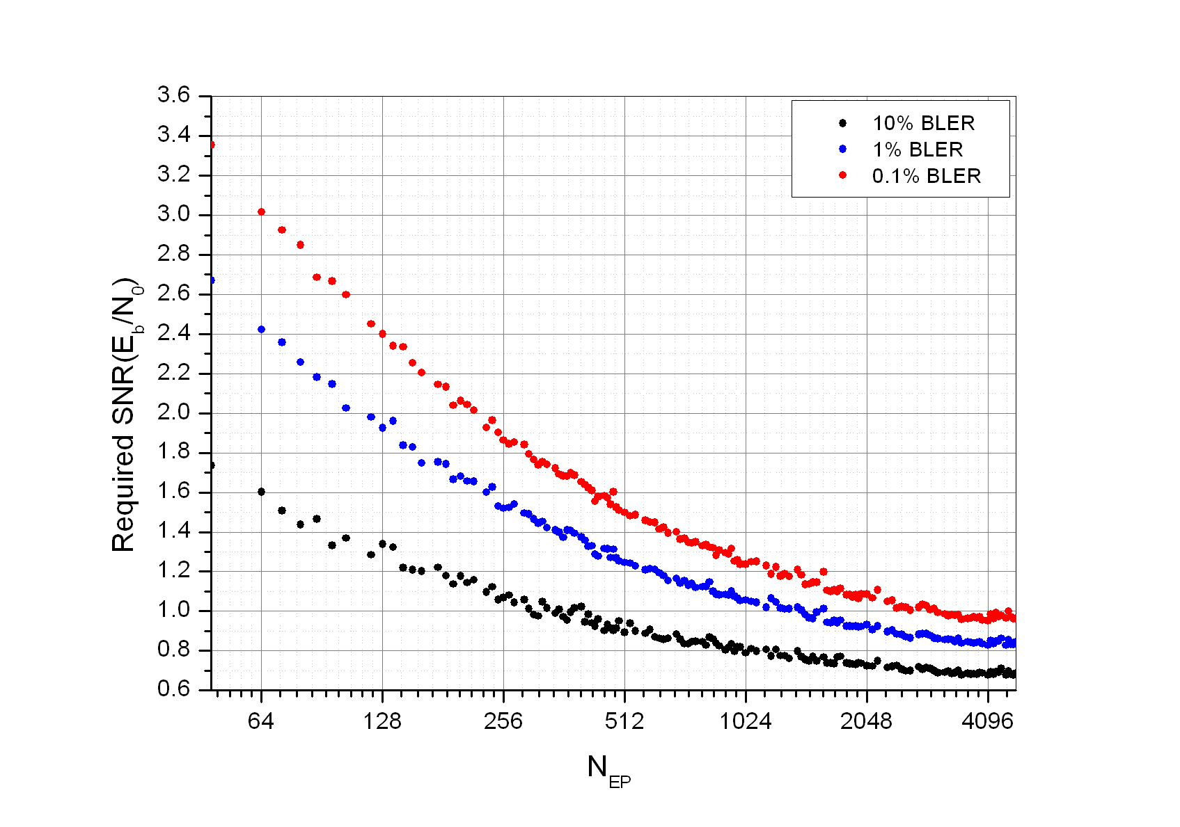
Figure 2 ─ BLER performance (N_{EP} versus Required SNR)

For the purpose of performance enhancement, the proposed CTC inner interleaver parameters in Table 2 include new interleaver parameters which are different from those of IEEE 802.16e CTC as shown in Table 4. Figure 3 shows the BLER performances using both IEEE 802.16e parameters and the proposed CTC inner interleaver parameters in Table 4. As shown in Figure 3, the BLER performances using new parameters have been improved than those using old parameters.
Table 4 ─ New CTC inner interleaver parameters with IEEE 802.16e CTC block sizes
N_{EP} | N | P₀ | P₁ | P₂ | P₃
48 | 24 | 5 | 0 | 0 | 0
72 | 36 | 11 | 18 | 0 | 18
96 | 48 | 13 | 24 | 0 | 24
144 | 72 | 11 | 6 | 0 | 6
192 | 96 | 7 7 | 48 58 | 24 48 | 72 10
216 | 108 | 11 | 54 | 56 | 2
240 | 120 | 13 | 60 | 0 | 60
288 | 144 | 17 | 74 | 72 | 2
360 | 180 | 11 17 | 90 40 | 0 132 | 90 128
384 | 192 | 11 | 96 | 48 | 144
432 | 216 | 13 17 | 108 126 | 0 92 | 108 74
480 | 240 | 13 | 120 | 60 | 180
960 | 480 | 53 | 62 | 12 | 2
1920 | 960 | 43 43 | 64 318 | 300 556 | 824 778
2880 | 1440 | 43 | 720 | 360 | 540
3840 | 1920 | 31 53 | 8 92 | 24 1124 | 16 476
4800 | 2400 | 53 | 66 | 24 | 2

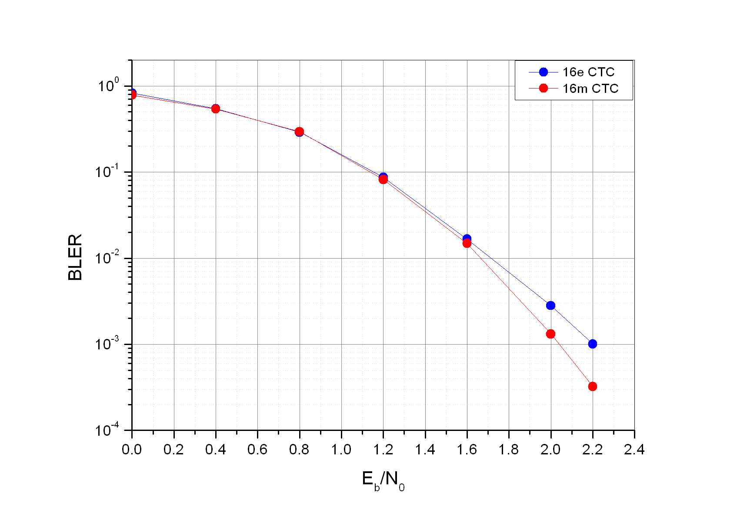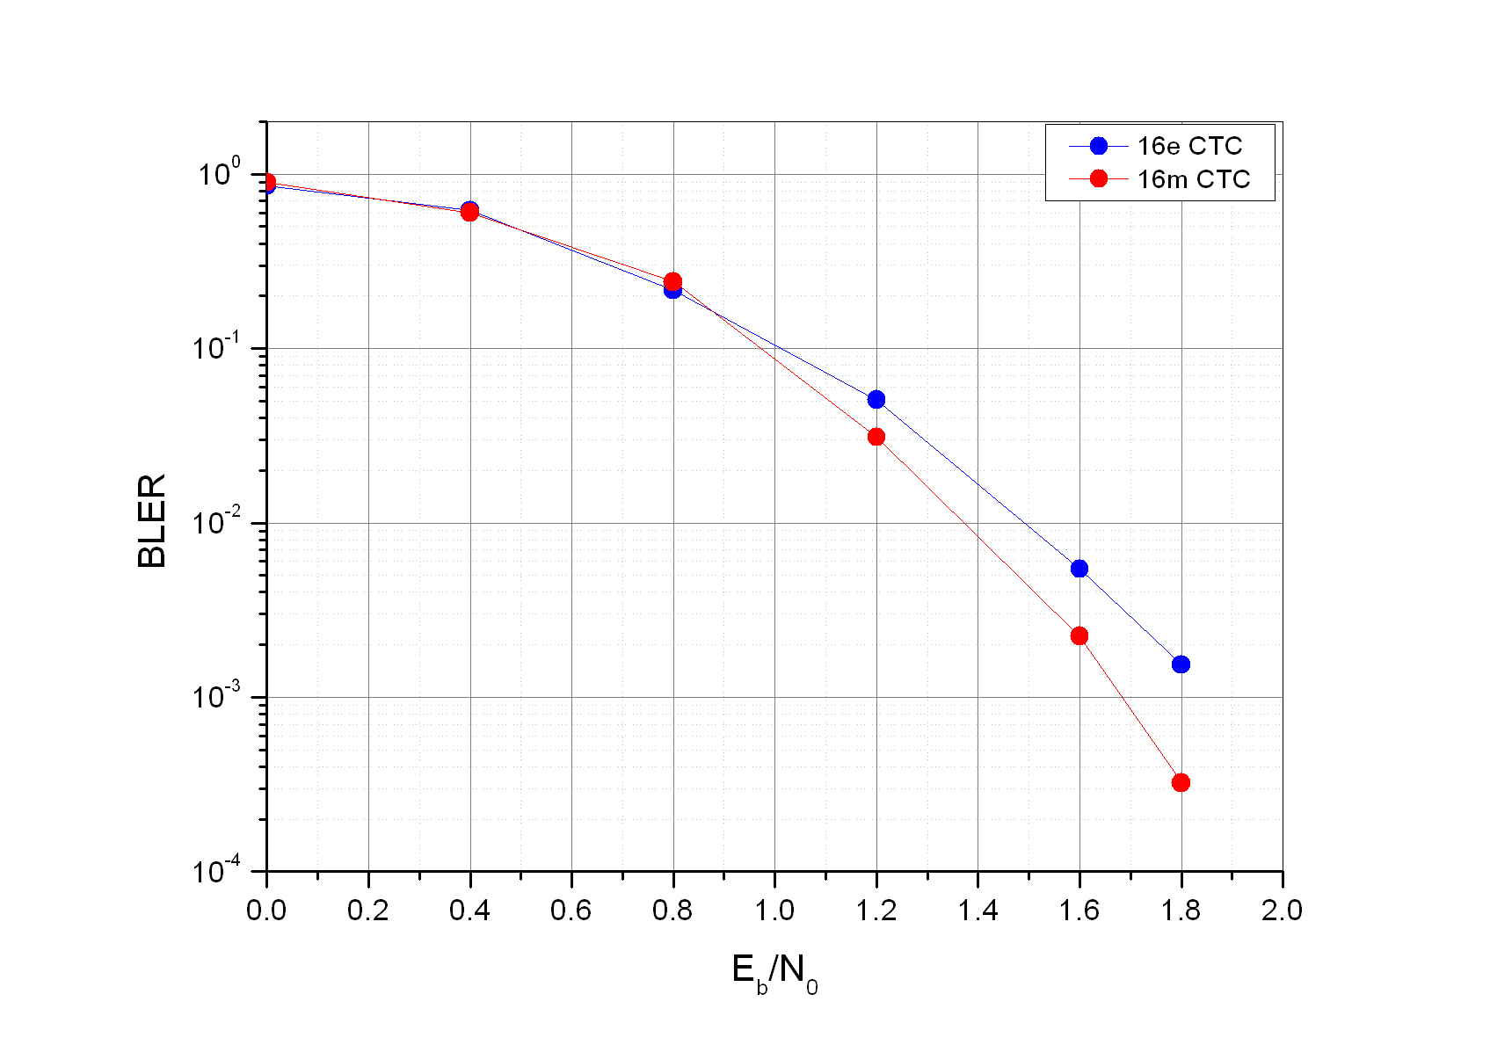
a) N_{EP} = 192 b) N_{EP} = 360

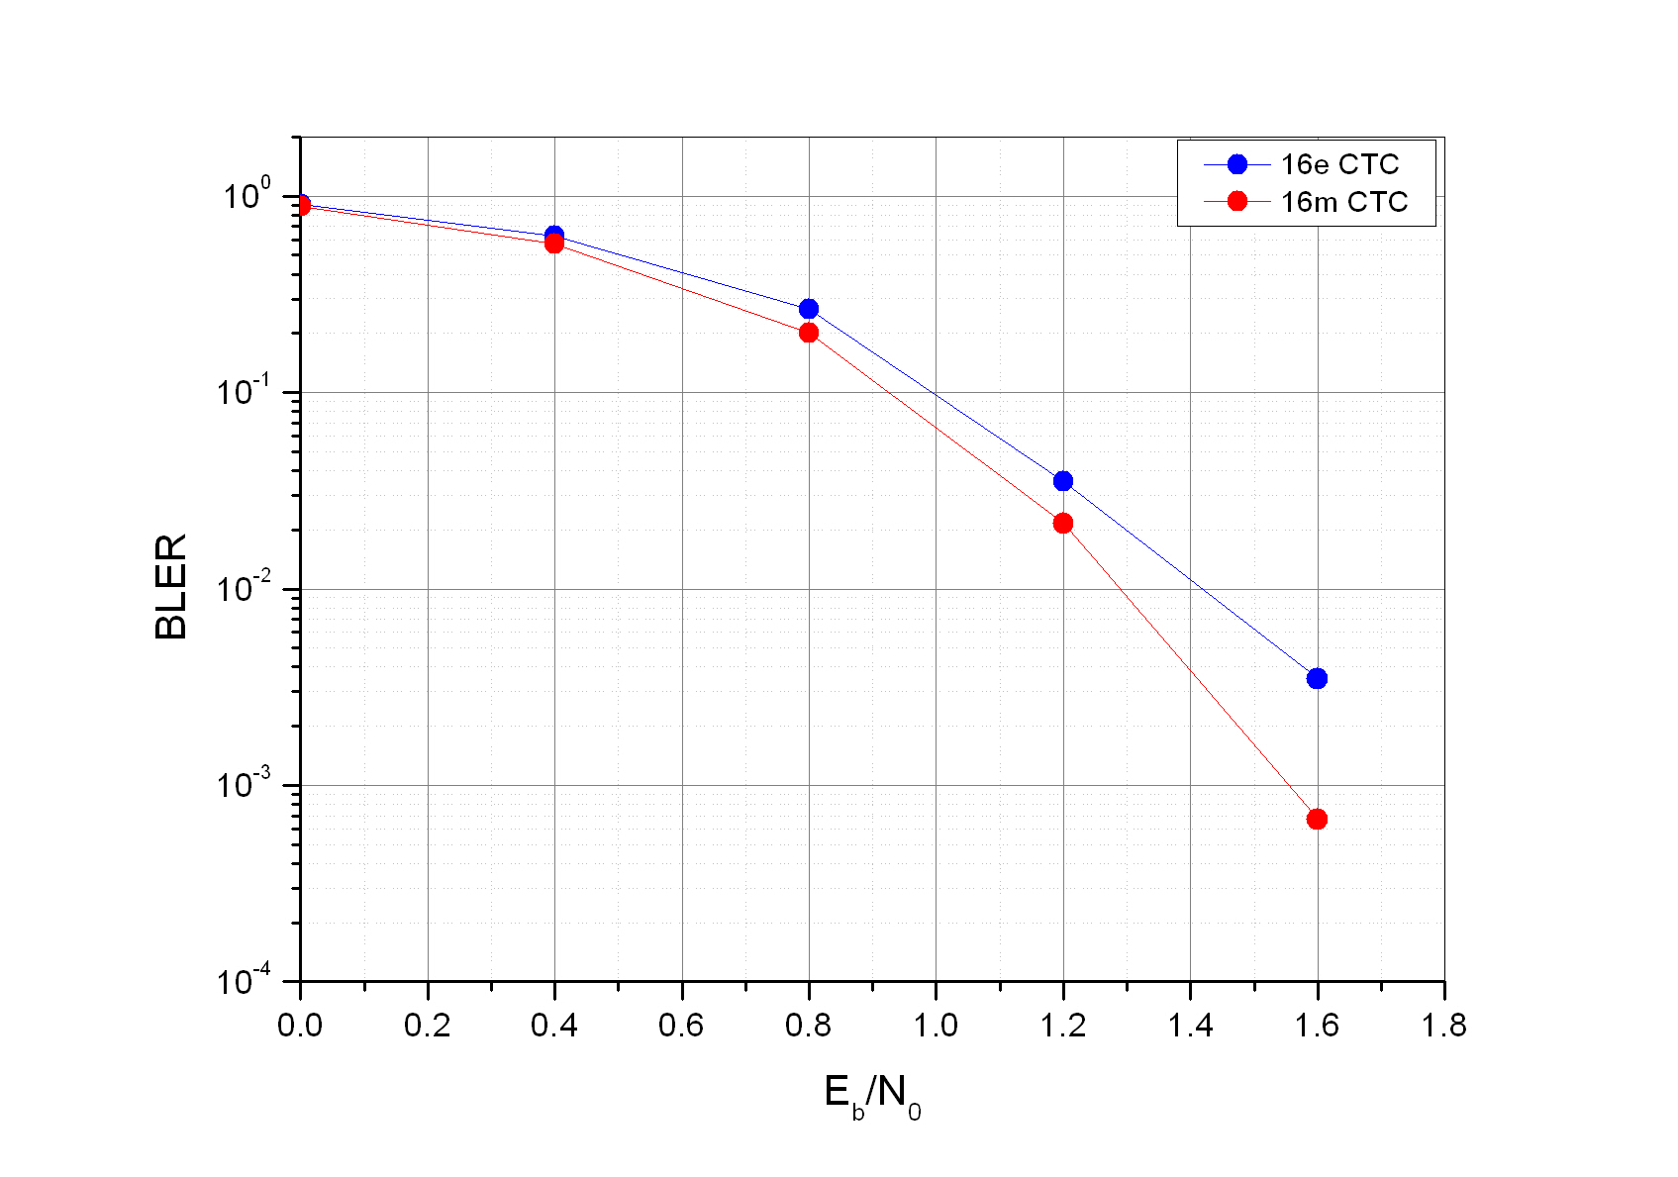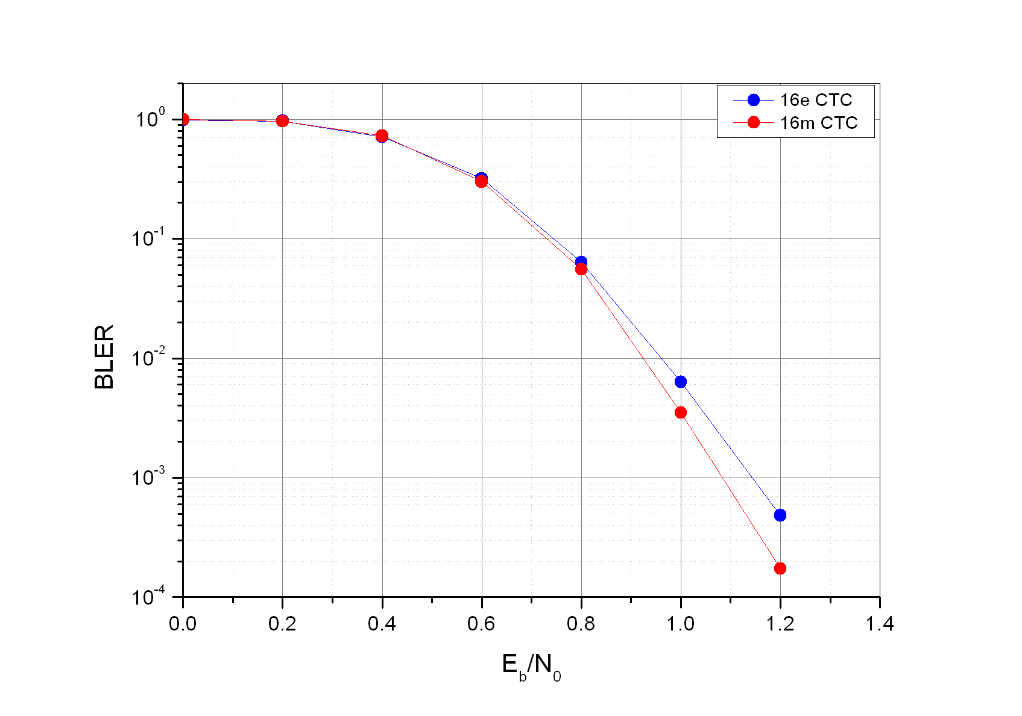
c) N_{EP} = 432 d) N_{EP} = 1920

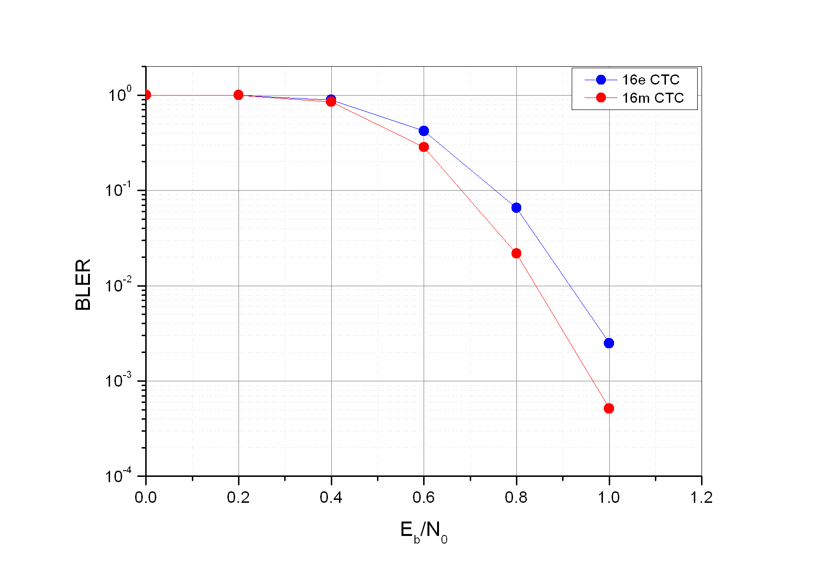
e) N_{EP} = 3840
Figure 3 ─ BLER performance comparison

References

[1] IEEE P802.16 Rev2/D8, “Draft IEEE Standard for Local and Metropolitan Area Networks: Air Interface
for Broadband Wireless Access,” Dec. 2008.
[2] IEEE 802.16m-08/003r6, “The Draft IEEE 802.16m System Description Document”
[3] IEEE 802.16m-09/0312, “Proposed Amendment Text on Channel Coding”

