Project | IEEE 802.16 Broadband Wireless Access Working Group <http://ieee802.org/16>
Title | Centralized Scheduling for Two Hop Relay Networks
Date Submitted | 2009-11-06
Source(s) | Karthik Sundaresan, Sampath Rangarajan, Linghang Fan, Mohammad A. (Amir) Khojastepour  NEC | karthiks@nec-labs.com
Re: | P802.16m/D2 Relay
Abstract | This contribution proposes text for consideration of centralized scheduling.
Purpose | To be discussed and adopted by TGm for use in IEEE 802.16m
Notice | This document does not represent the agreed views of the IEEE 802.16 Working Group or any of its subgroups. It represents only the views of the participants listed in the “Source(s)” field above. It is offered as a basis for discussion. It is not binding on the contributor(s), who reserve(s) the right to add, amend or withdraw material contained herein.
Release | The contributor grants a free, irrevocable license to the IEEE to incorporate material contained in this contribution, and any modifications thereof, in the creation of an IEEE Standards publication; to copyright in the IEEE’s name any IEEE Standards publication even though it may include portions of this contribution; and at the IEEE’s sole discretion to permit others to reproduce in whole or in part the resulting IEEE Standards publication. The contributor also acknowledges and accepts that this contribution may be made public by IEEE 802.16.
Patent Policy | The contributor is familiar with the IEEE-SA Patent Policy and Procedures:  <http://standards.ieee.org/guides/bylaws/sect6-7.html#6> and <http://standards.ieee.org/guides/opman/sect6.html#6.3>.  Further information is located at <http://standards.ieee.org/board/pat/pat-material.html> and <http://standards.ieee.org/board/pat>.

Centralized Scheduling for Two Hop Relay Networks
Karthik Sundaresan, Sampath Rangarajan, Linghang Fang, Amir Khojastepour
NEC

1. Introduction
The support for multi-hop relay has been included in the current 16m SDD [1]. Most of the application scenarios for 802.16m relays, which are in turn derived from 802.16j relays, consist mainly of two–hop networks [2]. While the relay stations (ARS) can be static or mobile (nomadic), the user terminals (AMS) are assumed to be mobile as represented in figure 1. While the current draft explicitly supports only distributed scheduling, we would like to emphasize the importance and inclusion of centralized scheduling for two hop relay networks with the following two arguments.

- One of the main reason a relay system is different and more sophisticated from a femto system is that the ABS has control over the data going to the ARS and AMS unlike in a femto system, where operation is not directly coordinated and the macro BS has no access to the data going to the femto ABS. Hence, interference mitigation (IM) is a big issue in femto systems. However, in relay systems, we have the advantage of taking care of the problem of interference effectively for two hops through centralized scheduling, where the ABS has control of the data being forwarded to the AMS. If centralized scheduling is not supported, then we are effectively forcing the relay system to be only as good as a femto system and putting ourselves in a disadvantageous position.

- Irrespective of where the control plane functionality is terminated (ABS or ARS), the data path has been agreed to be L2, which means that the BS has access to the data to be forwarded to the MS. Hence, the problem of scheduling is completely decoupled from control plane functionalities. Given that, this makes it easier to allow both the options of centralized and distributed scheduling. This does not interfere with the decision on control plane functionality. In addition, there are lots of merits to having centralized scheduling for two hops especially for addressing IM and effective flow matching between relay and access hops.

We present the pros and cons of both centralized and distributed scheduling to justify the need for centralized scheduling for the two-hop model.

Note that, there are different kinds of diversity gains available from relay networks:
multi-user diversity, channel (multiple OFDMA channels of varying gains) and hop diversity (varying gains on a channel across hops for a flow). However, to leverage these benefits effectively, centralized scheduling provides the best option for two hops taking throughput, delay and overhead into account. The pros and cons of centralized and distributed scheduling are listed below.

 | Distributed Scheduling | Centralized Scheduling
Throughput Performance | Inefficient scheduling  Lack of coordination –> interference  Diversity gains only within hops  No diversity gains across hops  Rate mismatch on relay & access hops  Buffer overflows and retransmissions | Efficient scheduling  Coordination – avoid interference  Diversity gains within and across hops  Efficient rate matching  Alleviate overflows & retransmissions
Delay | Delay increases with hops  Increased interference -> retransmissions -> increased delay | Delay increases with hops  Better than distributed
Signaling Overhead | CSI needed only at a hop level  Does not scale with increasing # hops | CSI from hops needed at eNB  Scales with increasing # hops  Not an issue for 2 hops
Complexity | Low complexity, processing delay at ABS  Increased complexity, processing delay at ARS | Increased complexity, processing delay at ABS  Low complexity, processing delay at ARS
Mobility Handover | Only reactive handovers possible | Proactive handovers possible; reduced handover delay

We evaluate the performance (preliminary) of centralized and distributed scheduling in a two-hop relay network consisting of 1 ABS, 30 AMS and 5 ARS. The MS are uniformly distributed around the ABS in a 600m cell radius. The ARS are distributed uniformly in the radius band between 275-325m from the ABS. The evaluations are conducted in an event-driven packet-level simulator, where UDP is used as the traffic source to generate packets for each of the flows (AMS) at a rate of 512 Kbps. The carrier frequency is 2.4 GHz, path loss component of 4 is used along with Rayleigh fading and log-normal shadowing for the channel model.

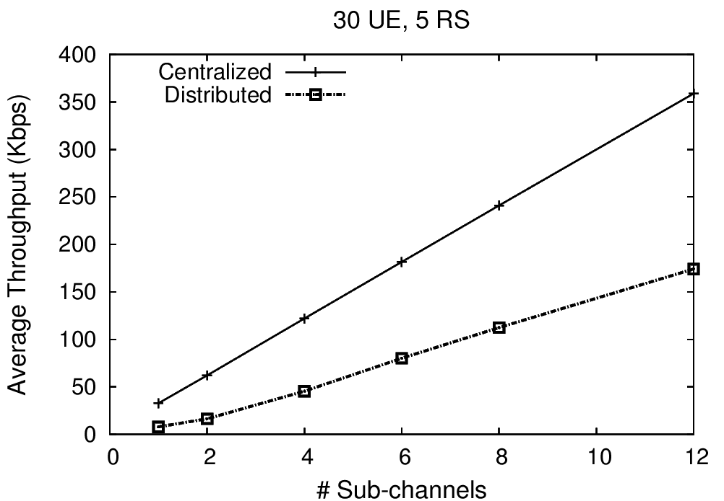
Fig 1. Performance of Distributed and Centralized Scheduling

The average MS’s throughput performance for centralized and distributed scheduling is measured as a function of the number of OFDMA sub-channels considered. While the ABS makes scheduling decisions on behalf of all ARS and AMS, each of the ARS makes its own scheduling decision for AMS associated with it without any coordination with the ABS or other ARS. The resulting impact of interference, rate mismatch between relay and access hops and inefficient scheduling decisions manifests in the form of degraded performance in the above result. It can be seen that the performance gain of centralized over distributed is more than 100%, justifying its importance.

Note that, the above result does not take into account the feedback overhead. But note that it would not alter the result much. This is because even in the distributed scheme, CQI is needed at the ARS and the ABS for the access and relay hops respectively. However, the CQI from access hop (AMS) does not have to be forwarded to the ABS in distributed scheme unlike in the centralized scheme. The distributed scheme will only have the ARS feed back the relay hop CSI. In centralized, the access hop CQI will also be forwarded. This leads to an additional hop worth of CQI for the two hop model, which is not significant. Further, some intelligent feedback reduction mechanisms by way of consolidating feedback at ARS can be employed to reduce the feedback on the relay hop (see accompanying contribution [4]). Thus, the performance completely justifies the slightly increased overhead for two-hop relay networks.

2. Proposed text
Modify the text in 15.6.1 and 15.6.2.6 to incorporate centralized scheduling as follows.
------------------ Start of Proposed Text --------------------------------------------
15.6.1 Relay Modes and General Description
In Advance WirelessMAN-OFDMA deployment supporting relay, a centralized or distributed scheduling model is used.
In distributed scheduling, each infrastructure station (ABS or ARS) schedules the radio resources on its subordinate link. In case of an ARS, the scheduling of the resources is within the radio resources assigned by the ABS.
In centralized scheduling, ABS schedules the resources on both relay and access links and notifies the A-MAP to be used by ARS on its subordinate links.
The ABS notifies the ARSs and AMSs of the frame structure configuration. The radio frame is divided into access and relay zones as described in 15.6.3.1.
15.6.2.6 Scheduling and QoS
The ABS may use persistent allocations (as described in 15.2.7) and group resource allocations (as described in 15.2.9) on the relay link. ARSs shall support the use of persistent scheduling and group resource allocations on the relay link.
In centralized scheduling, ABS shall schedule air link resources on the access link for AMS.
In distributed scheduling, the ARS shall schedule air link resources on the access link for communications with its associated AMSs. Frame-by-frame scheduling decisions are made by the ARS, however the ABS shall have the ability to constrain the resources utilized by the ARS. The ABS may specify the following resource usage constraints:
•Frequency partitions or subbands which an ARS is allowed to use/not allowed to use.
•Tx power that an ARS should use in a given partition or subband.
•Restrict/recommend groups of PMIs that an ARS can use in specified subbands

-------------------- End of Proposed Amendment Text -------------------------------------------

3. References
[1] IEEE 802.16m-08/003r9, “The Draft IEEE 802.16m System Description Document”.
[2] Usage Models (IEEE 802.16j-06/015)

[3] Technical requirement (IEEE 802.16j-06/016r1)

[4] IEEE 802.16m-09/, “Reducing Uplink Feedback for Channel-dependent Scheduling with Relays”

