Project | IEEE 802.16 Broadband Wireless Access Working Group <http://ieee802.org/16>
Title | Feedback mechanism for asymmetric carrier aggregation (16.2.8.1)
Date Submitted | 2010-03-16
Source(s) | Chiwoo Lim, Hyunjeong Kang, Jaeweon Cho, Taeyoung Kim  Samsung Electronics Co., Ltd. | chiwoo.lim@samsung.com
Re: | IEEE 802.16-10/0011: “IEEE 802.16 Working Group Letter Ballot #31: Announcement”  Target topic: “IEEE P802.16m/D4, section 16.2.8.1”.
Abstract | The contribution proposes a clarification on UL feedback channel region and DL CINR report for active DL only carrier in carrier aggregation mode.
Purpose | To be discussed and adopted by WG LB
Notice | This document does not represent the agreed views of the IEEE 802.16 Working Group or any of its subgroups. It represents only the views of the participants listed in the “Source(s)” field above. It is offered as a basis for discussion. It is not binding on the contributor(s), who reserve(s) the right to add, amend or withdraw material contained herein.
Release | The contributor grants a free, irrevocable license to the IEEE to incorporate material contained in this contribution, and any modifications thereof, in the creation of an IEEE Standards publication; to copyright in the IEEE’s name any IEEE Standards publication even though it may include portions of this contribution; and at the IEEE’s sole discretion to permit others to reproduce in whole or in part the resulting IEEE Standards publication. The contributor also acknowledges and accepts that this contribution may be made public by IEEE 802.16.
Patent Policy | The contributor is familiar with the IEEE-SA Patent Policy and Procedures:  <http://standards.ieee.org/guides/bylaws/sect6-7.html#6> and <http://standards.ieee.org/guides/opman/sect6.html#6.3>.  Further information is located at <http://standards.ieee.org/board/pat/pat-material.html> and <http://standards.ieee.org/board/pat>.

Feedback Mechanism for Asymmetric Carrier Aggregation
Chiwoo Lim, Hyunjeong Kang, Jaeweon Cho, Taeyoung Kim
Samsung Electronics Co., Ltd.

- Introduction
The contribution proposes the text changes of UL control feedback region assignment and the DL CINR report using MAC control message/header in asymmetric carrier aggregation to be included in the 802.16m amendment. In the current draft [1], the descriptions are only high level texts. So, the detail signaling and operation is not well defined yet. There are two issues: one is UL control feedback region assignment and another is DL CINR report using MAC control message/header. We suggest two proposals to solve these problems. Both proposals in this contribution maximize reuse of the existing MAC messages and A-MAP IEs. There is no modification to the existing MAC messages and AMAP IEs and we just add and clarify the required operation of ABS and AMS. Please see the followings to find two proposals in details.

1) UL control feedback region assignment
The current draft describes that “In multicarrier aggregation, the UL control channels corresponding to the secondary partially configured carriers shall be located in distinct non-overlapping control regions in the UL of the primary carrier”. However, there is no detail description that how to indicate the distinct non-overlapping control regions for secondary partially configured carrier.
This contribution proposes that using the AAI_SCD on active Secondary carrier to assign the UL feedback channels.
The required information in AAI_SCD is followings:
- Primary carrier index
- The start LRUs index for feedback channel
- The number of DLRUs for feedback channel
- The number of HARQ feedback channel per HARQ feedback region

The AAI_SCD is sent on the secondary partially configured carrier(s) and UL feedback channels are allocated on the primary carrier.
Please see the below figure as an example.

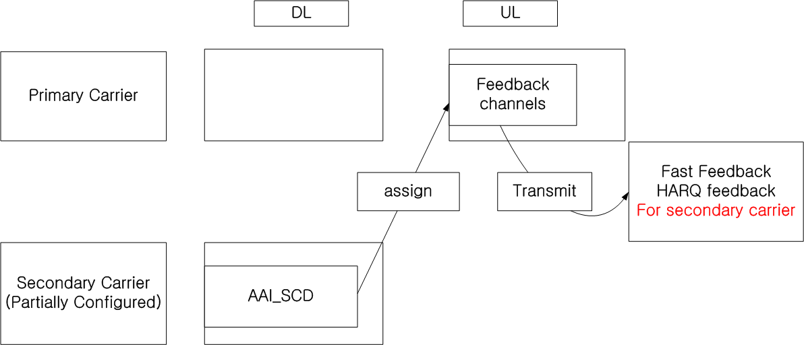

2) DL CINR report using MAC control message/header
The current draft also describes that “When measurement/report MAC messages are used for DL CINR report operation, the messages are transmitted on the AMS's primary carrier. The measurement/report MAC message may contain CINR reports for all carriers or for each carrier of the AMS”. However, there is no detail description that how to handle CINR report for secondary carrier(s) in message-based report.
This contribution proposes that using the Feedback Polling A-MAP IE on active Secondary carrier to inform UL burst region on primary carrier and using the separate MAC control message/header corresponding to secondary carrier.
Please see the below figure as an example.

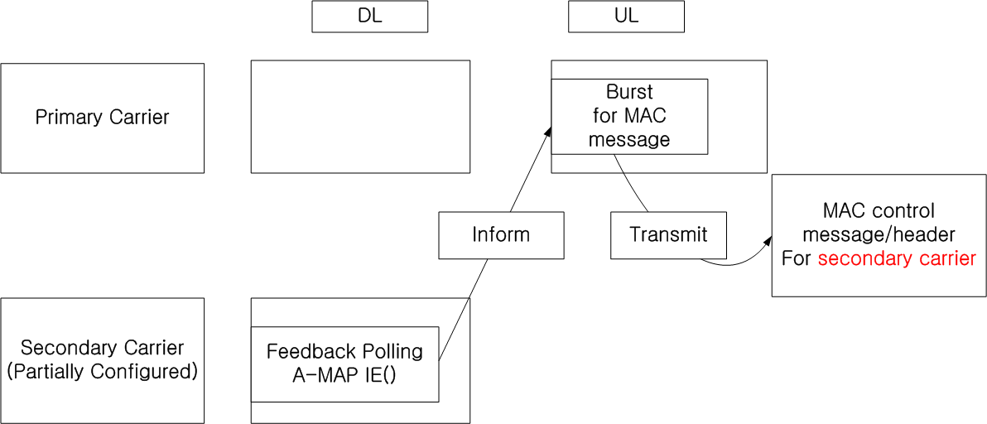

Reference
[1] IEEE P802.16m/D4, Feb. 2010

- Text change
------------------------------- Text Start ---------------------------------------------------

[Change the text on line 4 of page 229 in subclause 16.2.8.1 as follows:]
  - Partially configured carrier: A carrier configured for downlink only transmission in TDD or a downlink carrier without paired UL carrier in FDD mode. . Such supplementary carriers may be used only in conjunction with a primary carrier and cannot operate standalone to offer AAI services for an AMS. Whether a carrier is fully configured or partially configured is indicated using Advanced Preamble of the carrier. The AMS shall not attempt network entry or handover to partially configured carrier. In multicarrier aggregation, the UL control channels corresponding to the secondary partially configured carriers i.e., DL only secondary carriers shall be located in distinct non-overlapping control regions in the UL of the primary carrier. The UL control channel regions for the DL only secondary carriers are behind the UL control channel region for the primary carrier. The location information of the UL control channel for the DL only secondary carriers are informed through the AAI_SCD message which are transmitted on the secondary carriers. The AMS shall use the UL control channels on the primary carrier to feedback HARQ ACK/NACK and channel quality measurements corresponding to transmission over DL only secondary carrier.

[Change the text in subclause 16.2.8.2.8 as follows:]
16.2.8.2.8 DL CINR report operation
In multicarrier aggregation with fully configured carriers, aAn ABS may assign FastFeedback channels to each carrier of an AMS. When FastFeedback channel is assigned, the AMS reports CINR for a carrier over the assigned FastFeedback channel of the corresponding carrier at the feedback region as defined in Section 16.3.8.3.3.

In multicarrier aggregation with DL-only secondary carrier, the ABS may also directs the AMS to report CINRs of the active DL-only secondary carriers through FastFeedback channel(s) on the primary carrier at the feedback region. The feedback region is indicated using primary carrier index, the start LRU index for feedback channel, the number of DLRUs for feedback channel and the number of HARQ feedback channel per HARQ feedback region in the AAI_SCD message that is transmitted on the active DL-only secondary carrier as defined in Section 16.3.8.3.3. The feedback region of the active DL-only secondary carrier is behind the feedback region of the primary carrier.

When measurement/report MAC messages (i.e., AAI_SingleBS_MIMO_FBK, AAI_MultiBS_MIMO_FBK, Correlation Matrix Feed-back extended header) are used for DL CINR report operation, the messages are transmitted on the AMS's primary carrier. Feedback Polling A-MAP IE to inform a UL burst region is transmitted on each active DL carrier and the corresponding UL burst is assigned on the AMS’s primary carrier. The UL burst carries the messages for DL CINR report for the corresponding active DL carrier. The measurement/report MAC message may contain CINR reports for all carriers or for each carrier of the AMS.

[Change the text on line 49 to line 54 of page 595 in subclause 16.3.8.3.3 as follows:]
In a multicarrier system with active DL-only secondary carriers, the primary UL carrier should contains multiple feedback regions for the primary DL carrier and the active DL-only secondary carriers. The primary UL carrier should contains one feedback region corresponding to the primary DL carrier and each active DL-only secondary carrier, where the feedback region of the active DL-only secondary carrier is informed by the AAI_SCD message with a pre-defined mapping.

[Insert the following parameters in the AAI_SCD message after line 48 of page 116:]
-- UL feedback channel parameters for multicarrier
mcULFeedbackParams ::= SEQUENCE (SIZE (NumPC)) of uLFeedbackInfo OPTIONAL

uLFeedbackInfo ::= SEQUENCE {
-- primaryCarrierIndex for the primary carrier index
-- startLRUIndex for the start LRUs index for feedback channel
-- dLRUNum for the number of DLRUs for feedback channel
-- hARQChannelNum for the number of HARQ feedback channel per HARQ feedback region
primaryCarrierIndex BIT STRING SIZE(6) OPTIONAL,
startLRUIndex,
dLRUNum,
hARQChannelNum
}

------------------------------- Text End ---------------------------------------------------

